**Specifications for birthday wood decoration items:**

**Wood items**:

***Sample 1:***

* Length: 1.9 m
* Width: 0.9 m
* Thickness: 18 mm
* Color: white
* As show the picture
* Quantity:1

***Sample 2:***

* Wood: green MDF waterproof
* Length: 1.4 m
* Width: 0.9 m
* Thickness: 18 mm
* Color: white
* As show the picture
* Quantity:1

***Sample 3:***

* Wood: green MDF waterproof
* Length: 1.2 m
* Width: 0.9 m
* Thickness: 18mm
* Color: white
* As show the picture
* Quantity:1

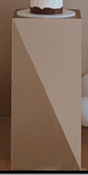 ***Sample 4:***

* Wood: green MDF waterproof
* Length: 0.9 m
* Width: 0.4 m
* Thickness: 18 mm with 6 mm Top
* Color: white
* As show the picture
* Quantity:1

***Sample 5***

* As show the picture:
* Quantity: 3 pieces as following
  + First one: Length: 2 m - Width: 0.9 m - thickness:18 mm
  + Color: pink
  + Second one: Length: 1.7 m- Width: 0.9 m – thickness: 18 mm
  + Color: pink
  + Third one: Length: 0.9 m - Width: 1 m - thickness: 18 mm
  + Color: pink

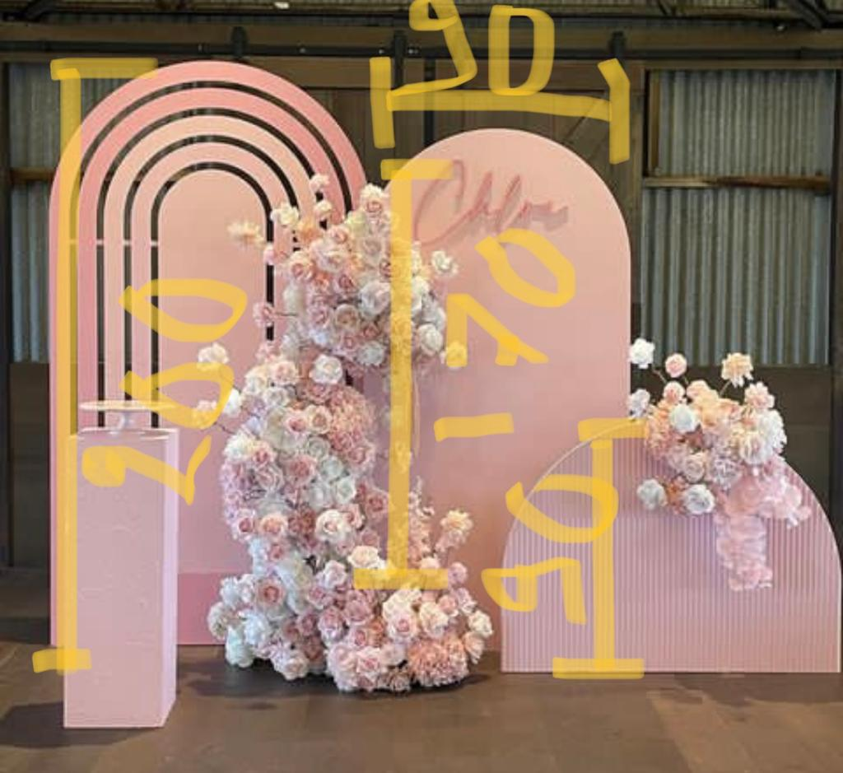

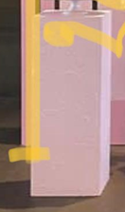 ***Sample 6:***

* Quantity: 1
* as show the picture
* Wood: green MDF waterproof
* Length: 0.9 m
* Width: 0.5 m
* Thickness: 18 mm
* **Color: pink**

***Sample 7***

* 3 woods green MDF waterproof pieces for birthday design as following:
* 1st: Length 1.9 m, Width 0.9 m, Thickness: **18 mm**, Color: **off-white**
* 2nd: Length 0.9 m, Width 0.50 m, Thickness: 18 mm, Color: **off-white**
* 3rd: Length 0.7 m, Width 0.50 m, Thickness: 18 mm, Color: **off-white**

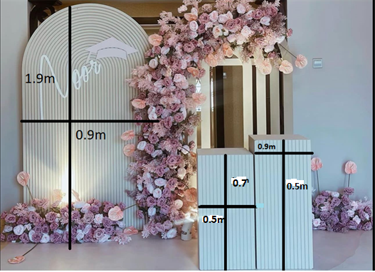

***Sample 8***

**Three woods green MDF waterproof pieces as shown and as per the following:**

1st : Length: 2m, Width: 0.9 m, Thickness 6 mm, Color : White, texture : same as picture, Quantity 2 opposite curves as shown in the sample below

2nd : Length : 0.9 m, Width : 0.5 m, Thickness 18 mm, Color : White , Texture : same as picture

3rd : Length : 1.8m , Width : 0.9 m, Thickness 18mm , Color : White, Texture : same as picture 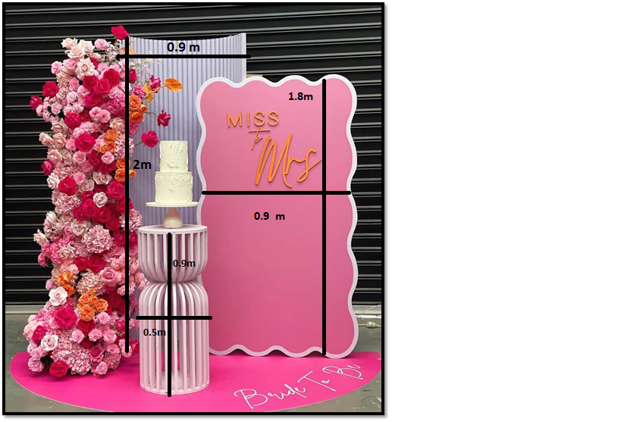

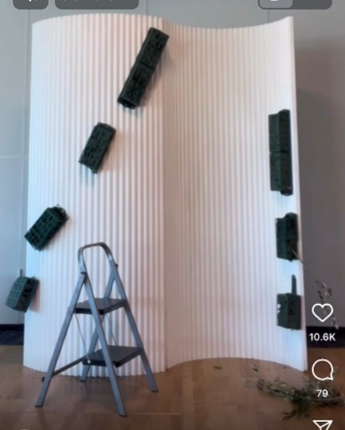

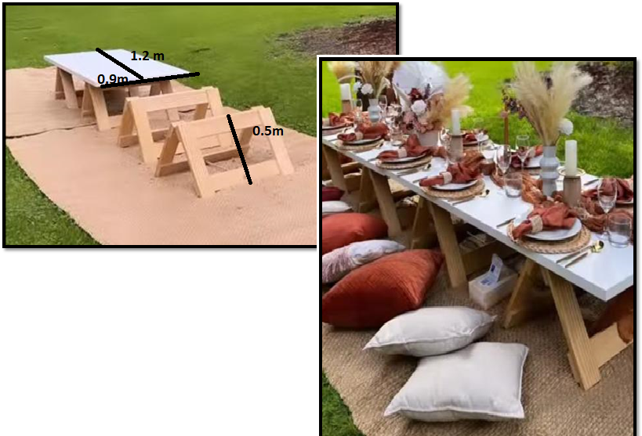 ***Sample 9:***

* wood green MDF waterproof
* Specs of the table: length 1.2m, width 0.9m, thickness 3.6 mm, color same as picture
* Spec of the table base: Height 0.5 m, thickness 3.6 mm, color same as picture
* quantity: 2 tables with 2 bases
* color same as picture

1. **Wood numbers with light**

* wood green MDF waterproof pieces
* length 1.2m
* width 0.6 m
* thickness 18 mm
* color white and light color white
* quantity : from number 0 till 9 duplicates of each number

