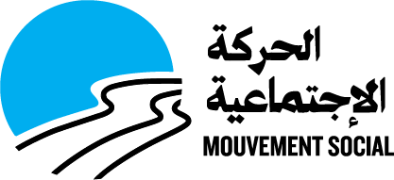

Terms of reference

Ref: BAD 97-2021

“Producing short videos about juveniles”

Shooting, Editing, Coloring and Sound design

For Mouvement Social, NGO
Beirut, Lebanon

Starting date of work: To be determined upon each assignment

Contact: Pierre Hattouny - Procurement officer
Email: p.hattouny@mouvementsocial.org

Mouvement Social (MS) is a development human-based non-governmental organization (NGO), not affiliated to any political party or religious group. It was founded by late bishop Gregoire Haddad and a group of multi-religious personalities, on a secular basis. It was acknowledged as a general interest association by the Lebanese State in 1961. Since its inception, MS is working towards sustainable development over all the Lebanese soil in a secular and non-discriminatory approach. It aims to build a fair and humane society, to improve the citizenship and autonomy of the underprivileged and to implicate youths in the development and improvement of their society. MS programs presently tackle fours courses of actions: education; socioeconomic empowerment; protection for minors; Volunteering. Its actions are spread all over the Lebanese territory.

Video Objectives
Produce professional short videos (during coming months till end of 2021)

The video generally describes MS intervention inside Roumieh prison and the preparation phase to the reintegration into society after release.
Shooting could take place in Roumieh prison and one MS center.

- Final video length: average 5-7 minutes
- Shooting: between 2 to 4 days (depends on conditions and availability of the prison management)

Qualifications
Required qualification and experience:
The service provider is expected to meet the following requirements:
- Minimum 3 years’ experience preferably with NGOs
- Proven skills and creativity in video shooting and editing
- Technical Requirements for material: Camera, lighting, sound, adapted computer for editing, and editing software.

Deliverables
Final Product to be delivered 3 weeks after shooting.

How to apply

Quotation will be sent by E-mail to Mr Pierre Hattouny - Procurement officer
Email: p.hattouny@mouvementsocial.org

Payment
Payment will be in fresh dollars.
Please provide your quotation covering: Shooting, Editing, Coloring and Sound design

Payment conditions: Bank check in USD cashed fresh money from Fransabank (Adliyeh branch only) – Banking commission (8$/1000) payable by the supplier.

Deadline
Deadline for submission: 13 October 2021
Please provide your quotation with CV / Portfolio

