UNICEF Lebanon Terms of reference (TOR) for LTA

PROJECT/ASSIGNMENT TITLE: Research
WORKPLAN CODE NUMBER:
Specific Intervention Code: In PRIME Rolling Work Plan: Research Output
Activity: Research
Background and Purpose:

UNICEF Lebanon is committed to support the children living in Lebanon through strategies, policies, and community advocacy in coordination with the Lebanese Governate and other public/private institutions. Also, UNICEF supports children through interventions and services provision that reach directly or indirectly.

And as UNICEF adopts the method of Result Based Management to ensure that results and are achieved and positive change are really occurring and can be proven; the evidence-based approach is considered a major pillar within UNICEF work, that would guide the effort of UNICEF and its partners.

And for that purpose, UNICEF Lebanon is looking to have a long-term agreement with local and international research firms; with professional and experienced teams; that could provide the different types of research services which could include all topics that UNICEF programmes could cover, like: Adolescents and Youth, Health, Nutrition, Water & Sanitation, Child Protection, Social Norms, Social Behaviors, Gender-Based Violence, Social Policy, Social Protection. Communication, Communication for development, etc.

General Conditions

- Due the variations in scopes and needs; the contractor will be requested; before the initiation of a contract; to submit a brief proposal describing the process of conducting the required tasks.
- The contractor will ensure as much as possible gender balance with the deployments of its team working on the requested tasks.
- The pricing should be calculated based on the annexed tabulation to this TOR.
- The contractor team should able to work using English and Arabic languages.
- The report should be submitted either in English or Arabic. A translation service could be requested from the contractor and it will be costed as an independent service.
- Having a Long-Term Agreement is not considered at any point a promise for signing contracts with UNICEF.
- All data collected for under this agreement and for the research purposes remains the sole property of UNICEF.

Management and financial arrangements

- The research will be managed by the research team at UNICEF in close coordination with the relevant section requesting the research. A specific staff member from UNICEF will be assigned to lead the communication with the contractor, in turn, the contractor is expected to assign a communication focal point.
- The contractor will commit to provide revisions based on provided feedback from UNICEF.
- The payment tranches will be agreed on before the signature of the contract based on deliverables, on a basis that UNICEF cannot proceed with the first payment until at least one deliverable is submitted.

Key tasks and deliverables:

The contractor will be asked to manage and conduct a research in all its phases including all tasks that usually exist in a research, such as but not limited to, literature review, research protocol, questionnaires, analysis plan, report, etc.) that will be detailed under the services in the coming paragraphs.

Each type of service comprises of several engagements and tasks. Each service is considered as one inseparable component and will be costed as such.

A contract could only include one service or many services. There is no contractual connection between the different services

Sub-contracting for specific tasks is conditional to UNICEF approval.

Service 1: Conducting and Managing research

- Ensure good synergy and collaboration with UNICEF and other stakeholders involved in the study, during the process.
- Submit an inception report/ or a research protocol. Proceeding with the research is conditional to the quality of the report or protocol submitted. The minimum requirements of the inception report/research protocol are the following:
  - Research Information (such as, the reason behind it, importance in relation to UNICEF’s mandate, objectives, etc.)
  - Research Process (e.g., literature review, involvement of stakeholders and end users, research personnel, budget and resources)
  - Methodology (including, research framework, limitations, research design, sampling design, data collection methods, analysis framework, etc.)
  - Research Tool (see 1.4)
  - Ethical considerations (e.g. ethical approvals, do no harm, etc.)
- As part of the inception report/research protocol, prepare the research tools and list of indicators in coordination with UNICEF; for qualitative and quantitative data collection.
- As part of the inception report/research protocol, provide a sampling design that fits best the objectives of the research and the Lebanese context; when needed.
- Provide revisions to the inception report/research design based on provided feedback by UNICEF.
- Get an Institutional Review Board (IRB) clearance, or any similar reputable and certified ethical board, for inception report/research design.
- Translate (back-translate when needed) the research tools (questionnaires, survey, interview protocol, etc.) from Arabic to English and English to Arabic.
- Provide a quality assurance plan and a protocol for data collection.
- Design and conduct data collection through electronic devices. Data collection on paper should only occur in case of force majeure usually caused by security concerns.
- Properly manage the collected data and ensure its security and privacy.
- The use of software for data analysis, quantitative (e.g, SPSS, R, STATA, etc.) and qualitative (Atlas.ti, NVIVO, etc.).
- Submit the cleaned and complete dataset.
- Submit the cleaned tabulation for the conducted analysis, along with the syntax files.
- Submit the transcripts and recordings for qualitative data collection.
- Conduct the required analysis within the approved analysis framework.
- Submit a research report that includes well designed graphs and infographs, when applicable and if possible, the graphs should be done using a professional design software and not using statistical software or others, such as Excel. The report can adopt the following structure to ensure it is logical and succinct:
  - Table of contents, list of annexes/figures/tables, etc.
  - List of Acronyms
  - Executive Summary (2 – 5 pages)
  - Introduction & Background
  - Methodology
  - Limitations
  - Ethical Considerations
  - Results, Discussion, & Recommendations
  - Conclusion
  - Annexes
  - The report should be written in a style accessible by the general audience and within an 80-pages limit. The executive summary should not exceed 5 pages, while including a summary on each section of the report and being aligned with the structure of the full report. The report should be both in English language, availability of professional translation of the report is an added value.
- Do the necessary revisions to the report based on provided feedback form UNCIEF.
- Submit a research brief that summarizes the research in a two-pager document.
- Submit a presentation that summarize the findings and recommendations of the research.
- Submit a policy brief or key finding brief in a two-pager format.
- Present the findings and recommendations of the research to UNCIEF team or to a public audience after the finalization of the report and the presentation.

Service 2: Conducting secondary analysis

- Ensure good synergy and collaboration with UNICEF during the process.
- Participate in meetings with UNICEF prior and during the research work.
- Submit an analysis plan, that includes at the least the following: analysis steps, software to be used, analysis framework, indicator list when relevant,
- Provide revisions to the inception report/research design based on provided feedback by UNICEF.
- The use of software for data analysis, quantitative (e.g, SPSS, R, STATA, etc.) and qualitative (Atlas.ti, NVIVO, etc.).
- Submit the cleaned tabulation for the conducted analysis, along with the syntax files.
- Conduct the required analysis.
- Submit a research report that would include well designed graphs and infographs, when applicable and if possible, the graphs should be done using a professional design software and not using statistical software or others, such as Excel. The report can adopt the following structure to ensure it is logical and succinct:
  - Table of contents, list of annexes/figures/tables, etc.
  - List of Acronyms
  - Executive Summary (2 – 5 pages)
  - Introduction & Background
  - Methodology
  - Limitations
  - Ethical Considerations
  - Results, Discussion, & Recommendations
  - Conclusion
  - Annexes
  - The report should be written in a style accessible by the general audience and within an 80-pages limit. The executive summary should not exceed 5 pages, while including a summary on each section of the report and being aligned with the structure of the full report. The report should be both in English language, availability of professional translation of the report is an added value.
- Do the necessary revisions to the report based on provided feedback form UNCIEF.
- Submit a presentation that summarize the findings and recommendations of the research.
- Present the findings and recommendations of the research to UNCIEF team or to a public audience after the finalization of the report.

Service 3: Peer Review

- Ensure good synergy and collaboration with UNICEF during the process.
- Participate in meetings with UNICEF prior and during the research work.
- Submit a methodological approach detailing the peer review approach.
- In case of qualitative research, transcribe verbatim data, when needed.
- In case of quantitative research, submit syntax files used, when needed.
- Submit a detailed report on the strengthens and weaknesses of the report being reviewed.
- As part of the report 3.4, provide concrete and relevant recommendations for the report being reviewed.

Mandatory Qualification Requirements:

- Registered company based on the Lebanese law and regulations.
- Able to work in all the governorates of Lebanon.
- Senior staff holding At the least a Master’s degree in social sciences, statistics, psychology, education, sciences, or an relevant field. A docotrate is an added value. Other team members to hold a degree in social sciences, statistics, psychology, education, sciences, or an relevant field.
- At least 8 years of proven experiences in qualitative and/or quantitative research.
- Proven experience in managing national and/or subnational research.
- Proven experience in working with multiple governoment and non-government stakeholders is an added value
- Ability to provide staff with Lebanese and Palestinian nationality for field work. Palestinian field workers will be required for any data colleciton within the camps or with Palestinian households/individuals living outside the camps.
- Previous research reports to be provided.

Profile of the company to be submitted together with CVs and educational degrees of the team members.

Evaluation process of the bids:

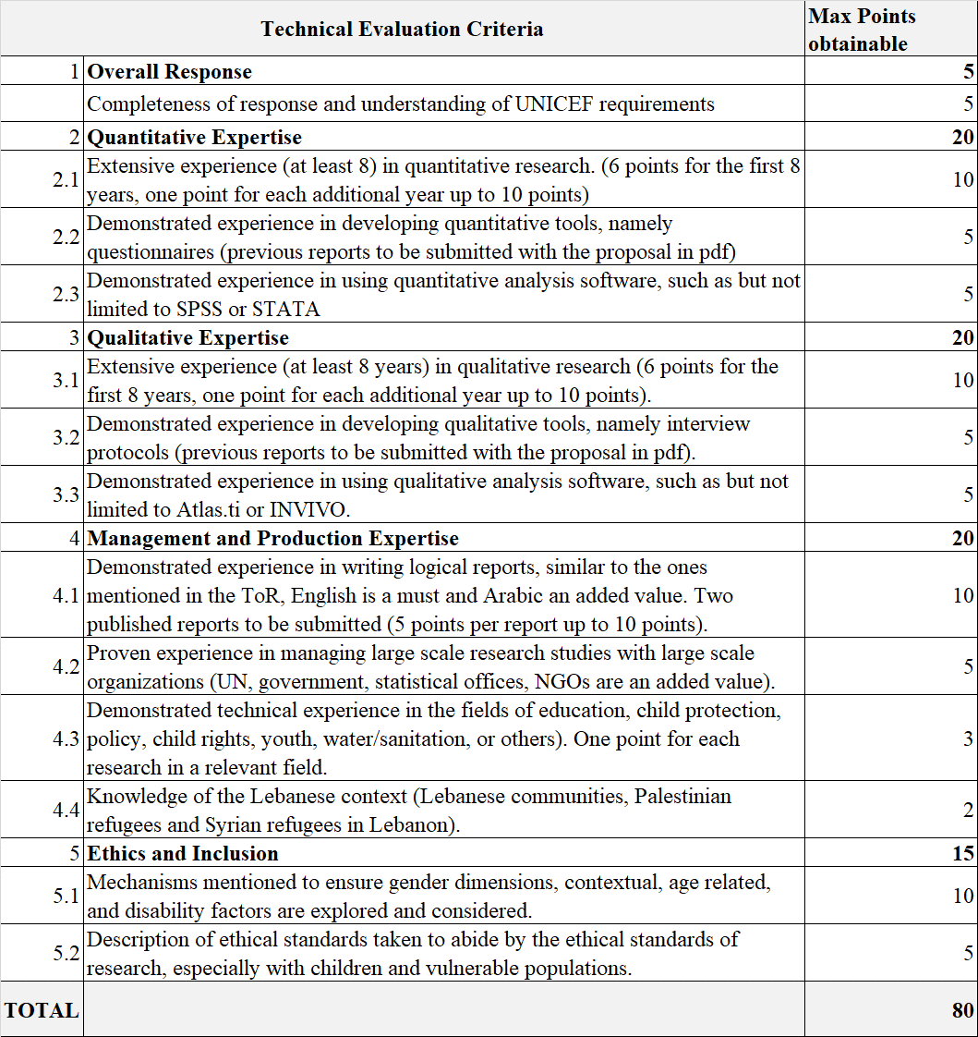

Passing score for technical evaluation is 56 points.

Ethical concern and confidentiality

In line with the UNICEF procedure for ethical standards in research, evaluation, data collection and analysis (in annex), the contractor will commit to the ethical standards and will ensure to treat all elements in confidentiality.

Timing/Duration of LTA: 2 years renewable for one additional year based on office need, market price and satisfactory performance.
Duty Station: Lebanon
Conditions
All workers meeting with local authorities or conducting field tasks should be Lebanese and speak Arabic. In case of tasks in the Palestinian Camps, Palestinian staff would be requested.

