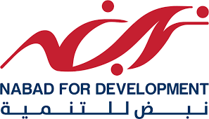
Conflict Resolution Training Program

Terms of Reference for Consultancy Services
“Training and Coaching”

Funded by
TROICARE
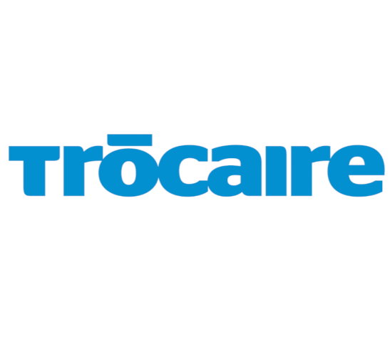

Implemented by
NABAD for Development – Lebanon
2024

Introduction
Founded in 2013, the Association Nabad for Development, hereinafter referred to as NABAD is a civil, nongovernmental, and non-profit organization working on the alleviation of human suffering, dismantlement of injustices, development of impoverished and disenfranchised communities, and empowerment of individuals. With the Universal Declaration of Human Rights as its basis for action, Nabad’s principal focus is on ensuring that individuals and communities are aware of their rights and responsibilities, can practice these rights, and have access to the means that allow them to enjoy these rights. Among the domains that the Organization has experience working in include alleviation of poverty and conflicts, raising public awareness on citizenship, protection, democracy, and human rights, empowerment of Community Committees and women, and promotion of social stability and peacebuilding. Nabad concentrates its efforts on helping refugees, developing Lebanese society in general, and the local communities in Bekaa and Mount Lebanon in particular, especially by supporting and developing poor families and enhancing the educational, economic, and social aspects of the marginalized and underprivileged segments thereof. Furthermore, it focuses on providing these communities with the resources and expertise that are necessary to reach a proper environment for creativity to consolidate, strengthen, and further develop their capacities and so of the civil institutions and avail access to the resources that allow them to reach their full potential.
The Organization’s scope of operation covers the entire area of Bekaa, South, Beirut, and Mount Lebanon. Nabad has a human resource base of 40 staff members and a volunteer corps of 300 professionals. All of the staff members have solid experience in the Emergency Response Operation for the Syria Crisis in various positions ranging from front-line field staff to senior management ranks and have developed solid expertise in the various sectors of the humanitarian.

Objectives of the training
Under the context of community sustainable development, “NABAD” intends to deliver full package training as part of capacity building targeting 100 Community Committees. The consultant will be working full time / 2 days including conducting the sessions plan. Thus, the community sustainable development context tackles the fragile inter-communal relations and social tensions between the host community and refugees living in those communities, and seeks to improve social stability and PSS service delivery through Community Committees volunteering, soft skills development, and psychosocial awareness activities for caregivers.
To ensure that a strong training package is delivered to 7 Community Committees to equip them with the knowledge of high quality regarding defining and understanding sustainability goals, community engagement techniques and participation in the decision-making process, resources management like waste management, recycling or conservation of natural resources, economic development strategies, environmental conservation like sustainable agriculture and food systems, and capacity building by training on relevant skills and knowledge, building resilience and leadership development. They shall learn the ability to be sustainable to avoid the depletion of natural resources in order to maintain an ecological balance. They shall also learn how to create thriving, healthy, diverse and resilient communities and techniques for engaging community members, and empowering marginalized groups.

These courses will be aimed at empowering a network of Community Committees in North, West and Central with the confidence and skills to take a main role in community sustainable development and management initiatives in their communities.
- Consultant main objective:
- Delivering clear curriculum technics and methodology which at the very minimum, should include the following areas of knowledge and learning:
- Promote sustainability development by defining and understanding its goals.
- Increase the capacity of local civil society represented by Community Committees to build public awareness through collaborative work with refugees and host communities addressing sustainable development.
- The Consultant approach to sustainability analysis and baseline shall be grounded in the guiding principles of our work: participatory; culturally sensitive; affirming and positive while honest and productively critical and valuing knowledge and approaches from within the context.
- To identify the role of sustainability Baseline.
- Delivering any required pedagogical support material (i.e.: training manuals, lesson plans, training material, etc.).
- Developing training methodologies/techniques, this may include creative tools such as games, audio-visuals, group discussions, demonstrations, and practice sessions with feedback and role play, pending the target audience.
- Ensuring or creating feedback loops that allow for suggestions, modifications, or grievances related to the sessions or exercises to adapt to changes occurring in the work environment, based on the feedback from trainees and IRL.
- Ensuring that all Community Committees are trained adequately, and have a solid understanding of the training material. This will include administering a test for Community Committees before and after the training, to assess the training’s quality and relevance.
- Developing pre-posttests, collecting pre-post data, and submitting a final electronic report.

- Responsibilities
The Consultant will advise on the sustainability development context. He/she will conduct a specific needs assessment of psychosocial knowledge and experience for Community Committees, provide advice on the strategic direction of the program, develop a psychosocial assessment system as pre and post-evaluation for the Community Committees, design a viable training program and provide capacity building to 7 Community Committees after assessing their skills and verify their needs also to emphasize the practical implementation of all topics that have been taken in training.

- Capacity building
The consultant will provide professional training to Community Committees based on identified training needs through a pre-test questionnaire. He/she will also train them on how to use the new assessment forms and effectively utilize the planning and implementation process.

Report and Formulation of Recommendations
At the end of his/her assignment, the consultant will prepare monthly reports and final reports in English. The report should contain collected assessment data, an analysis of the findings, the scope of the psychosocial impact, and the consequences based on pre and post-tests have been done for the trainees and the training activities.

Training outlines titles:
The trainer(s) will be committed to delivering the following training and the related materials (in Arabic) following the topics:
Training Topic
- Introduction to sustainable development:
- Defining sustainability and its pillars.
- Understanding the sustainable development goals.
- Techniques for engaging community members in the decision-making process and empowering groups.
- Local economic development strategies, entrepreneurship, and small business development.
- Sustainable resource utilization, waste management, and recycling.
- Capacity building by training on relevant skills and knowledge, leadership development, and building community resilience.

- Assess and develop the level of skills and potential among targeted groups of Community Committees in promoting sustainable development concepts through their communities.
- Methodological coaching/training about the concept of sustainability between refugee and host communities includes:
- Understanding Sustainability: This involves educating both refugee and host communities about the concept of sustainability, including its environmental, social, and economic dimensions.
- Cross-Cultural Communication: Training may focus on improving cross-cultural understanding, empathy, and respectful dialogue to foster cooperation and mutual respect.
- Community Engagement: Training programs often emphasize the importance of engaging both refugee and host communities in decision-making processes related to sustainability initiatives.
- Practical Skills Development: Participants may receive training in practical skills related to sustainability, such as organic farming techniques, renewable energy technologies, waste management strategies, and other environmentally-friendly practices. These skills empower individuals to contribute to sustainable development in their communities.
- Capacity Building: Training programs aim to build the capacity of both refugee and host communities to independently implement and sustain sustainability initiatives in the long term.

Requirements:
Qualified candidates (individuals and firms) are invited to apply for this task. The candidate (individuals and firms) can apply for one or more of the mentioned training topics.

a. Academic Qualifications:

University degree in social science, sociology, political science, or any other related field. MA is a plus.
b. Years of Experience:
A minimum of 5 years of relevant experience in local-level capacity-building skills and peacebuilding/dialogue processes.
A minimum of 3-5 years in conducting conflict assessments, conflict analysis
c. Competencies:

- Excellent Facilitation skills
- Excellent training skills
- Excellent reporting skills
- Proven impartiality and cultural and human rights sensitivity. Ability to build strong relationships with local actors using inter-personal skills to network effectively
- Excellent analytical, negotiating, and communication skills
- Ability to work under pressure, meet deadlines and show flexibility
- Excellent command of Arabic language and good command of English. French is a plus
- Good knowledge of the impact of the Syrian crisis on Lebanese Host Communities

Proposal Submission and Evaluation
- The Technical Proposal shall include, but not necessarily be limited to the following items:

- Introduction (including the consultant’s understanding of the required assignment).
- Qualifications and relevant experience of the consultant (attach CVs of proposed person/ team).
- Proposed approach and methodology for conducting the assignment with preliminary schedule submission and Evaluation of Technical Proposal.

Submission and Evaluation of Financial Proposal
- Only the applicants, who receive 45 points or more in the technical score, will be considered in the evaluation of the financial proposals.
- The financial proposal shall show all the direct costs related to the implementation of the assignment, while other operational costs such as transportation, communications, etc. can be implicitly included.
- Please use the following table, and do NOT add any additional budget lines, to facilitate evaluating and comparing the financial offers.

Training Date
- Last week of May 2024.

