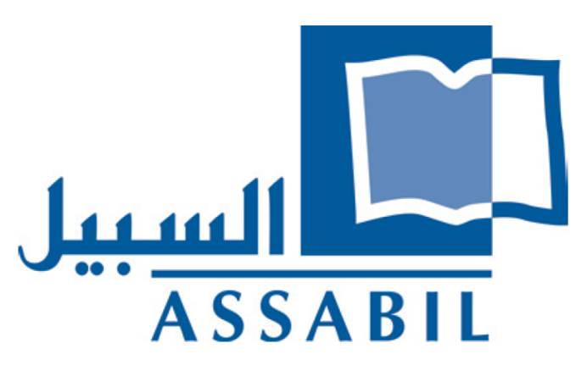
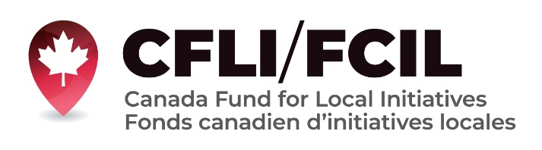

Terms of Reference

Project: Promoting inclusive governance at the local level for women, youth and refugees through debates, workshops and rap in Lebanon, CFLI-2022 BERUT 0003 Assabil, supported and funded by CFLI-Canada Fund for Local Initiatives
Position Title: Workshop Organizer
Place of Work: Beirut, Lebanon
Reports to: Project Manager- ASSABIL

Objective/purpose of consultancy

To increase the awareness of young people, women and members of refugee and migrant populations in Lebanon on issues of inclusive governance through a series of training workshops

Background

At the local level in Lebanon, there are many barriers to political participation and inclusive governance for women, young people, and refugee population - the three target groups of this project. Women’s participation in municipal councils is extremely low; people younger than 21 are not allowed to vote and often lack the skills and knowledge needed to exercise their rights and fulfill their responsibilities as citizens; refugee and migrant populations are excluded from the political process even in relation to issues that affect their lives directly and face obstacles when they seek to get organized.

From this reason, ASSABIL aims to nurture spaces of knowledge, discussion, and the incubation of project ideas especially in relation to inclusive governance and the political participation on a local level of the three main groups targeted in this project (women, young people and members of refugee and migrant communities) as well as other marginalized groups, addressing key concepts, barriers and potential solutions. Since ASSABIL manages the Beirut Municipal libraries and has a network of partner libraries all over Lebanon, the project will be carried out in partnership with five libraries in different parts of the country. Public libraries in Lebanon are meeting spaces for the different communities. They welcome all population groups to utilize the space and promote mutual understanding and respect.

Scope of work and key tasks

We are looking for a professional workshop organizer for the following main tasks:

- Carry out five workshops on topics related to inclusive governance

Format and structure of activities and resources

Five one-day workshops on issues of relevance to inclusive governance to be organized in the five project locations (a total of 25 workshops). There will be workshops on the same five topics in each of the five locations.

The topics of the workshops should be decided in coordination with ASSABIL and the librarians at the five partner libraries. Potential topics include but are not limited to instituting a gender quota for parliament, concepts of gender equality and parity, including distinctions between the two concepts; youthful political participation, people’s assemblies as an alternative space of organization, political participation of refugees; grassroots versus centralized political organizing.

Each workshop will last for one day and will include introducing and building awareness of key concepts, discussion of the local situation and developing at least one idea of an initiative to promote inclusive governance at the local level. Each group will present one of these ideas during the public event at the end of the project.

The workshop may be organized directed by the consultant or through a third party organization.

Project Participants

The target group of the project are young people, women and members of refugee/migrant communities affiliated with the following libraries: Bachoura Public Library, Geitawi Public Library, Monot Public Library, Barja Public Library, Ansar Public Library; Bekfayya Public Library, and the Ghassan Kanafani Library in Beddawi Camp.

Estimated Number of Beneficiaries: twenty young men and women in each workshop in each location (around 500)

Qualifications/level requirements

The workshop organization should have the following qualifications, experience and skills:
- Strong background knowledge and past engagement with issues of inclusive governance
- Experience in developing, facilitating and delivering training workshops
- Experience of working with at least one of the three groups targeted in this project (women, young people; members of migrant and refugee communities)
- Adaptability and flexibility in working within a complex and dynamic environment
- Ability to deliver high quality results in a timely manner.
- Fluency in Arabic is a must.

Period and duration of consultancy

The duration of the consultancy is from August 2022 to 28 February 2023. Tasks include

- Organizing a total of 25 workshops on 5 topics in 5 locations

Fee and Mode of Payment

Fees will be calculated based on the number of days worked. The payment will be made in US Dollars by cheque (Fresh).

How to apply

Both individuals and organizations may apply for this post. If you are qualified and interested please submit your CV (for individual applicants) or description and overview of past projects (in the case of organizations), a proposed methodology including detailed work plan mentioning deliverables, proposed workshop organizers (if not the applicant themselves) with justification; example of a previous training report or similar piece of work, two references, daily rate and expected budget to (recruitment@assabil.com) with the subject “Workshop Organizer”

Application deadline: 8 August 2022

United Nations Development Program (2008): Education and Citizenship. Concepts, Attitudes, Skills and Actions. Analysis of survey results of 9th grade students in Lebanon.

