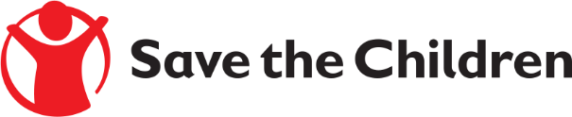

Tender Notice

Save the Children believes every child deserves a future. In Lebanon and around the world, we give children a healthy start in life, the opportunity to learn and protection from harm. We do whatever it takes for children – every day and in times of crisis – transforming their lives and the future we share.

Save the Children International in Lebanon is inviting submissions of tenders for a contract to provide the following products:

- Non Formal /Formal Educators (CB ECE(Teachers and TAs)-BLN-ABLN-YBLN- Retention support) for SCI learning centers in Bar elias, Kab elias, Taalabeya, Kfarzabad, Zahle Maallaqa Aradi, Joubb Jannine, Ghazze, Riyaq, Ablah). Ref# PR267809
Detailed technical specifications are included within the tender documents.
If you are interested in submitting a bid, please contact committee at the following address Lebanon.tender@savethechildren.org to express your interest and request the tender documents. Tender documents will be sent to you by return.
It is recommended to request the tender documents as soon as possible.
Completed tender documents are due to be submitted by 15:00 Beirut Local Time ON 26/05/2023

