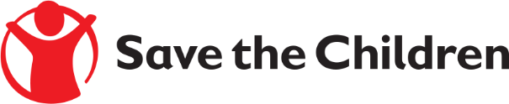

**Tender Notice**

Save the Children believes every child deserves a future. In Lebanon and around the world, we give children a healthy start in life, the opportunity to learn and protection from harm. We do whatever it takes for children – every day and in times of crisis – transforming their lives and the future we share.

Save the Children International in Lebanon is inviting submissions of tenders for a contract to provide the following products:

* ***Supplying Cholera Family Hygiene Kits, Cholera Household Disinfection Kits & Cholera PPE Disinfection kits Ref# FWA-B-2022-018***

If you are interested in submitting a bid, please contact SCI Procurement Committee at the following address ***lebanon.tenders@savethechildren.org*** to express your interest and request the tender documents. Tender documents will be sent to you by return.

It is recommended to request / collect the tender documents as soon as possible.

Completed tender documents are due to be submitted by **13:00 GMT+3 Lebanon ON 23 Dec 2022**