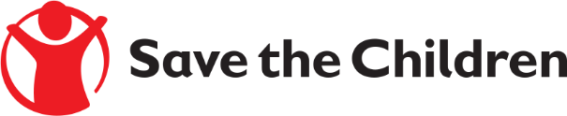

Tender Notice

Save the Children believes every child deserves a future. In Lebanon and around the world, we give children a healthy start in life, the opportunity to learn, and protection from harm. We do whatever it takes for children – every day and in times of crisis – transforming their lives and the future we share.

Save the Children International in Lebanon is inviting submissions of tenders for a contract to provide the following products:

- Procuring 07 Vehicles for the Lebanon Country Office
Detailed technical specifications are included within the tender documents.
If you are interested in submitting a bid, please contact SCI Procurement Committee at the following address lebanon.tenders@savethechildren.org to express your interest and request the tender documents. Tender documents will be sent to you by return.
It is recommended to request/collect the tender documents as soon as possible.
Completed tender documents are due to be submitted by 08 July 2024 at 16:00 Lebanon Local Time

