Fondation Diane
Université Saint-Joseph, CSH, Bloc C, 4th floor
Tél : +961 1 421 000 – ext 5722
Beyrouth 1104 2020 – Lebanon

Title of tender: Civil and MEP works -Re-Fit project
Reference number: 2022-Re-Fit-T1

A) INFORMATION FOR THE TENDERER

1) Information on the submission of tender

Subject of the contract:

The subject of this tender is to Implement Civil & MEP works

Deadline for submission of the tenders:
The deadline for submission of tenders is December 15, at 16:00. Any tender received after this deadline will be automatically rejected.

Address and methods for submission of the tenders:

The tenderers will submit their tenders using the standard submission form available in the Part B of the tender dossier. The tender will be submitted in 1 original. Any tenders not using the prescribed form might be rejected by DF.

Tender can be submitted by email to the following email: pascale.assaad@fondation-diane.org or by post containing the following information:
- Name and address of the tenderer:
- Title of the tender: Civil and MEP works -Re-Fit project
- Reference number (if applicable): 2022-Re-Fit-T1

If delivery in person, by post or courier service:
The tenders will be submitted in person, by post or courier service to the following address:
Fondation Diane
Université Saint-Joseph, CSH, Bloc C, 4th floor
Tél : +961 1 421 000 – ext 5722
Beyrouth 1104 2020 – Liban
Contact person: Pascale Assaad (pascale.assaad@fondation-diane.org)

The tenderers are reminded that in order to be eligible the tenders need to be received by DF by the deadline indicated above.

The tenderers are reminded that in order to be eligible the tenders need to be received by the organization by the deadline indicated above.

2) Technical information
The tenderers are required to provide the deliverables as indicated below. In the tenderer’s technical offer, the tenderers will indicate more details on the works to be implemented, referring to the following tables:

Item | Description | Unit | Quantity | Comments
 | Civil Works
1 | Steel Cabinet for battery storage | sqm | 1 | 92sqm of steel cabinet, steel tubes 5x10 for the structure,  aluminum sliding doors with fiber sheets to cover the back  side and the flooring.
2 | Floor | sqm | 1 | 47sqm, floor rounding and cleaning, primer floor  painting, 3mm epoxy flooring, 6.6sqm concrete casting with  steel rods (8cm thickness), steel stairs 50cm width 3m  long, steel stairs 80cm width 1.2m long 0.60m height,  12.5sqm aluminum and glass façade using 2 tubes 4x8 and  glass thickness 6mm clear, 80cmx210cm wall opening+  aluminum door.
3 | UN drum for storage of spilling | Unit | 1
 | Mechanical Works
4 | Emergency response equipment | Unit | 1
5 | Portable gas detector | Unit | 1
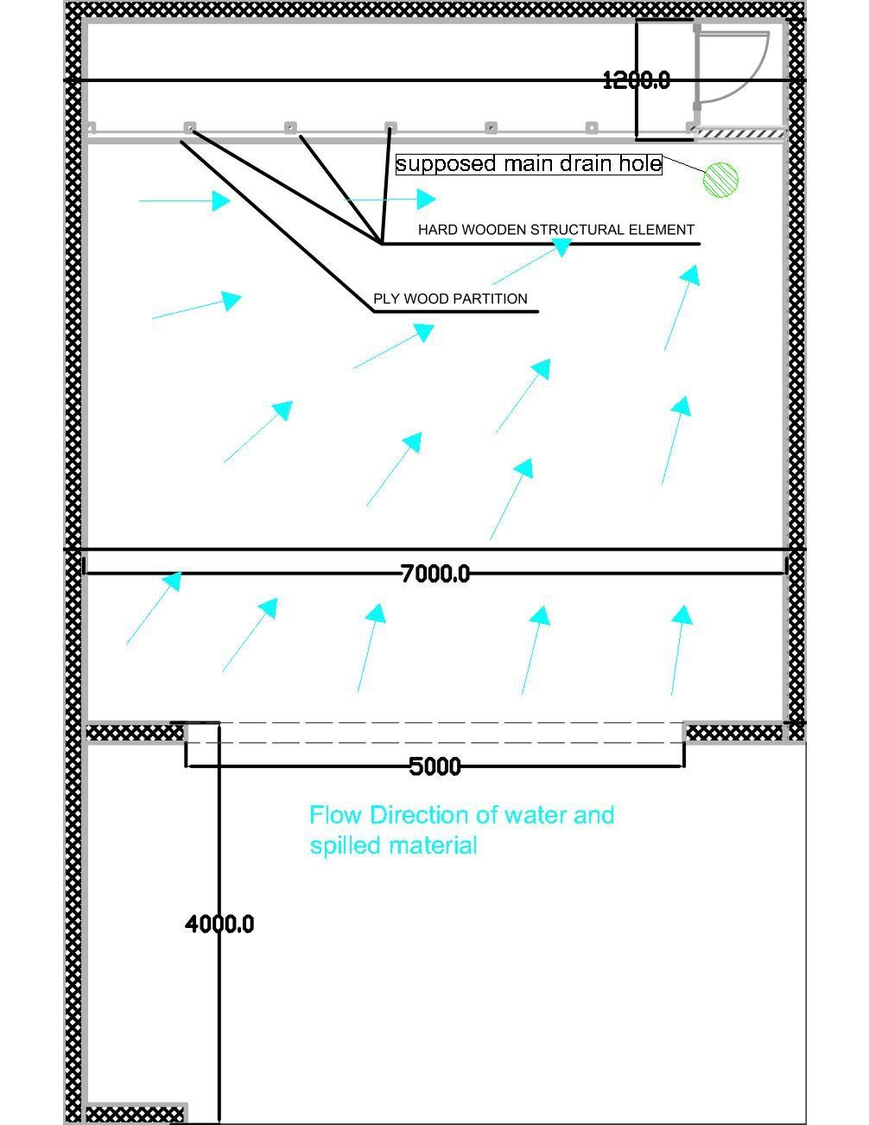
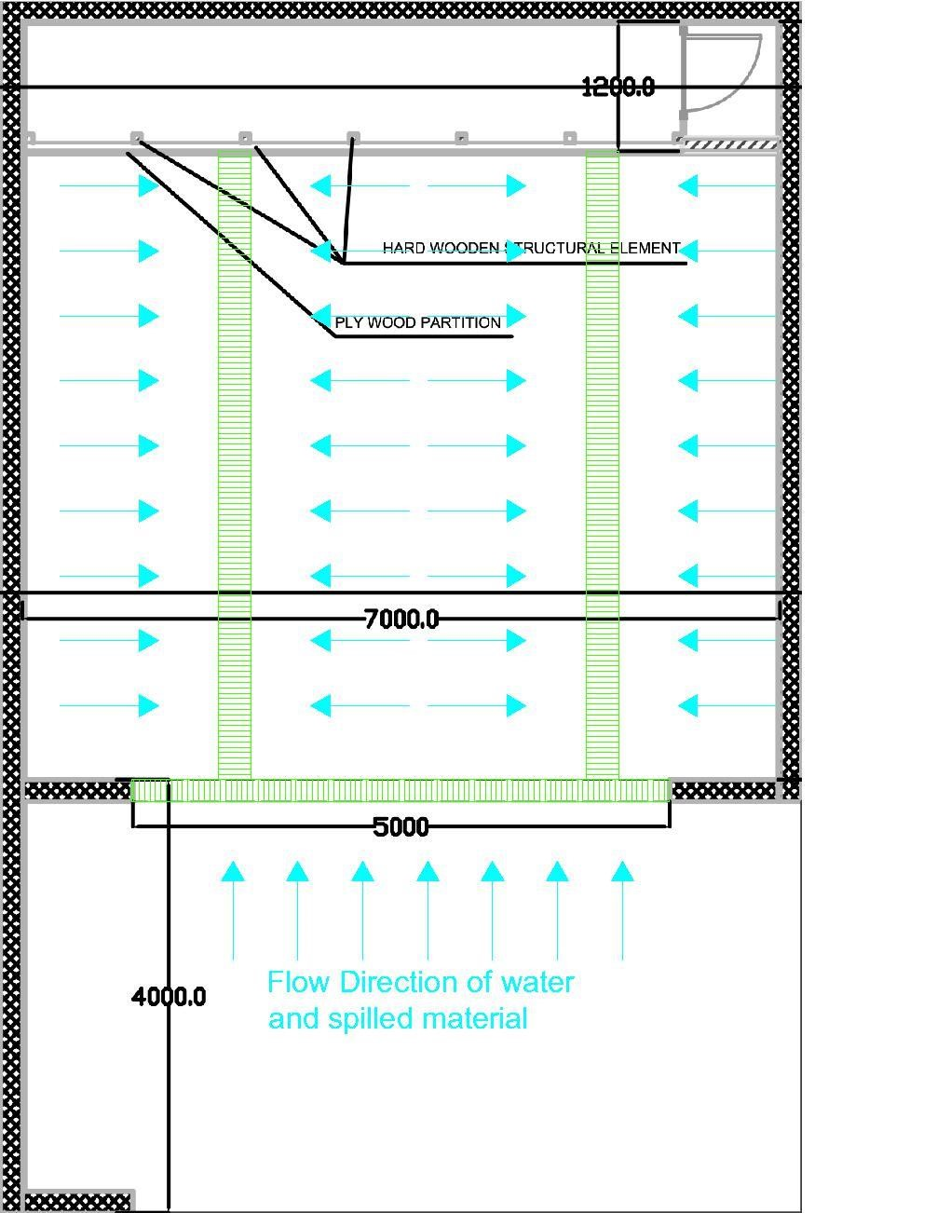
-

Large/multidirectional slope to be achieved
throughout the hole facility span, more
material to be used for levelling.

-

Increased risk of plugging

-

Option 2: Instal
lation of steel grills in the ground (Check
drawing below (Fig. 2))

Advantages:

-

Short travel distance of water and spilled
materials

-

Small/unidirectional slope to be achieved
throughout the span on the drainage grills.

-

Low risk of plugging

Disadvantages:

-

Higher
cost (material (steel), labor)

TOTAL
COST

Figure
1
:
Option 1 Drawing

Figure 2: Option 2 Drawing

3) Financial information
The tenderers are reminded that the maximum available amount of the contract is 44,720 EURO

4) Exclusion, selection and the award criteria
The tenderers will be disqualified if they are in one of the exclusion situations mentioned in the annexed Declaration on honor – Exclusion-Selection criteria. This declaration should be filled, signed, and submitted with the tender documents and dossier.
The selection criteria should be clear and non-discriminatory and may not go beyond the scope of the contract. The reference period for financial capacity may not go beyond the last 3 years for which accounts have been closed.
Economic and financial capacity of candidate
The objective of this criterion is to examine whether or not the candidate (i.e. the consortium as a whole, for applications from consortia):
- will not be economically dependent on the contracting authority if the contract is awarded to it; and
- has sufficient financial stability to take on the proposed contract.

Financial criteria
- the average annual turnover of the tenderer in the past 3 years must be at least 50000 Euro

Evidence to be requested to tenderers
- Financial statements or their extracts for a period equal to or less than the last 3 years;
- A statement of overall turnover and turnover for works, supplies or services covered by a contract during a period of no more than the last three financial years;
- Evidence of professional risk indemnity insurance

Technical and professional capacity of candidate
The objective of this criterion is to examine whether or not the tenderer:
- has sufficient on-going personnel resources, expertise and experience to be able to take on the proposed contract;
Professional and technical criteria:
- The tenderer should have completed at least 3 projects of the same nature/amount/complexity as the works concerned by the tender and implemented during the following period: 5 years from the submission deadline.
- All its key personnel must have at least 3 years’ appropriate experience and proven qualifications relevant to works of a similar nature to this project.
- The tenderer should have a professional certificate appropriate to this contract, such as Registration of the company.
- The tenderer should have at least 10 staff currently work for the tenderer in fields related to this contract;
- The candidate has worked successfully on at least 3 projects with a budget of at least 50,000 Euro in fields related to this contract in the past three years.

Evidence to be requested to tenderers
- a list of the following, with a description providing sufficient details on their relevance to the selection criteria:
  - of the principal services provided and supplies delivered in the past 3 years,
  - of the works carried out in the last 5 years, accompanied by proof of satisfactory execution for the most important works
- a statement of the technical equipment, tools or plant available to the economic operator for performing a service or works contract;
- a description of the technical facilities and means available to the economic operator to for ensuring quality of supplies and services;
- a description of the technical equipment, tools and plant to be employed by the firm for performing works contract;
- a reference to the technicians or technical bodies available to the economic operator, whether or not belonging directly to it, especially those responsible for quality control;
- for works or services, a statement of the average annual manpower and the number of managerial personnel of the economic operator for the last 3 years;

Award criteria
For WORKS, as a rule, the award criterion during the financial evaluation of works offers, is the lowest price. The financial evaluation may take into account not only the acquisition costs but, to the extent relevant, costs borne over the life cycle of the works (such as for instance maintenance costs and operating costs).

In general, contracts are awarded on the basis of the most economically advantageous tender established for the call for tender, based at least on the following elements:
- Total Cost of the tender
- Quality of the product or service and compliance with technical standards (meets the required specifications) and certification of required quality;
- Terms of delivery (timeframes and terms of delivery; technical assistance; proximity of supplier; transport to the delivery location; packaging and labelling; etc.)
- Environmental considerations
Tenderers must indicate in the tender submission form their economic, financial, professional, and technical capacity, in accordance with the above selection criteria. In addition, they must fill in, sign and submit the annexed Declaration on honor – Exclusion-Selection criteria (Annex 5) with their tender.

The offers received will be evaluated according to these award criteria:
- Lowest Price
- Reputation of the company
- Number of projects implemented

5) Ethics clauses and code of conduct

Absence of conflict of interest
The tenderer must not be affected by any conflict of interest and must have no equivalent relation in that respect with other tenderers or parties involved in the project. Any attempt by a tenderer to obtain confidential information, enter into unlawful agreements with competitors or influence the evaluation committee or DF staff during the process of examining, clarifying, evaluating and comparing tenders will lead to the rejection of its tender.

Respect for human rights as well as environmental legislation and core labor standards
The tenderer and its personnel must comply with human rights and applicable data protection rules. In particular, to be eligible, tenderers must comply with the environmental legislation including multilateral environmental agreements, and with the core labor standards as applicable and as defined in the relevant International Labor Organization conventions (such as the conventions on freedom of association and collective bargaining; elimination of forced and compulsory labor; abolition of child labor).

Zero tolerance for sexual exploitation, abuse and harassment
DF applies a policy of 'zero tolerance' in relation to all wrongful conduct which has an impact on the professional credibility of the tenderer. Physical abuse or punishment, or threats of physical abuse, sexual abuse or exploitation, harassment and verbal abuse, as well as other forms of intimidation shall be prohibited.

Anti-corruption and anti-bribery
The tenderer shall comply with all national applicable laws and regulations and codes relating to anti-bribery and anti-corruption. DF reserves the right to suspend or cancel the award of a contract if corrupt practices of any kind are discovered at any stage of the award process or during the execution of a contract. For the purposes of this provision, ‘corrupt practices’ are the offer of a bribe, gift, gratuity or commission to any person as an inducement or reward for performing or refraining from any act relating to the award of a contract or execution of a contract already concluded with DF.

6) Other information

All tenderers, successful and unsuccessful, will be informed of the results of the evaluation procedure in written.

The estimated time of response to the tenderers is 10 days from the deadline for submission of tenders

B) FORMAT OF OFFER TO BE PROVIDED BY TENDERER
- Tenderer’s information
Submitted by:

Name(s) and address(es) of legal entity or entities submitting this tender
Tenderer
Contact person:

Name
Address
Telephone
e-mail

- Tenderer’s statement

I undersigned hereby confirm that the works and deliverables offered in this tender are in full conformity with the specifications submitted to us by DF. The detailed description of the offered works by us is provided in the next point.
In addition to that we confirm that our organization/company is fully eligible for providing services under a contract financed by the EU funds. We confirm that we are not in any of the situations that would exclude us from competing in the EU financed tenders as indicated in the PRAG Manual

Furthermore, we agree to abide by the ethics clauses in the PRAG Manual and have no conflict of interests or any equivalent relation with other short-listed candidates or other parties in the tender procedure at the time of submitting this tender
- Technical offer

The tenderers are required to provide technical offer, based on the requirements indicated by Fondation Diane in the Part A: Information for the tenderer, Point 2: Technical information.
Item | Description | Unit | Quantity | Comments | Tenderer’s proposed
 | Civil Works
1 | Steel Cabinet for battery storage | sqm | 1 | 92sqm of steel cabinet, steel tubes 5x10 for the structure,  aluminum sliding doors with fiber sheets to cover the back  side and the flooring.
2 | Floor | sqm | 1 | 47sqm, floor rounding and cleaning, primer floor  painting, 3mm epoxy flooring, 6.6sqm concrete casting with  steel rods (8cm thickness), steel stairs 50cm width 3m  long, steel stairs 80cm width 1.2m long 0.60m height,  12.5sqm aluminum and glass façade using 2 tubes 4x8 and  glass thickness 6mm clear, 80cmx210cm wall opening+  aluminum door.
3 | UN drum for storage of spilling | Unit | 1
 | Mechanical Works
4 | Emergency response equipment | Unit | 1
5 | Portable gas detector | Unit | 1

The tenderers are encouraged to provide details on the planned works, including detailed specifications and/or brand names.

- Financial offer
Description | Unit | Quantity | Unit  Price  ($) | Total | Comments
Civil Works
Steel Cabinet for battery storage | sqm | 1 |  |  | 92sqm of steel cabinet, steel tubes 5x10 for the structure,  aluminum sliding doors with fiber sheets to cover the back  side and the flooring.
Floor | sqm | 1 |  |  | 47sqm, floor rounding and cleaning, primer floor  painting, 3mm epoxy flooring, 6.6sqm concrete casting with  steel rods (8cm thickness), steel stairs 50cm width 3m  long, steel stairs 80cm width 1.2m long 0.60m height,  12.5sqm aluminum and glass façade using 2 tubes 4x8 and  glass thickness 6mm clear, 80cmx210cm wall opening+  aluminum door.
UN drum for storage of spilling | Unit | 1
Mechanical Works
Emergency response equipment | Unit | 1
Portable gas detector | Unit | 1

The offered total price for the works indicated in the previous point is:
XXX EUR / OTHER CURRENCY

The offered price includes implementation/delivery of described items as well as all accompanying costs, for example transport, logistics, material costs, when required.

Name
Signature
Date

Annex - Declaration on honor – Exclusion-Selection criteria

C) FORMAT OF CONTRACT TO BE SIGNED

CONTRACT TITLE: Civil and MEP works -Re-Fit project

REF (if applicable): 2022-Re-Fit-T1

Concluded between:

Fondation Diane
Université Saint-Joseph, CSH, Bloc C, 4th floor
Tél : +961 1 421 000 – ext 5722
Beyrouth 1104 2020 – Lebanon
by:

AND

Company name:
Address Mosbeh,
Contractor Represented by: Mr.
Phone number
Email

Article 1: Subject of the contract

The subject of the contract is the overall works and deliverables as indicated in the contractor’s offer – ‘’Part B: Format of offer to be provided by the tenderer’’

Article 2: Contract value

The total contract value for execution of works indicated in the Article 1 is: XXX EUR/OTHER CURRENCY.

Article 3: Contracting documents

This documents which form the part of this contract are (by the order of precedence):
- Contract agreement
- Contractor’s offer as provided in the tendering phase – ‘’Part B: Format of offer to be provided by the tenderer’’
- Bank guarantee, when applicable
- Any other supporting documentation if applicable (* - in case of asking for registration of company or other information)

Article 4: Deliveries and payments

The contractor will deliver without reservation the works indicated in the contractor’s offer ‘’Part B: Format of offer to be provided by the tenderer’’. The deliveries will be implemented within the indicated dates.

Fondation Diane will pay to the contractor the works in the amount indicated in the Article 2 of this contract document. The payments will be issued by the following time schedule.

Month |  |  |  | <EUR/OTHER>
December 2022 |  | Interim payment (*if applicable) |  |  | <75 % of the
 |  |  |  |  | contract value>
January 2023 | Balance payment |  |  | < |  | Remaining | amount >
 | Total |  |  | <Total contract value>

This clause can be introduced in case of service contracts:
* - The contractor will provide contracting authority with the brief report on execution of the services

Article 5: Duration of the contract

The duration of the contract is 2 months.

Article 6: Cancellation of the contract
The contract can be suspended by the Contractor due to one of the following reasons:
- Fondation Diane not fulfilling payment and other obligations

The contract can be terminated by Fondation Diane due to one of the following reasons:
- The Contractor is in serious breach of the contract, failing to meet contractual obligations
- The Contractor is bankrupted or being wound up, is having its affairs administrated by courts, has entered into arrangements with creditors, has suspended business activities, is the subject of proceedings concerning those matters, or is in any analogous situations arising from a similar situation provided for in national legislation or regulations.

Article 7: Resolving of disputes

This agreement and any dispute or claim arising out of, or in connection with, it or its subject matter or formation, which cannot be settled otherwise shall be governed by and construed in accordance with Lebanese law.
The court of Lebanon will have exclusive jurisdiction to adjudicate any dispute arising under or in connection with this Agreement

For the Contractor | For DF
Name: Mr. Camil Sleiman | Name:
Title: General Manager | Title:

Signature: | Signature:
Date: | Date:

