

TENDER DOSSIER

Equipping stations in Daraya with a solar water pumping system

Publication reference:

TD RO-LBBEY-23-0034-LBKYE-0010 Beirut-Lebanon

Issued by: Oxfam
Publication Date: [23/2/2023]

TABLE OF CONTENT
INSTRUCTIONS TO TENDERERS 3
1 PURPOSE OF THE TENDER DOSSIER 3
2 INVITATION TO TENDER TIMETABLE 3
3 INSTRUCTIONS TO TENDERERS 3
3.1 Supplier Application 4
3.2 Tender Proposal 5
3.2.1 Currency 6
3.2.2 Tender validity 6
3.2.3 Tender Presentation 6
3.2.4 Compliance 6
3.2.5 Technical Offer 6
3.2.6 Price proposal 6
4 CONDITIONS OF TENDERING 7
4.1 Questions / Request for clarification 7
4.2 Clarification meeting / site visit 7
4.3 Alteration or withdrawal of tenders 7
4.4 Costs of preparing tenders 7
4.5 Late Proposal 7
4.6 Eligibility 7
4.7 Compliance 7
4.8 Right to reject all tenders 8
4.9 Power to accept part of a tender 8
4.10 Specification 8
4.11 Confidentiality 8
4.12 Tender Process 8
4.13 Notification award and contract signature 9
4.14 Ownership of tenders 9
4.15 Type of contract 9
4.16 Cancellation of the tender procedure 9
APPENDIXES 11

INSTRUCTIONS TO TENDERERS

PURPOSE OF THE TENDER DOSSIER

The purpose of this Tender is to obtain competitive offers for equipping the Daraya water pumping station belonging to the BMLWE with solar water pumping Systems.
A detailed description of the assignment and services required by Oxfam is contained in the technical specifications (see APPENDIX A – Technical specifications).

INVITATION TO TENDER TIMETABLE
 | DATE | TIME  (City)
Mandatory field visit | 9 March  2023 | 10;30, Beirut
Deadline for request for any clarifications from Oxfam | 10 March  2023 | 17;00, Beirut
Last date on which clarifications are issued by Oxfam | 14 March  2023 | 17;00, Beirut
Deadline for submission of tenders (receiving date, not sending date) | 17 March  2023 | 17;00, Beirut
Notification of award to the successful tenderer | 10 April  2023 | 17;00, Beirut

INSTRUCTIONS TO TENDERERS
In submitting a tender, the tenderer accepts in full and without restriction the special and general conditions governing this contract as the sole basis of this tendering procedure, whatever their own conditions of sale may be.

Tenderers are expected to examine carefully and comply with all instructions, forms, provisions and specifications contained in this tender dossier.

Failure to submit a tender containing all the required information and documentation within the deadline specified will lead to the rejection of the tender.

The participation procedure will be carried out in two successive stages; both are to be submitted together
- Suppliers application analysis
- Tender proposal analysis from qualifying applicants.

Responses should be sent in an outer sealed single envelope which will contain two further envelopes corresponding to the two different sections of the tender:
- Inside Envelope 1: “Supplier Applications” – 2 copies
- Inside Envelope 2: “Supplier Tender Proposals” – 2 copies

Documents within these envelopes should be well organized based on the above criteria

In addition Suppliers should provide:
- 1 soft copy of all the requested documentation (on USB flash drive)

Outer envelope to be marked as follows:
Oxfam - TD RO-LBBEY-23-0034-LBKYE-0010
Do not open before March 17, 2023

Tenderers do not have the option of submitting their tender electronically, unless clearly stated by the Oxfam procurement team.
The outer Main Envelope should only mark Oxfam GB/tender reference/Do not open before the 17th of March 2023
Any Bidder’s logo or relevant mark on the outer envelope that reflects the niche of the company will be considered as disqualified.
Failure to attend site visit will be considered as disqualified

Language: All documents shall be submitted in English.

The supplier application and tender proposal shall be submitted together before the deadline for reception of applications on the [17 March 2023] at [17:00, Beirut] to:

Logistics Lebanon
Oxfam office -1st floor-Sodeco Square Block B, Beirut

It is the responsibility of the Tenderer to ensure that their offer is complete and meets Oxfam´s requirements. Failure to satisfy all aspects of the tender dossier may lead to the offer being rejected without further reason being given. It is therefore essential to ensure that you read this document carefully and answer in full all questions asked.

Supplier Application

The application must be submitted in an envelope entitled:

“Supplier Application “Supplier name” response to Oxfam tender: [TD RO-LBBEY-23-0034-LBKYE-0010]”

Which contains;
- APPENDIX B - Tenderer’s Declaration
- APPENDIX D- International Supplier Questionnaire

All of which must be initialled and signed by an authorised person, with powers to represent the company.
Selection criteria for administrative compliance and bidder qualification:
This part concerns the information given in the supplier questionnaire, each tenderer can also include any other document he wishes, to assist us in judging their suitability according to the below criteria;

- Bidder shall be fully compliant with the present TOR. A detailed compliance list shall be submitted as per attached form (see Annex IV & V).
- Proof of Company Registration.
- Copy of insurance policy (legal liability at a minimum).
- Ministry of Finance registration certificate and VAT if applicable.
- A copy of the financial statements for last Three years (balance sheet and income statement).
- Audit Report in last two years
- An organisational (human resources) chart
- Name(s) and CVs or brief summary of professional background of key personnel to be involved in implementation of the Contract
- The bidder must have a minimum of 3 years’ experience in construction of solar photovoltaic solutions.
- The bidder must have experience in implementing project of a similar size, scope and application.
- List of previous and current contracts in the past 3 years for similar works, including Power of the system, name of contracting party, contract value and date of completions).
- The bidder must make available a minimum of Three reference projects in solar pumping or PV on-grid system in which they have worked. The reference projects must be of a similar scope, size and implemented locally or internationally. References with contact name and phone number shall be provided.
- Bidder PV projects references including contact names and phone numbers.
- List of equipment.
- Company Profile.
- I.D. card for the person signing the bid empowered by the power of attorney.
- Detailed activity schedule (timeline) for the proposed works.
- Proposed methodology of work clearly developing the expected work phases
- All materials & items provided by the supplier should be available in the local market.
- Bidder shall sign all the tender documents as sign of full acceptance of tender’s conditions.
- Bidder shall provide completed priced Bills of Quantities (BOQ) (see Annexes II & III)
- Bidder shall submit at tender stage the following documents:
- Datasheets, certificates and any other technical documents to show compliancy of all the specified components in Appendix A. This shall include at least PV modules, inverter with filter, pump, controller, flowmeter, level sensor, all electrical accessories such as DC & AC cables, DC & AC SPD’s, DC and AC switches and fuses, batteries, hybrid inverter, PLC changeover switch & materials for the chlorination system..
- Preliminary supporting structure drawing to assess soundness of this structure.
- Preliminary single Line Diagram to assess soundness of electrical design.
- Solar simulation as well as water output simulation
Please note that:
- There should be an overall positive reputation for good business practice, professionalism and financial stability.
- The scope of this tender must not represent more than 20% of the bidder’s total annual turnover to ensure that capacity restrictions do not impact quality.

Tender Proposal
Tenderers are invited to submit their best technical and economic tender in English to the exact formats and specifications required by Oxfam. Tenders not respecting these formats and specifications will be rejected.

The tender must be submitted in an envelope entitled:
“Tender proposal “Supplier name” to Oxfam tender: [RO-LBBEY-23-0034-LBKYE-0010]”

Which contains:

- Tender Technical offer
- Price proposal

Price proposal must be initialled and signed by an authorised person.

Currency
All prices shall be expressed in Fresh US Dollars not including VAT. This is to allow for a fair comparison of prices, following the award of the contract; the working currency will be decided between Oxfam and the contracted party. Where exchange rates have been used to arrive at a US Dollar figure this should also be provided.

Tender validity
Tenders shall remain valid for a period of two (2) calendar months after the deadline for receipt of tenders.

Tender Presentation
Tenderers may submit a tender for some or all of the services demanded according to their capacity to supply.

Prices and lead times, presented in the tender, should be firm and valid for the whole duration of the agreement from the date of its signature by both Parties.

The price proposal should be submitted according to the template in APPENDIX E – Price Proposal.

Compliance
Your basic offer shall be strictly in accordance with the technical specifications specified in the APPENDIX A -Technical specifications.

Award of the contract is based on the criteria listed at paragraph 4.12 Tender Process

Technical Offer
A technical tender offer describing the way in which the tenderer intends to carry out the tasks as described in the contract. Respecting all the obligations imposed by the specifications, bearing in mind the principals and values of Oxfam.

The tender should include, as stipulated in the Technical Specifications under Appendix A:

- A technical bid consisting of a detailed description of the services offered
- A detailed methodology to achieve the consultancy objectives
- Summary of working model: team involved in the service
- Detailed activity Schedule (timeline/ workplan) for the proposed works
- A list of materials and technical equipment owned by the supplier (machines, technical instruments, vehicles, etc…)
- Name(s) and CVs or brief summary of professional background of key personnel to be involved in implementation of the Contract

Price proposal

- Clear breakdown of costs related to service requested
- A detailed price list Fresh USD for all the services linked to the technical requirement (e.g. equipment service, staff training)
This list forms an integral part of the contract resulting from this invitation to tender and will serve as a control instrument for our finance team during invoice verification. Any component not found in this list can be neither invoiced nor paid, therefore, it should be comprehensive. By providing this price list, tenderers agree to abide by it and its accompanying conditions in carrying out the contract.
- Additional services that the service provider would be willing to provide Oxfam at no cost

CONDITIONS OF TENDERING

Questions / Request for clarification
Any requests for clarification may be submitted by email to sheneskehian@oxfam.org.uk, & eelkhoury@oxfam.org.uk until the 14th of March 2023.

Clarification meeting / site visit
A clarification meeting and site visit will be mandatory for all bidders.

A mandatory meeting and site visit will be held on the 9th of march 2023 at 9:30am at the Oxfam office in Beirut to present project requirements and allow for a Q&A for interested bidders. A mandatory site visit to the location on the same day at 10:30am will be facilitated by Oxfam’s technical team with the presence of the consultant.
Minutes will be taken during the meeting which will be communicated, together with any clarifications in response to written requests which are not addressed during the meeting, in writing to all the tenderers at the latest of march 14 2023 before the deadline for submission of tenders. No further clarification will be provided after this date. All the costs of attending this meeting will be borne by the tenderers.

Tenderers are required to conduct a mandatory site visit to the station in question for a brief technical assessment in coordination with Oxfam’s logistics team, for further details & confirmation an email should be sent confirming attendance to eelkhoury@oxfam.org.uk. & Sheneskehian@oxfam.org.uk before 8th of March 2023 before 3:00 pm

Failure to attend site visit will be considered as disqualified
Visits by individual prospective tenderers, other than this meeting, cannot be permitted during the tender period.

Alteration or withdrawal of tenders
Tenderers may alter or withdraw their tenders by written notification prior to the deadline for submission of tenders referred to in Article 2. No tender may be altered after this deadline. Withdrawals must be unconditional and will end all participation in the tender procedure.

Costs of preparing tenders
All costs incurred by the tenderer in preparing and submitting the tender are not reimbursable. All such costs will be borne by the tenderer.

Late Proposal
Tenders must be received before the 17th of March 2023 at 17;00 Beirut time. Tenders received after the closing date will not be considered, unless in Oxfam sole opinion there are exceptional circumstances which have caused the delay.

Eligibility
Participation in tendering is open on equal terms to any natural and legal persons or company.

Compliance
Oxfam reserves the right to reject all bids not submitted in the format specified and any bids where any of the required forms are not completed.

Right to reject all tenders
Oxfam is under no obligation to accept any tender.

Power to accept part of a tender
Oxfam reserves the right, unless the tenderer expressly stipulates to the contrary in the tender, to award batches separately or in any combination.

Specification
If the tenderer wishes to propose modifications to the specification (which may provide a better way to achieve Oxfam ´s objectives) these must be considered as an alternative offer. The Tenderer must make alternative offers in a separate letter to accompany the tender. OXFAM is under no obligation to accept alternative offers.

Confidentiality
Tenderers must treat the invitation to tender and all associated documentation supplied by OXFAM as confidential.

Tender Process
Oxfam reserves the right to negotiate, accept or reject any or all proposals and quotations at its sole discretion and to pursue or act further on any responses it considers advantageous.

The contract will be awarded to the administratively and technically compliant tender that is the most economically advantageous, taking into account the quality of the services offered and the price of the tender, otherwise referred to as “best value for money”.

Tenders will be evaluated on the criteria listed below:
CRITERIAS | Award criteria | Score up to | Max. Score | % of overall
Capability / competence of tenderer to perform the service required | Experience in implementing of similar type of works, of similar scale | 15 | 30 | 30%
 | Experience with Oxfam or other international NGOs of a similar Oxfam volume. | 3 | 30 | 30%
 | Experience working with Lebanese Water Establishments | 2 | 30 | 30%
 | Qualifications, skills, languages or experience of key personnel engaged in the project, list of equipment | 10 | 30 | 30%
Quality / Understanding of requirements | Meeting technical specifications ( Specs to match or closely resemble those mentioned in BoQ).  Exhibit a high level of expertise in the installation of PV and chlorination systems, as well as possess | 35 | 40 | 40%
Quality / Understanding of requirements | Ability to meet delivery dates OR Reliability of plan proposed | 5 | 40 | 40%
Prices for  Services | Price proposal of service in accordance with the request | 30 | 30 | 30%
TOTAL MAXIMUM GENERAL SCORING |  |  | 100 | 100%

In the interests of transparency and equal treatment and without being able to modify their tenders, tenderers may be required, at the sole written request of the evaluation committee, to provide clarifications within 48 hours. These requests can only be for clarification purposes, not for the correction of major details.

Any attempt by a tenderer to influence the evaluation committee in the process of examination, clarification, evaluation and comparison of tenders, to obtain information on how the procedure is progressing or to influence Oxfam in its decision concerning the award of the contract will result in the immediate rejection of his tender.

Notification award and contract signature

The successful tenderer will be informed in writing that their tender has been chosen (notification of award). Oxfam will agree with the selected tenderer on the final contract version and will send the signed documents in two original copies to the successful tenderer.

The unsuccessful tenderer will be informed by e-mail within the 30 days following the award.

Within 10 working days following the reception, the successful tenderer will sign, date and send back the contract. The selected tenderer will have to communicate the number and exact references of the bank account where the payments will be executed.

If the successful tenderer fails to sign and send back the contract within 10 working days, Oxfam can consider (after notification) the award as null and void.

Ownership of tenders
Oxfam retains ownership of all tenders received under this tender process. Consequently, tenderers have no right to have their tenders returned to them.

Oxfam guarantees that tender offers shall remain confidential.

Type of contract
The contract that will be concluded between the successful tenderer and Oxfam is done according to Oxfam’s standard contract. A contract draft is included in Appendix F – Contract Template.

By submitting an offer to this Invitation to Tender, the tenderer accepts Oxfam´s contract terms. If any remark or reserve were to be raised by the tenderer, they should be clearly written down in a free format document included in the tender. Such documents should include the tenderer’s proposal to replace the discussed sections of the contract.

If the tenderer submits an offer with no clear feedback on Appendix F – Contract Template, then Oxfam will consider the submitted contract draft has been accepted in full by the tenderer.

Cancellation of the tender procedure
In the event of a tender procedure's cancellation, tenderers will be notified by Oxfam.

Cancellation may occur where:
- The tender procedure has been unsuccessful, namely where no qualitatively or financially worthwhile tender has been received, or where there has been no response at all.
- The economic or technical parameters of the project have been fundamentally altered.
- Exceptional circumstances or force majeure render normal performance of the project impossible.
- All technically compliant tenders exceed the financial resources available to Oxfam.
- There have been irregularities in the procedure, in particular where these have prevented fair competition.

Under no circumstances will Oxfam be liable for damages, whatever their nature (in particular damages for loss of profits) or relation with the cancellation of a tender, even if OXFAM has been warned of the possibility of damages.

Tenderers are requested not to contact Oxfam during the tender assessment period, unless through the formal questioning mechanism outlined above or if they are an existing Oxfam supplier, and then only in pursuit of existing Oxfam business.

APPENDIXES

Appendix A: Technical Specifications / to be printed filled signed & stamped

Appendix B: Tenderer´s declaration / to be printed filled signed & stamped

Appendix C: Oxfam’s Supplier Code of Conduct / to be printed filled signed & stamped

Appendix D: Supplier Questionnaire / to be printed filled signed & stamped

Appendix E: Price proposal/ to be printed filled signed & stamped

Appendix F: Oxfam Contract Template / to be printed signed & stamped

Appendix G: Technical Drawings / to be printed signed & stamped

Appendix H: Stress Analysis / to be printed signed & stamped

Appendix I: Unpriced BoQ / to be printed signed & stamped

Appendix A: TECHNICAL SPECIFICATIONS

Introduction
Oxfam is a global movement of people, working together to end the injustice of poverty through campaigning and responding to the needs of the poor. Oxfam has been working in Lebanon since 1993. We provide humanitarian assistance to vulnerable people affected by conflict, and we promote economic justice and good governance, and women’s rights. Oxfam also works with local partners to contribute to the protection and empowerment of marginalized women and men.
Following consultations and discussions with the Beirut and Mount Lebanon Water Establishment (BMLWE) on requirements to improve the water supply to vulnerable communities, Oxfam with the support the Lebanon Humanitarian Fund (LHF), will install a solar water pumping system in the pump station located in Daraya (Chouf).
The site is located in Daraya, in the Mount Lebanon, with coordinates 33°38'21.8"N 35°30'09.6"E. The solar PV system will be installed on a municipality land at the tank location.
The design of the solar system is proposed in the proceeding sections to accommodate for the capacity needed to operate the system fully.

- Project Components
The existing transfer pump which the solar system shall power it is used to pump water from small tank to a concrete storage tank (350 m arial distance away) that in turn distributes water to end-users by gravity.

Oxfam is planning to equip the pump with a solar water pumping system of 73-Kilowatt peak KWp, capacity to operate a 30 kW pump. The solar system shall include solar panels, steel structure, civil works, Variable Frequency Drive (VFD), fence and CCTV and an online control and monitoring system with all the accessories and required electronic equipment to power the existing water pumping system. In addition to installing a new liquid chlorination system, including operating it on solar power. Also, renovation and rehabilitation of the tank site and the pump station as detailed in the design below.

The inverter shall be installed in a new electrical room located at the water tank station. The VFD inverter will be located at around 350m away from the pump location, as such low voltage AC cable shall be routed along LV electric poles as specified in the topographic survey.

The PV panels will produce energy that will be directly used to power the pump without a battery storage. PV panels will produce DC power, the conversion of DC to AC current will be done via a variable speed drive inverter.

A hybrid solar system connected to a small battery bank shall be installed at the water tank station to power the chlorination system, lighting system, CCTV and monitoring system.

- Project Objectives
The project aims to provide a Solar power system for water pumping to supplement the EDL grid and diesel power generation in order to:

- Meet the domestic water needs of the refugees and host communities living in the area at minimum costs.

- Maximize the reduction of EDL grid energy and/or diesel fuel demand by pumping as much water as possible through solar pumping solution.

- Design and install systems with adequate controls and protections to become sustainable and reliable.

- Develop an operation and maintenance program, including a 2-day hands-on training to Beirut And Mount Lebanon Water Establishment Technicians.

- System Design
Due to the complex nature and multiple variables involved in calculating solar system performance, and in order to avoid receiving different designs from multiple bidders; the solar system have been completely designed by the consultant. Bidder shall abide by the proposed design and specifications and shall guarantee the good operation of the proposed equipment along with specified output.
However, it is the contractor’s’ responsibility to ensure their installation plans fit the site. The contractor is solely responsible for the accuracy of the data that their bid is submitted upon. At the end of the project, the Contractor is responsible of producing all as built/ shop drawings to the Oxfam engineer’s satisfaction and submitted in hard and soft copies to the relevant authorities and establishments subject to the approval of Oxfam Engineer.

- Scope of work
For this work entails supply, delivery, installation and commissioning of a complete, suitable Solar PV generator and renovation of existing EDL Grid and diesel generator connections. Also adding a new liquid chlorination system to ensure the disinfection of water before storing it in the main distribution tank. The scope of works shall include the following:
- Site preparation (Clearing, pruning, excavation, etc.)
- All planning and permitting works required for the project implementation.
- Submission of the required documentation.
- Procurement of all equipment, accessories and services.
- Transport of all equipment to the sites including onsite temporary storage and security. Equipment under contractor responsibility until completion/handover date.
- Supply & Installation of the solar modules support structure, positioning of the solar modules on the steel structure, securing them with required clamps and accessories.
- Supply & Installation of a suitable base to fix the solar modules support structure. Solar modules will be mounted as per attached tender drawings. Solar modules supporting structure should be warranted by EPC contractor to withstand the weather conditions of the area (wind 150km/hr. and snowfall of 1-meter). Refer to Annex I – Daraya Technical Drawings and Annex II – Daraya BOQ.
- Supply & Installation of PV generator system including all needed equipment such as but not limited to: Photovoltaic modules, solar pump inverter, Hybrid inverter, junction boxes, combiner boxes, DC & AC protections, DC & AC cables and cable trays, change-over switches, cable connections to the pump, monitoring and control equipment, earthing and lightning protection, equipotential bonding of all metallic parts (including the existing items). Refer to Annex I – Daraya Electrical Technical Drawings and Annex II – Daraya BOQ.
- Supply & Installation of a lockable powder coated steel enclosure to house the controller and main electrical components complete with rodent proof cable access to the enclosure and provision for enough air circulation.
- Supply & Installation of cable routing civil works required such as trenches and gateways for cables. Refer to Annex I - Daraya Technical Drawings.
- Supply & Installation of AC main cable and its civil works required such as LV electric poles and cable column. Refer to Annex I-Technical Drawings.
- Supply & Installation of a CCTV system covering all angles of the tank site to protect and monitor the entire site. Refer to Annex II – Daraya BOQ.
- Supply and installation of PV wash system including electro-mechanical connections needed for cleaning PV modules.
- Supply and install a new electrical room to be executed above the existing valve chamber near the tank with access door. Room should be finished block work type coated and painted (white colored) with lockable steel door, exhaust fan and lights.
- Existing valve room: Contractor to renovate the room with new painting of walls from inside, new door locks, cleaning the room from debris, new ceiling lights and build adequate bridge over the pipe to reach the other door.
- Supply and install a new room to house new Liquid-Chlorination system. The room to be executed inside the new electrical room with access door, and should be finished block work type coated and painted (white colored) with lockable door, exhaust fan and lights.
- Supply and install a new liquid chlorine dosing system consist of main items: 300-liter FRP tank, chemical dosing pumps (duty/standby) with chemical tank mixer and all required accessories, complete with tank level switch, chlorine sensor and dosing tubing. ½” fresh water PVC line should be installed to serve the filling of the tank when needed.
- AC cable line from tank location down to pump location. Contractor to submit size calculation sheet along with routing shop drawing.
- Renovation of electrical panel boards at pump location.
- Supply and install a project visibility board that should include the Oxfam and LHF logos, the project title “Equipping Water Pumping Stations with Solar Systems in the water deprived areas of Bakhaoun and Harf Es Siyad in Donnieh and Daraiya in Chouf” and the phrase "Funded by the Lebanon Humanitarian Fund (LHF)". Board design to be approved and signed off on by Oxfam.

- Supply and installation of fence at the PV system location.
- Upon completion of the installation the contractor shall commission and test the system.
- The contractor shall submit, a delivery, installation and commissioning report (both soft and hard copies) of all the works done. Including an Operation & Maintenance manual detailing in an easy-to-follow manner, the procedures to be employed in managing the newly installed solar pumping facilities.
- Continuous training of pump operators on the solar system operation and maintenance for a period of at least one year, including a 2-day hands-on training to BMLWE Technicians.

- Methodology of the System
The system needs to operate the pump and deliver water from small tank to the main large tank. The system is composed of solar PV modules, solar pump inverter with sinewave filter, steel mounting structure and other equipment and accessories that complement this system such as PLC solar PV and water monitoring device. The system is also integrated with the Grid/Generator input to be able to operate the pumping station in emergency conditions (cloudy winter day, PV system fault detection, etc.)

The system needs to operate a 30kW submersible pump enabling it to fill the main water tank. Thus, the solar PV system is properly sized for maximized pump operation during daytime and is connected directly to a properly sized pump inverter. The pump would continuously work when the solar PV system is supplying enough power for the pump’s operation; otherwise, the pump needs input from the Grid/ Generator side to operate in emergency cases of system shutdown or in extreme weather condition days.

For this integration to take place, an automated system would be installed containing a motorized change over switch that would be installed between the solar PV input and the Grid/Generator input and directly connected to the pump inverter. An online PLC monitoring system is connected to the full system along with weather station) to continuously log the data from the inverter and check the irradiance levels through the pyranometer. If the pyranometer detects low irradiance level compared to the input threshold value, an order to switch the motorized change over switch from solar PV input to Grid/Generator input is sent through the PLC monitor.

Moreover, the system could be controlled remotely, or manually operated or shut down using a manual transfer switch installed between the pump inverter output and the grid/generator input in case of fault detected in the automated system.

To complete the project, 3 support systems have been added: chlorine dosing system, panels washing system and CCTV system. The chlorine system designed is a simple liquid chlorine dosing which uses a metering pump with ORP sensor to control the dosing rate in the filling line. The washing system consist of 2000-liter tank with a small pump (1/2 hp) and flexible hose to reach the panels. The CCTV system is to avoid vandalism as much as possible to protect the entire project benefit, and thus it is an added value system in this project.

- Documents Deliverables
After contract award all the here below documents shall be prepared by the contractor in line with the here above specifications and requirements and submitted for approval prior to execution.
- Document submittal schedule (to be submitted 1 week after contract signature)
- Project execution schedule.
- All system’s components datasheets and certificates, highlighting the specific models and selections of parts that will be used in the project, with quantities if need be.
- PV modules layout indicating the configuration and the required space, with schematic drawings of the allocated area for PV array.
- Single Line diagram of power and control connections.
- Schematic drawings showing Power and Control cables’ routing between electrical room, submersible pump, upper Tank and PV Panels.
- Schematic drawings showing equipment layout inside the electrical room.
- Fence’s material submittal and shop drawing
- CCTV submittal and shop drawing
- Liquid Chlorination system submittal includes: data sheets and Chlorination system shop drawings (P&ID and GA drawing) with sizing calculation based on minimum 2ppm chlorine dosing
- Detailed calculation notes (such as cable sizing, panel board’s equipment sizing, bus- bar sizing, short circuit current ratings, etc…)
- Software simulation case study showing irradiation simulation, in addition to the system power generation for 12 months’ period for the designated location.
- Simulation should also show variation of pump’s flow and operating speed according to the available solar irradiation throughout the day and throughout the different seasons. Variation impact on power consumption should also be indicated.
- Water tests methodology.
- PV tests methodology.
- Bearing test results, Concrete Cylinders, Slump test.
- O&M manuals and as built drawings.
- 24hrs testing and commissioning report
- Training manuals.
- Troubleshooting videos and manuals

- Specifications
  - Solar photovoltaic (PV) Modules:
Contractor shall supply, deliver and install the PV modules according to the following criteria:

- PV capacity at STC (Wp) shall be at least 73.6 KWp
- PV-modules must have a product warranty of at least 10 years and a linear power warranty of at least 97% after 1 year, 90% after 10 years and 80% after 25 years. All PV-modules must be plus-sorted and thus deliver more power than their designation indicates. This must be clearly stated in the manufacturer's data sheet.
- The inverters must have a product warranty of at least 5 years and an efficiency of at least 97% according to international standards by the end of the warranty term.
- All modules must be of a robust design. Only certified Polycrystalline or Mono-crystalline silicon modules will be accepted from Tier1 Manufacturers.
- Number of cells in a module: 72 cells.
- Rated power of the PV panel >or = 545Wp at STC.
- Module conversion efficiency: greater or equal to 20.8%
- Module DC voltage up to 1000 VDC
- Cell protection: Cells should be protected by antireflective coated tempered glass.
- Module shall withstand load up to 5400 Pascal.
- I-V curve should be supplied.
- PV modules must be approved to IEC/EN 61215 ,61730-1/2, certified and listed. Certifications have to be issued by an internationally recognized laboratory.
- Measures against Potential Induced degradation (PID)
- Including but not limited to:
  - All fixing accessories on module framing.
  - Earthing of the PV modules.
  - Device preventing any risk of electrolytic couple
  - Report flash testing of the modules to be provided before installation.
- Modules shall be guaranteed by manufacturer for 25 years with no more than 10% de-rating for the first 10 years, and 20% de-rating within 25years.
- The PV Modules shall be clearly labelled and permanently marked with a data plate containing the following information: manufacturer’s name and physical address, type/model number, the watt-peak power rating at STC, open circuit voltage and short circuit current, voltage and current at maximum power point, tolerance and temperature coefficient, country of manufacture, certification, e.g.: UL listing, IEC 61215,ISO certification, with fool-proof +ve/-ve connectors
- Tilt and orientation of PV have to be as per design drawings. Refer to Annex I - 2 –Daraya Electrical Technical Drawings.
- PV module wiring, and associated components should resist to UV, wind, water and other environmental conditions. Wiring and components should be fit for this purpose and built in such a way as to minimize exposure to detrimental environmental effects. Particular attention is drawn to the need for prevention of water accumulation in cable/ module support systems.
- Warranty: Minimum 10 years on material and manufacturing.
- Provide manufacturer’s flash test report for each panel used in the project.

  - Metallic support structures:
Contractor shall supply, deliver and install the metallic support structures according to the following criteria:

- The contractor shall limit his structure installation to the allocated area.
- Land shall be cleared by the contractor in terms of rocks and vegetation after coordinating on best location for installation.
- All Steel structure shall be Sand blasted (or bullet shot), cleaned and degreased, coated with epoxy primer before delivery to site, then painted after installation, datasheets of coats to be submitted by contractor. Refer to Annex I - Daraya Technical Drawings.
- Measurements in the Drawings files are not for fabrication; Contractor shall make his own fabrication drawings upon award of the contract.
- Particular attention should be given to wind loads on PV modules and structure so that they withstand up to 140 Km/h gust speed.
- Particular attention should be given to snow loads on PV modules and structure.
- Wind and snow load calculation study for PV array should be presented according to international structural codes software simulation.
- Mill test for Steel beams to be submitted by contractor for validation of stress analysis.
- The contactor has the option to join members by welding or plates, either of which chosen should be submitted under the method of joining.
- Bolts and nuts used to anchor the structure to concrete/other structural members should be grade 8.8, torque wrench shall be used.
- Welding should abide by AWS requirement; welding rods and thickness and welding procedure and treatment should be submitted by contractor for approval.
- Safety procedure for Steel Structure should be planned to avoid any injury to site, equipment, and personnel.
- Fire extinguishers, water buckets, safety gloves, life rope, helmets, safety shoes, welding masks…. And other needed PPE, are mandatory during the welding process.
- The contractor is to produce detailed drawings of the structure, including foundations, for approval by Oxfam and the consultant before installation.

  - Solar pump VFD inverter:
Contractor shall supply, deliver and install the solar pump inverter according to the following criteria:

- Nominal power is understood for high torque machines
- One solar pump inverter, 3-phase rated at a minimum of 45kW, with a single MPPT channel. The quoted inverter(s) capacity shall be at a minimum temperature of 40 degrees Celsius.
- The three-phase inverter shall be of 380V and 50 HZ output
- Minimum Protection class for solar pump inverter should be IP54
- Solar pump inverter should have a Solar Pumping Application software with integrated MPPT Functionality.
- Integrated input Noise Filter.
- Generated harmonics measured at the point of connection, when operating at the rated power shall not exceed a total harmonic distortion of 3%
- The inverter is to be tested by the contractor under his liability. If during testing and commissioning, the inverter proves to display issues with harmonics or data reading, the contractor must find the best mitigation on his expenses.
- Pump operation selection through either DC Input or 3-Phases AC input of Inverter should be possible.
- Inverter efficiency should be greater than or equal to 95%
- Solar pump inverter should be equipped with communication ports: MODBUS/RS485 or other, allowing monitoring and control of inverter operation.
- Proper external protection measures on AC and DC sides of solar inverter should be taken, including surge protection. Refer to Annex I –Daraya Technical Drawings.
- Solar Pump inverter should be able to withstand Operating Temperatures of 60 ᶱC.
- Meet relevant international standards such as EN 61800-1, EN 61800-3, EN 60204-1 or equivalent
- Any intervention on the inverter must be possible in full electrical safety. The necessary external protection devices need to be added in the immediate proximity of the inverter.
- Complete installation following recommendations by the manufacturer (minimum spacing, temperature of the room, etc.)
- Minimum manufacturer warranty of 2 years from commissioning.

  - Hybrid (On/Off) Inverters:
Contractor shall supply, deliver and install hybrid (On/Off grid) inverter according to the following criteria:

- Rated power of the inverters should be Monophase Hybrid 5KW (capable of charging Lithium batteries)
- Should be connected in parallel with a back-up generator in addition to EDL public Grid.
- The single-phase inverter shall be of 230V and 50 HZ output
- MPP tracking channel wider or equal to 430 VDC-720 VDC.
- The minimum European efficiency of the inverter shall be a minimum of 97%.
- Insulation testing feature on DC side.
- AC type 1+2 surge arrestor shall be provided on the AC side.
- Acoustic noise less than 45 dB (A).
- Ground connection of the inverter(s) to the equipotential bonding conductor and to the protective conductor on the Ac Side;
- Suitable consideration of the inverter(s) ventilation to avoid potential capacity de-rating.
- Inverter must meet following standards: EN 62109-1&2, EN 61000-2 & 3. Safety according to EN 60335-1, 60335-2-29. Emission and immunity according to EN 55014-1, EN 55014-2, EN 61000-3-3. Anti-islanding according to VDE AR-N 4105.
- Minimum manufacturer warranty of 2 years from commissioning.

  - Site CCTV monitoring:
Contractor shall supply, deliver and install a CCTV system with cameras installed to monitor the metallic fence all around the PV field according to the following criteria:
Supply, install, test and commission CCTV system as per specifications Refer to Annex III – Daraya BOQ. :
- DVR. 4CH, DS-7104HGHI-F1, H.264+, AHD,CVI,TVI Up to 2MP, Analog, IP Up to 5 MP, Up To 4-ch IP Cameras Connected, Full channel recording at up to 1080p lite resolution, Audio: 1 Rca, HDMI/
- HD Camera | Bullet | 2MP TVI, 3.6mm, IR: 20Meter
- Hard Disk | 3.5" | 4 Terra | SV |Seagate SkyHawk Surveillance HDD, SATA, RPM: 7200
- Cable | RG-59 | 92M | Thin | Black CCTV System | Cable | RG-59 | 92M | Thin | Black Video, Audio, Power.
- Power Supply | 12V | 15A
- Connector | BNC Cable | BNC Male| DC Male BNC & DC Cable: 20cm
- Connector | BNC Cable | Male Shield BNC Male Open-End Wire 30cm w/ Shield
- Power Cable | German Plug - Open Cable End, 3x0.5mm Open End Electrical Cable German Plug 3x0.5mm Open End Electrical Cable German Plug
- Cable | HDMI | 1.5m HDMI Male - Male Cable 1.5m
- Power Strip | 5 Outlet UK | 2x0.75mm | 2M | Outlet, UK, 5x Socket, Choko 4.0mm, Cable 2m, 0.75mm
- Cabinet | 4U | 60x45 Wall Mount, (W:60 x D:45 x H:30) cm
- Minimum manufacturer warranty of 2 years from commissioning.
- CCTV system to be remotely monitored through internet access.
- Detailed shop drawing of the CCTV system shall be submitted for approval.

  - Monitoring and Control Equipment:
The contractor shall supply, deliver and install the instrumentation, control and monitoring systems according to the following criteria:
- Instrumentation
- Instrumentation shall be provided to fully monitor the operation of the works and where necessary to carry out automatic control functions.
- The instrumentation system shall be designed to allow for normal override of all automatic instrumentation control functions.
- All analogous instruments shall have:
- 4-20 mA output and/or Modbus
- DC power supply input: 10-30 VDC, 50mA
- Terminal block: 0.5 mm2 - 0.75 mm2
- EMC: FCC Part 15, ICES-003, EN 61326-1:2006, Emission class B, Immunity class A
- Enclosure: UL 94 V-2, ROHS compliant, IP65
- Humidity: 0 to 100% condensing
- Calibration shall be completed for the installed sensors, transmitters and meters according to the operation manual of each.

- Pressure Measurement
- A Pressure gauge shall be of the Bourdon tube or diaphragm type and shall be constructed with stainless steel case and bezel and shall be connected for on-site inspection.
- The case shall be liquid (glycerin 99.7%) filled, and its diameter shall be not less than 100mm. Over-range protection up to 130%.
- A digital pressure gauge shall be installed for monitoring application and to be connected to the PLC.
- The pressure gauge is connected to the multi-channel transmitter along with the other measuring devices.
- Level Detection and Measurement
- Level Sensor shall be of submersible hydrostatic type, with a minimum cable length of 8m. It shall have an IP68 protection.
- Level Sensor shall be located inside the tank and its transmitter shall be mounted outside the tank inside an IP65 protection housing.
- pH and Chlorine Detection and Measurement
-The pH sensor shall be digital potentiometric pH sensor for standard applications in process and water technology.
-The pH electrode must be located inside the pipe of incoming water.
- The chlorine sensor shall be located inside the tank.

- Flow Detection and Measurement
-Flow meter shall be of electromagnetic type, with the ability of bi-directional flow measurement for standard water applications.
-Diameter shall be chosen upon the contractor’s site survey.
-Flow meter shall comply with PN40 standard.

- Pump Motor Temperature Detection
-Motor Temperature sensor shall be installed to prevent from overheating and any further damages.
- Temperature sensor shall be connected to the PLC for online monitoring.

- Transmitter
- Multi-Channel transmitter shall be used with a minimum of 4 digital input channels, connected to the flowrate, pressure, pH and chlorine sensors.

- Monitoring and Control System
- PV System Monitoring and Sensors
The contractor must supply, install and commission a monitoring and control system for PV system including the installation and supply of:
- Pump Inverter Monitoring Module:
The contractor must install the pump inverter’s monitoring module in order to monitor and control the solar pumping system. The module includes a graphic interface that enables real-time data capturing, real-time pump data, and real-time data like water flow, solar DC voltage, DC ampere, Instantaneous power, Energy (kWh), AC output voltage, etc.
The module connects to the pump inverter through RS485 communication cable.

- Weather Station
- Irradiance sensors (GHI and POA Sensors): that range between 0-1750W/m²,
including one global horizontal irradiance sensor and one plane-of-array sensor.
- Ambient Temperature Sensor: that ranges between -40 to 80°C.
- Back-of-Module (BOM) Sensor: that ranges between -40 to 80°C.

Modbus RTU communication and an Ethernet Modbus TCP option must be included with the weather station.

- Programmable Logic Controllers (PLC)
The PLC is responsible to control the PV system along with the AC operation, switching between the systems. The control system shall have the ability of switching between the solar system and the Grid/Generator input through manual and auto-mode.
The controller must carry the following minimum specification:
- Analog input reading, suitable for the irradiation sensor output
- Accuracy +-5%
- Multiple input thresholds
- Dry contacts
- Timers
- Conforms to CE

Data logger is used to log data continuously, and during the operation of the solar PV System the logging of the system shall be at a minimum of 10 minute-intervals should be possible.
A continuous Internet connection shall be available to ensure continuous data logging of the parameters of the system.
The measurements to be included in the monitoring system are as follows:
- Measurements from the Grid Side
  - Diesel generator run status ON/OFF
  - Utility grid status ON/OFF
  - Power consumption from diesel/utility grid in kW
- Measurements from Solar VFD Monitoring System:
  - DC Voltage
  - DC Current
  - AC Power generated in kW
  - Total apparent power in kVA
  - AC Voltage
  - AC Current
  - Daily Delivered Energy in kWh
- Measurements from the Weather Station:
  - Global Horizontal Irradiance (W/m²)
  - Plane-of-Array Irradiance (W/m²)
  - Back-of-Module Temperature (°C)
  - Ambient Temperature (°C)
- Measurements from Sensors:
  - Pressure at the Discharge Line
  - Pressure at the Suction Line
  - Water Level inside the tank (Empty/Full)
  - pH of Water
  - Chlorine residual of Water
  - Flowrate at each Existing Discharge Lines

- System Operation
- Operator should be able to shift between Generator Supply, EDL grid or PV supply.
- Pump inverter should have its own controller: Controlling, monitoring and saving vital parameters.
- Minimum manufacturer warranty of 2 years from commissioning.

System Setpoints:
- All sensor parameters and alarm functionality shall be set from the HMI.
- All sensors shall have the option to be disabled by an authorized person
- Configuration page shall be password Protected.
- If the sensor detects low water level inside the tank, the pump should stop, and shall proceed again once the level of water is recovered.
- If the sensor detects low OR high pressure, the pump should stop immediately. A pre-defined range of values shall be inserted that retains the pressure of water from exceeding/falling behind the standard limit and the system shall be paused for a set time before running the pump again. Alarm notification shall be sent to the operator within the first 5-10 seconds of the fault detection.
- If the motor has high temperature, the pump should stop. The pump should run again if the temperature recovered. The high temperature Alarm needs reset from the operator.
- If the pump has any failure in the system, the pump should stop and shall run again after the operator push the reset button and after the fault disappear.
- If there’s a difference between system power (calculated through weather station) and DC power from pump inverter, a notification shall be sent to the operator and the operator shall checkup either due to panel cleaning or any other issue.
- If flow rate of main discharge line is not equal to the summation of the flow rates of the secondary discharge lines, then an alarm shall be sent to the operator and then stopping the system.
- If the drain is open, the any flow/pressure related parameters shall be bypassed.
- The duration between pump stop and start shall be 5 min.
- If the pump fails to start for three consecutive times over the range of 30min. The operation shall be disabled at least for 1 hour until skilled operator go to protected setting and reset the time. This time shall be settable, so the maintenance department define the required the Time.

Starting System Mode:
- The operators shall select the operation mode depending on the motorized change-over switch connection if the pump is connected to existing autotransformer starter or to the solar pump inverter.
- The selection page is in the configuration area protected by Password. Only authorized person can change the starting mode.
- The existing grid/generator starter is used as a backup system only, in case of solar system failure, or there is not enough power generated from the solar system.
- The switching mechanism between the solar and grid/generator Input is through motorized change-over switch. The pump inverter does not allow for simultaneous connection between solar PV and the grid input/ generator input, as such a motorized change-over switch is installed before with the inverter to switch between the PV input and the grid/generator input for the pump’s operation.
- Emergency push buttons shall be installed for the pump and the generator respectively, and the push button shall be installed next to the pump/generator. This push buttons used to shut down the pump/generator in case of any fault detection of either.

Manual-Mode Operation:
The system shall operate manually switching between solar PV system (DC Source) and Grid/Generator (AC Source) through the HMI installed.
In case the operator needs to shut down the pump inverter, and switch to the existing AC source, an MTS shall be installed switching between the pump inverter output and the starter output prior to the pump.

Auto-Mode Operation:
The system operates automatically when the PLC is detecting the minimum threshold of irradiance values from the pyranometer to properly operate the pumping system through solar PV. If the pyranometer’s reading is less than the set threshold, then the system will switch from solar PV to the AC side (Grid or Generator).

The PLC shall check all the safety parameters are fulfilled for a safe pump operation including:
- Water level inside the tank
- Pressure of water at the discharge and suction line.
- Flowrate of water for the existing discharge lines
- pH and cl2 levels of water
- Any other safety parameters needed

Pump Runs/Stops If:
The pump shall operate normally from the solar PV or Grid/ Generator side unless:

- Irradiance is below the minimum threshold, pump stops
- Low water level in the tank, pump stops
- Low/high pressure of water, pump stops
- Any fault detected from pump inverter, pump stops
- Low flow level, pump stops
- Any fault detected from existing starter, pump stops

The pump shall stop operating at any fault detection mentioned above, and shall resume its operation after a manual reset and safety time frame has passed (time frame is set at 10min and can be edited through the interface).

Operation through Solar / Grid / Generator
If irradiance is above the minimum threshold, the system shall operate continuously from solar unless EDL source is available, the PLC shall switch the source from DC (solar PV) to AC (EDL).
If irradiance is below the minimum threshold, the PLC system shall switch its operation from solar to EDL if available, if not it shall operate from the generator.

The PLC shall receive system data logger values from the pump inverter monitoring module and these values include
- DC Voltage
- DC Current
- AC Power generated in kW
- Total apparent power in kVA
- AC Voltage
- AC Current
- Daily Delivered Energy in kWh
The PLC shall receive from the Modbus, the following values
- Global Horizontal Irradiance (W/m²)
- Plane-of-Array Irradiance (W/m²)
- Back-of-Module Temperature (°C)
- Ambient Temperature (°C)
- Pressure at the Discharge Line
- Pressure at the Suction Line
- Water Level inside the tank (Empty/Full)
- pH of Water
- Cl2 residual of Water
- Flowrate of the Existing Discharge Lines
The graphic interface is used to monitor and show the values of the logged data through the PLC. All configurations and operations must be user-friendly and the settings must be password protected. All faults must be clearly viewed and accessed through the interface.
The interface shall view all the parameters indicated above, and the start/stop button of the system operation.
The interface shall include data collection and graphs over some timeframe specified, and shall include logged water production, flow of water, daily DC power production, irradiance, etc.
The PLC shall include data storage through a cloud-based application, for 3 years of system’s operation.
Fuel Level sensor shall be added to the diesel tank and connected to PLC to monitor diesel consumption.

  - Protection Circuits and cables:
Contractor shall supply, deliver and install the protection circuits and cables according to the following criteria and as mentioned on the tender drawings:

- Circuit breakers should be provided for short-circuit conditions.
- All electronics components must take into consideration temperature compensation issues.
- Full protection against open circuit, accidental short circuit and reverse polarity should be provided.
- All circuit breakers, fuses, disconnects and cables used on DC side must be listed or recognized for use in DC circuits where applicable. Equipment only rated for use in AC circuits will not be permitted for use in DC circuits.
- All cables and items that are exposed to the sun should be UV resistant.
- All cables installed must follow the specifications listed in the BOQ and voltage drop calculations in the Electrical Technical Drawings.
- Solar cables (Photovoltaic cables) specifically manufactured for solar applications shall be used. They should be manufactured according to the international standard EN 50618- H1Z2Z2-K.
- Electrical junction boxes shall be UV resistant, IP65, weatherproof
- Earthing and lightning protection systems shall be added in installation. The earth rods shall be buried in natural ground and the resistance value (as tested in dry season) shall be less than 5 ohms. It is responsibility of contractor to add the necessary number of earth rods to reach the required value (less than 5 ohms).
- Provide at least one AC disconnector located adjacent to the inverter. Refer to Annex I – Daraya Technical Drawings.
- Provide a Solar PV/EDL/ Diesel generator motorized changeover switch close to the inverter. Refer to Annex I - Daraya Technical Drawings.
- Provide a motorized changeover switch between pump inverter and the grid/generator input.
- Provide a lockable manual transfer switch between the Grid/Generator input and the pump inverter directly connected to the pump, in case of solar system emergency shutdown.
- Provide at least one DC disconnector adjacent to the inverter. In that particular case, it is also important to have a clear label warning in English and Arabic to be provided by contractor against operator disconnecting DC connections under load (when pump is running). Refer to Annex I - 2 – Daraya Electrical Technical Drawings.
- Surge suppression on the DC and AC side of the inverter must be provided near the inverter and DC surge protection near the PV modules. Refer to Annex I - Daraya Technical Drawings.
- Minimum warranty of 2 years from commissioning.

  - Water cleaning system:
Contractor shall supply, deliver and install the water cleaning network system according to the following criteria:
- Water for cleaning shall be provided from a branch line connected to one of the existing gravity lines. The system consists of 2000-liter tank, ½ hp pump and 50-meter flex hose with reel.
- Flexible hoses of 50 meters with end terminal adjustable brass jet nozzle, one soft telescopic brush, two set of overalls, safety gloves and helmets shall be provided.
- Proper valves and pressure gauge should be part of the system
- Cleaning pump shall be located inside the FRP tank, and hose reel shall be hanged outside the tank properly installed to the acceptance of the engineer.
- The FRP tank (2000-liter) should be installed as shown in the site layout drawing.

  - New Electrical room:
The existing pump room is not advised to accommodate the new inverters and Li-ion battery; therefore, a new electrical room shall be added. The new electrical room shall be located on top of valve chamber room. The room should with 2.2 m in height. Blockwork should be supported from the four angles adequately. An external ladder should be installed as an access to the room, and lighting system and safety system (fire extinguisher, safety signs, etc.) should be also included. Safety signs should be included in both Arabic and English languages.
The new electrical room will include the solar pump inverter, DC combiner box, main electrical control panel and the existing control panel (relocated) along with PLC monitoring system.

  - New Chlorination room:
Since the existing project apparatus is not equipped with disinfection system by any means; therefore; a new chlorination system is added. The new chlorination system shall be of liquid chlorine type and it needs a new room which shall be located inside the new electrical room (see drawing). Room should be with access door, lights and exhaust fan with safety measures (fire extinguisher, safety signs, etc.) to be included. Safety signs should be included in both Arabic and English languages.
The new Chlorination room shall include 300-liter FRP tank, dosing pumps (1duty/1standby), chemical mixer (tank mounted type) and all required electrical and instrumentation needed.

SECURITY AND SITE PROTECTION MEASURES

  - Fence:
The bidder shall supply and install galvanized steel perimeter fencing to surround and secure the complete solar power plant. All associated equipment within the scope of supply shall be enclosed within the fence, except for items installed in already secured electrical or mechanical rooms.
The Fence shall include all necessary foundation, fixing, supports and access gates to facilitate the operation and maintenance of the plant.
The bidder shall provide working drawings for the proposed fencing installation.
For more details about the fencing layout and specifications, refer to the drawing section.

  - Lightning Protection:
Each solar power plant shall be provided with lightning protection. The purpose of which is to protect the Solar PV plant and existing equipment on site from lightning strikes, and overvoltage hazards. The source of over voltage can be lightning, atmosphere disturbance etc.
The contractor must keep a certain separation distance between the conductive parts of the solar PV system and the LPS, to prevent shadows, induced overvoltage, and arcing.
If separation distance cannot be maintained, the metal components of the solar PV system must be connected to the LPS through a conductor with a cross-section of at least 16mm2.
The Lightning protection system should be implemented according to IEC 62305-3 and best practices for similar systems.
The ground rods of the earthing system and lighting protection system should not be bonded.
For more details about lightning protection location and specifications refer to the layout drawings

  - Earthing Protection:
The contractor is responsible for the installation of an electrical earthing system in the form of earthing rods, with a ground resistance value less than 5 ohms.

The rods may be copper or copper-clad steel, one or two meters long.

The distance between rods should be two- or three-times depth.

The contractor shall be responsible for the installation of proper earth connections, and grounding of all electrical items accessible to personnel including but not limited to:
- Solar modules frames,
- Mounting Structure,
- Inverters,
- Electrical Cabinets,
- Cable trays, combiner & junction boxes,
- Control, Data Monitoring Equipment,

The earthing and bonding cables have to be yellow-green colored.

The earthing system shall be compliant with IEC 60364-7-712 – Low voltage electrical installations – Part 7-712: Requirements for special installations or location.

  - Safety Signs:
The contractor shall supply and install the following safety signs which shall be treated against oxidation, and supplied with the descriptions below:
    - Danger High Voltage
    - Warning do not touch
The minimum dimensions of the safety signs must be 20 cm height and 50cm length.
The contractor shall Provide signage at all disconnecting means including switches and circuit breakers in accordance with NEC article 690.17.

  - Fire-Fighting Equipment:
Each electrical room shall be provided with portable dioxide (CO2) fire extinguishers minimum weight 5Kg, complete with a gauge and wall bracket.
In addition to the above equipment, the site should be equipped with at least the following items:
- Portable Power Emergency lights
- Electrical sockets for maintenance,

  - General project requirements:
When awarded the contract, the Contractor shall abide by the following specifications during execution:

- All system’s components exposed to atmosphere should be water and corrosion resistant.
- The system should be fully operational in the following conditions:
    - Relative humidity up to 95%
    - Ambient temperature -10°C to 45°C
    - Rural environment with the presence of dust, insects, birds…
    - Wind speed up to 140 Km/h gust speed.
    - Snow load up to 100 cm.

- All system’s components should be manufactured according to international Quality and environment management system Standards ISO 9001 and ISO 14001 respectively.
- All main equipment, boards cables and switches shall be labelled with plastic labels or stickers.
- The electrical installation should be designed according to the national and international standards. All cables and wires shall have an adequate cross section that considers the maximum current, total distance and voltage drop less than 2% on DC side, and less than 4% on AC side. Cables and wiring shall be protected from UV radiation. Calculation notes shall be submitted.

  - Testing and commissioning:
In addition to standard commissioning by the contractor, the following tests shall be conducted.

- Contractor shall execute the following water tests:
  - Pump test to make sure the pump is providing the required flow at the required head when fully powered by the EDL grid or the diesel Generator.
  - The daily water production by solar energy depends on the solar availability. Contractor shall conduct twice a 24-hour test in presence of the consultant in order to measure the water output from solar energy only and to assess that the solar Photovoltaic system is producing the expected water quantity according to the project flows. For this the contractor will propose for prior approval a test methodology that is able to quantify the real and expected water output from solar energy.

- Contractor shall execute the following PV tests:
  - PV string test to assess each string performance.
  - Inverter test to assess inverter performance.
  - Cables insulation resistance test to assess cables integrity.
  - Earthing test to assess earthing performance.
Methodology of the above tests shall be submitted for approval by the consultant prior to execution.

  - O&M Manuals & Training:
- Contractor shall provide PV system essential maintenance and troubleshooting Guide (in English or Arabic).

Contractor shall provide a two days training program to the BMLWE water establishment operators, that will include at least:
- Basics on the solar PV system commissioned (Components and operation)
- Operation and Maintenance of the Solar PV system (for future hand over)
- All basics issues that might occur and the relevant trouble shooting.
- This training should be complemented with documents (along with relevant images and videos) other than the manuals provided by equipment manufacturer. These documents/media should highlight step by step procedures for troubleshooting.
- The documents to be in English and/ or Arabic and training and Media language to be in Arabic.
- After final approval of these documents by the consultant, contractor shall provide hard and soft copies.
- In addition, a plan for continuous capacity building of the pump operators for a minimum period of 1 year after commissioning shall be provided.

  - Documentation:
After contract award all the here below documents shall be prepared by the contractor in line with the here above specifications and requirements and submitted for approval by the consultant prior to execution.
- Document submittal schedule (to be submitted 1 week after contract signature)
Project execution schedule.
- All system’s components datasheets and certificates, highlighting the specific models and selections of parts that will be used in the project, with quantities if need be.
- PV modules layout indicating the configuration and the required space, with schematic drawings of the allocated area for PV array.
- Single Line diagram of power and control connections.
- Schematic drawings showing Power and Control cables’ routing between electrical room, pump, upper Tank and PV Panels.
- Schematic drawings showing equipment layout inside the electrical room.
- CCTV shop drawing
- Software simulation case study showing irradiation simulation, in addition to the system power generation for 12 months’ period for the designated location.
- Simulation should also show variation of pump’s flow and operating speed according to the available solar irradiation throughout the day and throughout the different seasons. Variation impact on power consumption should also be indicated.
- Water tests methodology.
- PV tests methodology.
- O&M manuals and as built drawings.
- 24hrs testing and commissioning report
- Training manuals.
- Troubleshooting videos and manuals.
  - Layout Drawings
The contractor shall provide detailed layout plans and wiring diagrams along with his proposal.
The drawings shall consider the following:
- Dimensions of arrays, including tilt and orientation
- The total number of modules
- Access roads for equipment and maintenance
- DC and AC cables routing
- Electrical room showing Location of the VFD’s, junction boxes, fire extinguishers, etc. inside the room

- Warranty, Defects Liability, Service and Maintenance
- The preliminary completion date is the date at which the contractor completes all his works, commission the system and train the technicians and get a provisional acceptance certificate from the client.
- The final completion date is the date at which the warrantee period starts. The client shall issue a final acceptance certificate.
- The Contractor Warrantee Period shall be one year from Preliminary completion date.
- The Contractor warrantee shall cover all works, manpower, spare parts, replacements, resulting from failure of equipment, systems and accessories supplied by the Contractor, except when said failures are due to Client’s fault.
- All components of the system mentioned above shall also be covered by the manufacturer’s guarantee for the period specified in section 7.
- Rectification of all defects developed in the solar pumping plants during Warranty period shall be done by the contractor promptly, at most within two (02) days from date of receipt of the complaint.
- It is understood that any alteration made to the equipment or accessories without the prior approval of the Contractor will automatically cancel the remaining warranty period on the affected part.
- Prior to the final completion date, the contractor must be available to answer any request that comes from the operator. The reply delay should be within one week.

- Delivery time
- The execution period until preliminary completion is three (03) Months starting contract signature.
- In case of any delay in the completion and delivery of the works within the execution period, the contractor shall pay an amount of 500$ for each day of Delay up to 10% of the contract value, except where such delays are due to the client’s fault.

- Reporting
- Throughout the implementation process a weekly report must be submitted to Oxfam’s technical team detailing implementation status and progress as well as any challenges or incidents which may have taken place throughout the week.

Appendix B: TENDERER´S DECLARATION

We the Undersigned accept in full and without restriction the conditions governing this tender as the sole basis of this competition, whatever its own conditions of sale may be, which we hereby waive.
We have examined carefully, understood and comply with all conditions, instructions, forms, provisions and specifications contained in this tender dossier including the contract template with its annexes and the Oxfam Ethical and Environmental Policy. We are aware that failure to submit a tender containing all the information and documentation expressly required, within the deadline specified, may lead to the rejection of the tender at Oxfam’s discretion.

We hold no reservation in regard to the tender dossier; and are aware that any reservation may result in the rejection of the tender by Oxfam.

We are not aware of any corruption practice in relation to this competition. Should such a situation arise, we shall immediately inform Oxfam in writing.

We declare that are affected by no potential conflict of interest, and that we and our staff have no particular link with other Tenderers or parties involved in this competition. Should such a situation arise during performance of the contract, we shall immediately inform Oxfam in written.

Company name and address:
Company’s Representative name:
Title of Representative in the Company:
Representative’s signature and stamp:
City, date:

Appendix C: SUPPLIER CODE OF CONDUCT

See attached file

Appendix D: SUPPLIER QUESTIONNAIRE

ALL Suppliers and Subcontractors to complete Sections 1-6 and the declaration.
Suppliers providing branded products and services, rental vehicles and construction projects
to also complete section 7 and 8.

 | 1 A) Company Profile |  |  |  |  |  |  |  |  |  |  |  |  |  |  |  |  | Oxfam Use only
 | Name of Company
 | Name of Oxfam staff member you have contact with; if any. (Name, Department, Location)
 | Registered Office address
 | Ordering Address (if different)
 | Payment Address (if different)
 | Telephone Number
 | Email
 | Website
Company Registration number
(Please attach a copy of the certificate)
 | Year established
 | Please state your position in the supply chain e.g. Agent, Manufacturer, Service Provider, Importer, Trader
 | Please specify the product/service being supplied to Oxfam
 | Do your goods or services carry the Oxfam brand?
Company turnover in trading currency
(please attach recent financial statement)
 | Turnover of the part of the business that would serve Oxfam
 | Location of other operational sites (national and international), their functions and approximate numbers of employees where Oxfam goods or services could be positioned
 | 1 B) Total Number of Workers
 |  |  |  |  |  |  | Men (%) |  | Women (%) |  |  |  | Total
 | Permanent Workers
 | Temporary directly employed workers
 | Agency indirectly employed workers
 | Homeworkers/outworkers
 | Management
 | Is your company committed to achieving the labour, environmental and business integrity standards in Oxfam's Ethical and Environmental Policy |  |  |  |  |  |  |  |  |  |  |  | Yes
 |  |  |  |  |  |  |  |  |  |  |  |  | No
 | 2) Health & Safety
 | Is there anyone designated as being responsible for Health and Safety issues in your company? |  |  | Yes/ No. Give details
 |  | 3) Management Systems and Policies
 |  | Do you have or are you working towards any of the following ethical/environmental, legal and technical management standards (add more fields if necessary) |  |  |  |  |  | ISO9001 - Quality
 |  |  |  |  |  |  |  | ISO14001 - Environment
 |  |  |  |  |  |  |  | ISO26000 - Social Responsibility
 |  |  |  |  |  |  |  | SA8000 - Labour standards
 |  |  |  |  |  |  |  | Other
 |  | Confirm which policies your company has in place. Please attach these: |  |  |  |  |  | Quality
 |  |  |  |  |  |  |  | Health & Safety
 |  |  |  |  |  |  |  | Environmental Management
 |  |  |  |  |  |  |  | Labour Standards
 |  |  |  |  |  |  |  | Equal Opportunities
 |  |  |  |  |  |  |  | Training & Development
 |  |  |  |  |  |  |  | Other
 |  | 4) Ethical (Labour) Standards
 |  | Do you ensure your company meets worker related legislation? (e.g. wages, hours, health & safety) Please share what you have in place to support this. | Yes/No. Give details.
 |  | 5) Environmental Standards
 |  | Do you ensure that your company meets all required local laws/regulations covering the environment? Please share what you have in place to support this. | Yes/No. Give details.
 |  | Do you have an environmental policy in place? Please attach |  |  |  |  |  |  |  |  |  |  |  |  | Yes
 |  |  |  |  |  |  |  |  |  |  |  |  |  |  | No
 |  | 6) Experience & Subcontracting
 |  | Please provide details of 3 customers/clients for whom you have completed contracts for in the last 3 years, willing to provide a reference. If available, attach reference letters.
 |  |  | Reference 1 |  |  |  |  | Reference 2 |  |  |  | Reference 3
 |  | Customer/Organisation
 |  | Contact name
 |  | Telephone No
 |  | Date awarded contract
 |  | Contract scope and details
 |  | Please detail what experience you have with dealing with International Non Governmental Organisations (INGO): If yes, please provide details about the scope of contract and the INGO name.
If you supply services to OXFAM, do you subcontract/outsource services?
If yes, please share name and contact details of the sub-contractors and the type of service provided.
 |  | Please complete Sections 7 and 8 IF providing branded products or services, rental vehicles or construction projects
 |  | 7) Pay & Hours
 |  | What is the national minimum wage (per hour)?
 |  | What is the lowest hourly pay in your company?
 |  | What deductions taken from worker's wages e.g. pension, tax?
 |  | If yes, how much are the charges and what are they for?
 |  | What are the normal weekly working hours for employees?
 |  | Do workers have at least 1 day off in 7? |  |  |  |  |  |  |  |  |  |  |  | Yes
 |  |  |  |  |  |  |  |  |  |  |  |  |  | No
 |  | What is the average overtime worked each month
 |  | What is the minimum age of worker your company would hire?
 |  | Explain how you ensure workers are not hired below the minimum age requirement
 |  | Were any health and safety risk assessments carried out in the last year? |  |  |  |  |  |  |  |  |  |  |  | Yes
 |  |  |  |  |  |  |  |  |  |  |  |  |  | No
 |  | 8) Worker Management Communications
 |  | How do you ensure employees are aware of their rights? |  |  |  | Written Contracts
 |  |  |  |  |  | Staff notice boards
 |  |  |  |  |  | Intranet
 |  |  |  |  |  | Employee Handbook
 |  |  |  |  |  | Other
 |  | What forms of representation are used? |  |  |  | Union
 |  |  |  |  |  | Employees share ownership
 |  |  |  |  |  | Elected Health & Safety Committee
 |  |  |  |  |  | Workers co-operative
 |  |  |  |  |  | Works Council
 |  |  |  |  |  | Staff Association
 |  |  |  |  |  | Other
 |  | Do any workers belong to a Trade Union |  |  |  |  |  |  |  |  |  |  |  | Yes
 |  |  |  |  |  |  |  |  |  |  |  |  |  | No
 |  | If yes, please provide the name/s of the Union/s
 |  | Declaration (to be completed by Senior Authorised Manager. Please insert electronic signature or type name): I confirm that all the information given is accurate. For and on behalf of the supplier :

Name : |  | Position :
Date : |  | Signature :

For Oxfam use only - Risk Rated by
NB There are some industries Oxfam has run campaigns on to highlight the harm they can cause to poor communities. If your company, or any parent or subsidiary, has any involvement with the production or sales of weapons, pharmaceuticals, infant formula or pesticides; or with the Finance industry please tell your Oxfam contact.
Name : |  | Position :
Date : |  | Risks :

Appendix E: PRICE PROPOSAL

The format can be modified or changed according to requirements.

Appendix F: CONTRACT TEMPLATE

PRIVATE & CONFIDENTIAL


CONTRACT AGREEMENT
Made on the…………of………….20…..

BETWEEN:

and together Oxfam and the Contractor shall be the “Parties”, and “Party” will be interpreted accordingly.
RECITALS

- Oxfam has been entrusted by [ ] for the implementation of certain Works (as defined below) in relation the [ ] at [ ] (the "Project").

- Oxfam wishes to appoint the Contractor for the performance of the Works under the Contract.

- The Contractor wishes to undertake such appointment on the terms and conditions set out in the Contract.

NOW IT IS AGREED AS FOLLOWS:

- The Contractor agrees to execute the Works in accordance with the Contract. Except as otherwise expressly provided elsewhere in the Contract, the Contractor shall supply all equipment, services and other things necessary to execute and complete the Works. The Works are more particularly described in Schedule 3 (Specification) attached hereto.

- Oxfam agrees to pay to the Contractor, in full consideration for the execution of the Works, the Contract Price in accordance with the Contract.

- All defined terms used in the Contract shall have the meanings set out in this Contract Agreement or in Clause 1 of the Conditions of Contract attached hereto in Schedule 2 (Conditions of Contract), as applicable.

- The Contract shall consist of this Contract Agreement, the Contract Particulars, the Conditions of Contract, the other Schedules listed below, and the further documents (if any) which are expressed therein to form part of the Contract:
  - Schedule 3 - Specification
  - Schedule 4 - Pricing
  - Schedule 5 - Health, Safety & Environment
  - Schedule 6 - Ethical and Environmental Purchasing Policy

EXECUTED BY THE PARTIES HERETO

Signed by or on behalf of OXFAM by

………………………………….

Name:

Title:

In the presence of:

………………………………….
Name:

Signed by or on behalf of the CONTRACTOR by

………………………………….

Name:

Title:

In the presence of:

………………………………….
Name:

Schedule 1

CONTRACT PARTICULARS

These Contract Particulars contain amendments and additions to the Conditions of Contract. To the extent of any inconsistency between the terms of the Conditions of Contract and the Contract Particulars, these Contract Particulars shall prevail. Clause references in these Contract Particulars are references to the clauses of the Conditions of Contract.

Item | Sub-Clause | Information
Applicable Law | 1.1.1 | Refers to the law of [the Country]
Commencement Date | 1.1.4
Defects Liability Period | 1.1.7 | [*tick as appropriate]  Period of:  6 months  12 months  18 months  following the Completion Date.
Time for Completion | 1.1.12
Language | 1.2 | English
Documents forming the Contract listed in the order of priority  Dates for possession of the Site | 1.4  2.1 | Contract Agreement  Contract Particulars (Schedule 1)  Specification (Schedule 3)  Conditions of Contract (Schedule 2)  Pricing (Schedule 4)  Other Schedules
Delay Damages | 5.4 | 1000 $ for each day of Delay up to a maximum of 10% of the contract value  if the delays exceed 30 days, Oxfam have the right to terminate the contract
Authorised Person | 9 | Name:  Address:
[Contract Price] / [Estimated Contract Price]  Currency of payment | 10 | [ ] as may be adjusted in accordance with the Contract.  [For cost plus/ schedules of rates or remeasurable contracts, insert the estimated contract price as at the Commencement Date:]  [ ], being the estimated Contract Price as at the Commencement Date, as may be adjusted in accordance with the Contract.  ………
Invoices  Advance Payment amount  Performance Security | 10.2  10.5  10.6 | The Contractor shall submit invoices for progress payments on the following basis:  [There shall be no advance payment and no corresponding advance payment guarantee]  Amount:
Retention | 10.7 | *delete as appropriate:  [The retention amount to be deducted from each payment shall be to a maximum of 10 % of the Contract Price]
Insurance | 11 | [Note: the types of insurance and extent of cover should either be set out here or in the Specification or communicated to the Contractor]
Dispute Resolution | 14 | [Note: if an alternative dispute resolution procedure other than that set out in clause 14 is required - specify here. If clause 14 is acceptable please mark the column as "Not Applicable"]
Notice | 16.4 | Oxfam's address for notices shall be:
Site |  | means the land at: …………..as more particularly described in the Specification

Schedule 2

CONDITIONS OF CONTRACT

- Definitions and Interpretation
  - Definitions

In addition to terms defined in the Contract Agreement, the following words and expressions shall have the meanings set out below.
    - "Applicable Law" means all national or state legislation, statues, legislation and regulations or by-laws of the country stated in the Contract Particulars.
    - “Authorised Senior Representative” means a senior member of each Party representing that Party’s wishes and with the authority to negotiate and discuss any dispute in good faith with the intention of such dispute being settled.
    - “Commencement Date” means the date on which the Works shall commence, as specified in the Contract Particulars.
    - “Completion Date” means the date on which Oxfam notifies the Contractor that the Works are complete in accordance with clause 6.2.
    - "Contract" means the Contract, the Contract Particulars and other Schedules attached hereto or as listed in the Contract Particulars.
    - "Country" means the country in which the Site is located.
    - "Defects Liability Period" means the period stated in the Contract Particulars for notifying defects in the Works, calculated from the date on which the Works are completed as certified by Oxfam under clause 7.
    - “Force Majeure Event” means an exceptional event or circumstance: which is beyond a Party's control; which such Party could not reasonably have provided against before entering into the Contract; which, having arisen, such Party could not have reasonably have avoided or overcome; and, which is not substantially attributable to the other Party.
    - "Party" means either Oxfam or the Contractor, as the context requires.
    - "Site" means the places to be provided by Oxfam as described in the Specification where the Works are to be executed, and any other places specified in the Contract as forming part of the Site.
    - "Specification" means the document(s) listed at Schedule 3, which specifies the purpose, scope, technical criteria and/or design for the Works and includes Oxfam's requirements in respect of those parts of the design of the Works which are to be carried out by the Contractor (if any), and any modifications to the same in accordance with the Contract.
    - "Time for Completion" means the time for completing the Works as stated in the Contract Particulars (as may be extended in accordance with the Contract).
    - "Unforeseeable" means not reasonably foreseeable by an experienced contractor as at the Commencement Date.
    - "Variation" means any change to the Specification or the Works which is instructed or approved by Oxfam as a variation under clause 8.
    - "Works" means all work and design (if any) to be performed by the Contractor under the Contract, including temporary works.
  - Communication

Wherever provision is made for the giving or issue of any notice, instruction or other communication by any person, such communication shall be in the language stated in the Contract Particulars.
  - Interpretation
    - Words importing persons or parties shall include firms and organisations.
    - Words importing the singular or one gender shall include the plural or the other gender where the context requires.
    - Words such as "include" or including " shall be construed to mean without limitation.
  - Priority of Documents
The documents forming the Contract are to be taken as mutually explanatory of one another, If an ambiguity or discrepancy is found in the documents, Oxfam shall issue any necessary instructions to the Contractor, and the priority of the documents shall be in accordance with the order as listed in the Appendix.

  - Law
The Contract and all non-contractual obligations of the Parties in relation hereto shall be governed and construed in accordance with the governing law as stated in the Contract Particulars.

  - Statutory Obligations
The Contractor shall comply with the laws of the countries where activities are performed. The Contractor shall give all notices and pay all fees and other charges in respect of the Works.

- The Contractor’s Obligations
  - The Contractor shall carry out all works and services required under the Contract for the design (to the extent the Contractor is responsible for the same as required under the Specification), construction and completion of the Works and remedying of defects therein in accordance with the requirements of the Contract and Applicable Laws.
  - The Contractor shall:
    - carry out the design (where applicable) and execution of the Works with all the skill, diligence and prudence that would reasonably and ordinarily be expected from a skilled and experienced designer and construction contractor applying the standards generally adopted by professional and skilled designers and construction contractors in the design and construction of works of a type, complexity and scale similar to the Works and to be located in conditions comparable to the Site;
    - provide all supervision, labour, materials, plant and equipment which may be required for the Works. All materials on the Site will be deemed to be the property of Oxfam on delivery to the Site (or on earlier payment for the same, if applicable); and
    - perform the Works regularly and diligently in a good and workmanlike manner using good quality materials (which shall be fit for their intended purpose) in accordance with the Specification and all Applicable Law in order to achieve completion of the Works by the Time for Completion.
  - The Contractor shall be deemed prior to the date of the Contract to have: reviewed the Specification and any other data provided by Oxfam which may influence or affect the Works; inspected and examined the Site and its surroundings; and obtained for itself all necessary information about all risks and circumstances regarding the Site and its surroundings; and satisfied itself as to the correctness and sufficiency of the Contract Price for the carrying out of the Works hereunder. The Contractor shall therefore not be entitled to any extension to the Time for Completion or to any addition to the Contract Price or other cost or loss in the event of a delay to the Works or any additional expense arising as a result of or in connection with the same, subject to the provisions of clauses 3.3 and 3.4 below.
  - In the event that the Contractor encounters adverse physical conditions at the Site that were Unforeseeable, which may include sub-surface or hydrological conditions ground conditions but shall not include climatic conditions, the Contractor shall notify Oxfam as soon as practicable with full supporting information. To the extent that the Contractor suffers delay which materially impacts the critical path for the completion of the Works by the Time for Completion or incurs increased cost as a result of Unforeseeable adverse physical conditions at the Site, it shall be entitled to an extension to the Time for Completion and/or increase in the Contract Price in respect thereof.
  - The Contractor shall be responsible for any loss or damage to the Site or any neighbouring property if caused or contributed to by the acts or omissions of the Contractor (or anyone for whom the Contractor is responsible) and the Contractor shall comply with any instructions of Oxfam to restore, replace or repair any such loss or damage at the Contractor's cost.
  - The Contractor shall comply with Oxfam's Ethical and Environmental Purchasing Policy, which are attached hereto in Schedule 6, as may be updated by Oxfam and notified to the Contractor from time to time.
  - The Contractor shall be responsible for security measures in relation to the Site and the Contractor's equipment, plant and materials and shall comply with any requirements in relation to security set out in the Specification or otherwise notified by Oxfam to it from time to time.
  - The Contractor shall, as specified in the Contract or as instructed by Oxfam, allow appropriate access opportunities to and co-operate with Oxfam, its personnel, other relevant agencies or any other contractors engaged at the Site. Any such instruction shall constitute a Variation if and to the extent that it causes the Contractor to incur cost in an amount which was Unforeseeable and provided always that the Contractor has complied with its obligations under this sub-clause.
  - If required, the Contractor shall grant Oxfam reasonable access to its records and premises in order to monitor the Contractor's compliance with the terms of the Contract.
  - Oxfam and its advisers and other relevant agencies may at any time from the date of the Contract enter the Site in order to inspect and view the state and progress of the Works and/or to undertake quality testing. Oxfam and the Contractor shall also meet from time to time at the Site in order to review progress of the Works and the Contractor's performance generally.
  - The Contractor shall obtain any consents or permits required for the carrying out of the Works except to the extent a consent or permit is to be obtained by Oxfam, as specified in the Specification.
- Design Responsibility And The Specification
  - The Contractor shall carry out design in respect of the Works to the extent required under the Specification. The Contractor shall promptly submit to Oxfam all designs prepared by it and within fourteen (14) days of receipt Oxfam shall notify the Contractor of any comments or shall approve or reject the same. If the design is not in accordance with the requirements of the Specification, Oxfam may reject it, stating the reasons. The Contractor shall promptly amend (taking into account Oxfam's comments) and resubmit any designs which are subject to comments or rejection.
  - The Contractor shall remain fully responsible for any design prepared by it notwithstanding any comment or approval or rejection of the same by or on behalf of Oxfam. The Contractor shall also remain responsible and shall indemnify Oxfam against any claim for any infringement of any intellectual property rights by any other person in respect of such design.
  - Oxfam shall be responsible for the content of the Specification. Prior to the commencement of the Works hereunder, the Contractor shall scrutinise the Specification and notify Oxfam of any non-compliance, non-conformity, discrepancies, errors, omissions, defects, or inadequacies in the Specification and drawings (if any) and shall give notice to Oxfam of any change, amendment, or modification required to cure the same and any required amendments to the Contract Price or Time for Completion for Oxfam to consider in its discretion.
  - If during the course of the Works the Contractor suffers delay and/or incurs cost as a result of an error in the Specification and an experienced contractor exercising due care in accordance with good industry practice would not have discovered the error when scrutinising the Specification in accordance with 3.3 above, the Contractor shall give notice to Oxfam with full supporting details of the Time for Completion and payment of cost to which it considers itself entitled. After Oxfam has received this notice, Oxfam shall proceed to agree or determine these matters in its discretion.
- Health, Safety & Environment
  - In carrying out the Works the Contractor shall comply (and shall ensure anyone who the Contractor is responsible for complies) with all Applicable Laws, regulations and industry best practice concerning matters of health, safety and environment, Oxfam’s Health and Safety Policy attached in Schedule 5 and any additional standards specified by Oxfam.
  - The Contractor shall be liable for any losses, damages, expenses, liabilities, claims, costs or proceedings resulting from any personal injury to or death of any person as set out in clause 11.1.
- Commencement and Completion
  - Oxfam shall procure in favour of the Contractor the right of access to and possession of the Site (or relevant parts thereof) at the times set out in the Contract Particulars or as otherwise notified by Oxfam to the Contractor. The Contractor acknowledges that such right and possession may not be exclusive to the Contractor. The Contractor will commence the Works on the Commencement Date and shall complete the Works on or before the Time for Completion (as may be adjusted by Oxfam under clause 5.3).
  - Within fourteen (14) days of the Commencement Date, the Contractor shall submit to Oxfam a programme for the Works in the form specified by Oxfam. The programme shall be adjusted by the Contractor and resubmitted to Oxfam whenever the previous programme is inconsistent with the progress of the Works or the Contractor's obligations.
  - Oxfam may by notice to the Contractor make any reasonable adjustments to the Time for Completion provided such adjustment is made in writing and is signed by Oxfam. The Contractor shall be entitled to an extension to the Time for Completion if it is or will be delayed by:
    - any delay, impediment or prevention caused by or attributable to Oxfam or its personnel or other contractors engaged in relation to the Project;
    - a Force Majeure Event;
    - a Variation instructed under clause 8 of the Contract; or
    - any other cause of delay giving an express entitlement to extension of time under the Contract;

provided that, despite the Contractor's reasonable endeavours to mitigate, such event will materially impact the critical path for the completion of the Works by the Time for Completion. The Contractor may recover from Oxfam any additional expenses which are reasonably incurred by the Contractor during the carrying out of the Works to the extent that such additional costs are caused by the events in sub-clause 5.3.1. The Contractor shall be entitled to be paid for any additional costs in respect of any Variation in accordance with clause 8.
  - If the Works are not completed by the Time for Completion (as may be extended in accordance with the Contract), the Contractor shall pay Oxfam delay damages at the rate specified in the Contract Particulars per day of delay between the Time for Completion and the date the Works are completed, up to the maximum amount stated in the Contract Particulars.
  - Such delay damages may be deducted from any sums due to the Contractor under the Contract and/or recovered as a debt (including under the Performance Security, if required). The Parties agree that the delay damages are a genuine, fair and reasonable pre-estimate of the actual damage that will be suffered by Oxfam as a result of the delay in completion of the Works and do not constitute a penalty.
- Taking-Over
  - The Contractor shall notify Oxfam at least seven (7) days in advance of the date on which when it considers the Works are complete.
  - Oxfam shall as soon as reasonably practicable inspect the Works and shall notify the Contractor whether it considers the Contractor has completed the Works, stating the date accordingly or reject the notice. Alternatively, Oxfam may notify the Contractor that the Works, although not fully complete, are ready for taking-over, stating the date accordingly and any outstanding minor works still to be completed. Oxfam shall take over the Works upon the issue of such notice, duly signed by an authorized Oxfam signatory. The Contractor shall promptly complete any outstanding work, and subject to clause 7, clear the Site.
  - Risk of loss of the Works will transfer from the Contractor to the relevant agency or other entity notified by Oxfam upon completion and certification of taking-over the Works by Oxfam.
- Defects
  - Oxfam may at any time during the Works and prior to the end of the Defects Liability Period notify the Contractor of any defects, work which has not been carried out in accordance with the Contract or outstanding work in a schedule of defects. Unless Oxfam instructs otherwise, upon receipt of such schedule the Contractor shall as soon as is practical commence diligently with the making good of any defects and other faults referenced in the schedule. This making good shall be at the Contractor’s cost and at no cost to Oxfam (subject to clause 7.2 below).
  - The cost of remedying defects attributable to any cause which is not attributable to the Contractor shall be treated as a Variation.
  - Where Oxfam notifies to the Contractor that any defect, shrinkage or other fault:
    - is affecting the use or occupation of the completed Works;
    - gives rise to a health and safety risk; or
    - is causing damage;

or is likely to do so if not rectified without delay, the Contractor shall ensure that the required works of making good are commenced as soon as is practical (and in the event of emergency within twenty four (24) hours of being requested to do so) and proceeded with diligently thereafter.
  - Failure to remedy any defects or complete outstanding work notified under clause 7.1 within a reasonable time of Oxfam's notice, or within the time period stated in clause 7.3 where applicable, shall entitle Oxfam to carry out all necessary work at the Contractor's cost.
- Variations and claims
  - Oxfam may instruct or request a Variation by notice in writing to the Contractor. Within seven (7) days of a notice from Oxfam requesting a Variation, the Contractor shall submit its proposals for such Variation including the work or services to be performed and any impact on the Time for Completion and Contract Price for consideration by Oxfam. Oxfam shall respond with approval, disapproval or comments as soon as reasonably practicable.
  - In the event that Oxfam instructs a Variation, it shall proceed to agree or determine any impact on the Time for Completion and Contract Price and shall notify the Contractor accordingly. Variations shall be valued by Oxfam on the basis of a lump sum amount agreed by the Parties or, were appropriate, at rates and prices set out in the Contract or, in the absence of such agreement or rates, on a fair and reasonable basis.
  - The Contractor shall comply with all instructions in writing from Oxfam relating to the Works including any instructions for a Variation. The Contractor will not be entitled to recover the costs of any additional or varied work unless such work has been undertaken pursuant to an instruction issued under this clause 8 (or unless undertaken pursuant to clause 7).
  - A Party shall notify the other as soon as it is aware of any circumstances which may delay or disrupt the Works or which may give rise to a claim for additional payment. The Contractor shall take all reasonable steps to mitigate such circumstances.
  - The Contractor's entitlement to an extension of the Time for Completion or additional payment shall be limited to the time and payment which would have been due if it had given prompt notice and had taken all reasonable measures.
- Oxfam's Representatives
  - Oxfam's personnel stated in the Contract Particulars or otherwise notified by Oxfam to the Contractor from time to time shall have authority to act for Oxfam within the scope of their delegated authority.
  - Oxfam may also appoint a firm or individual to carry out certain duties. The appointee may be named in the Contract Particulars or notified by Oxfam to the Contractor from time to time. Oxfam shall notify the Contractor of the delegated duties and authority of Oxfam's representative.
- Payment And Security
  - In consideration of the carrying out and completion of the Works, Oxfam shall pay to the Contractor the Contract Price by way of progress payments in accordance with the valuation and payment provisions set out in the Contract Particulars and Schedule 4 (Pricing) and at the times specified therein.
  - The Contractor shall submit to Oxfam an invoice in relation to each progress payment to which the Contractor considers it is entitled in accordance with Schedule 4 (Pricing). The Contractor shall submit all supporting documents in relation to amounts claimed.
  - Within fourteen (14) days following receipt of an invoice and all related documentation, Oxfam shall notify to the Contractor the sum that Oxfam intends to pay against that invoice and, if Oxfam intends to reasonably withhold any sums (and Oxfam reserves the right to withhold or set off any amounts due or to become due to Oxfam), Oxfam shall set out in the same notice details of the sum(s) that it proposes to withhold together with reasons. Oxfam shall than have a further thirty (30) days to make such payment.
  - The Contract Price is inclusive of any applicable sales and other taxes. The Contractor shall meet the cost of all taxes payable in relation to the Works. If Oxfam is required to withhold or deduct any amount on account of tax from a payment due to the Contractor, Oxfam will not be required to gross up that payment.
  - Where it is specified in the Contract Particulars that an advance payment is to be paid, on the date of signature of the Contract, the Contractor shall provide and thereafter maintain a valid advance payment bank guarantee (in a form and from an institution reasonably acceptable to Oxfam) for the amount specified in the Contract Particulars. The Contractor shall ensure that the guarantee provided under this sub-clause is valid and enforceable until the advance payment has been repaid in full. The advance payment shall be amortised by deducting from all subsequent payments from Oxfam to the Contractor the sum indicated in the Contract Particulars. Such deductions shall cease when the amortised value of the advance payment is reduced to zero. Payment of the advance payment shall be subject to Oxfam receiving the advance payment guarantee in accordance with this sub-clause.
  - Where it is specified in the Contract Particulars that a Performance Security is required, within fourteen (14) days of the Commencement Date, the Contractor shall provide and thereafter maintain a valid Performance Security (in a form and from an institution reasonably acceptable to Oxfam) for the amount stated in the Contract Particulars. Payment to the Contractor under the Contract shall be subject to Oxfam receiving the Performance Security in accordance with this sub-clause. The Contractor shall ensure that the Performance Security provided under this sub-clause is valid and enforceable until Oxfam certifies that the Works are completed.
  - Where it is specified in the Contract Particulars that a retention is to apply, Oxfam may withhold a retention percentage from each payment made to the Contractor until the maximum limit on the retention amount is reached. Fifty percent (50%) of such retention money shall be released to the Contractor upon the date the completion notice is issued under clause 6.2 and the remaining balance shall be released by Oxfam to the Contractor at the end of the Defects Liability Period.
  - The security referred to in this clause (including the advance payment guarantee, performance security and retention) shall be held by Oxfam against any default by the Contractor in the execution of its obligations under the Contract and during the Defects Liability Period (as applicable). Oxfam shall be entitled to demand and draw upon all and any of the security (on one or more occasions) in the event of any breach or default by the Contractor of its obligations under the Contract and/or any insolvency of the Contractor and/or in settlement of any sum owed by the Contractor to Oxfam.
- Liability and Insurance
  - The Contractor shall hold harmless Oxfam from any claims, losses, damages, expenses, costs or proceedings incurred as a result of or in connection with the default, actions or omissions of the Contractor or any person for whom the Contractor is responsible under or in relation to the Works including in respect of any death or personal injury to any person and/or damage to any property, but except to the extent that the same arise by reason of any breach, failure, negligence or other default of Oxfam or any person for whom Oxfam is responsible.
  - The Contractor will purchase and maintain for the duration of the Contract any insurance that is required for works of the type of the Works by Applicable Law or is specified by Oxfam in the Specification, unless otherwise agreed. Certificates of such insurance and evidence of payment shall be made available to Oxfam upon request.
  - The policies shall be issued by insurers and in terms approved by Oxfam.
  - All monies received from insurers relating to loss or damage to the Works shall be held jointly by the Parties and used for the repair of the loss or damage or as compensation for loss or damage that is not to be replaced.
  - If the Contractor fails to effect or maintain any of the required insurances or fails to provide adequate evidence of the same, Oxfam shall be permitted to take out such policies at the Contractor's cost and recover the same from monies due to the Contractor.
- Assignment and Subcontracting
  - The Contract shall be binding upon the Parties hereto and their representatives, successors, and permitted assignees.
  - The Contract is personal to the Contractor and the Contractor shall not assign, or transfer any of its rights and/or obligations under the Contract to any third party without the prior written consent of (and upon conditions acceptable to) Oxfam.
  - Oxfam may assign or transfer its rights and/or obligations under the Contract without the consent of the Contractor, including but not limited to novating the Contract to the relevant authority or agency. In the event of a novation by Oxfam, the Contractor shall enter into a novation agreement in the form provided by Oxfam and shall procure that the performance security (if any) is reissued in favour of the novatee.
  - The Contractor shall not subcontract the whole of the Works. The Contractor shall not subcontract any part of the Works without Oxfam's prior written consent. The Contractor shall be fully responsible for the acts and defaults of any subcontractors as if they were the acts and defaults of the Contractor.
- Termination
  - In the event that Oxfam: (i) fails to make any undisputed payment to the Contractor which is due in accordance with the Contract; or (ii) is materially in breach of its obligations under the Contract; and such failure or breach is not remedied within twenty one (21) days of written notice of such failure or breach being received by Oxfam, the Contractor shall issue a notice to Oxfam stating that it intends to terminate the Contract. If the failure or breach is still not remedied within fifteen (15) days of the notice of the intention to terminate, the Contractor may, without prejudice to any other right it may have, terminate the Contract with immediate effect by notice to Oxfam.
  - Oxfam has the absolute right if it decides in its absolute discretion that it does not wish to progress the Works, to suspend or terminate the Contract at any time and for any reason (including but not limited to reasons concerning the security of Oxfam or any of its employees or agents) by giving immediate notice to the Contractor. In the event of a Force Majeure Event occurring which prevents or delays a Party's performance of the Contract, such Party shall give notice to other and the Parties shall discuss the impact of the Force Majeure Event. Such Party shall at all times use all reasonable endeavours to minimise any delay in the performance of the Contract. If the performance of the Contract is substantially prevented for a continuous period of 120 days, then either Party may give notice to the other to terminate the Contract. Upon such termination, the Parties shall proceed in accordance with clause 13.8 and Oxfam shall pay to the Contractor the amounts payable for any work carried out and any other cost or liability which was reasonably incurred by the Contractor in the expectation of completing the Works.
  - In addition to Oxfam's rights under clause 13.2, in the event the Contractor is materially in breach of its obligations under the Contract, and such breach is not remedied within fourteen (14) days of written notice of such default, Oxfam may, without prejudice to any other right it may have, terminate the Contract with immediate effect by notice to the Contractor. In the case of the insolvency of the Contractor or, breach of clause 15 or the provisions of Schedule 6, Oxfam may by notice terminate the Contract immediately.
  - In addition to Oxfam's rights under clauses 13.2 and 13.3, in the event that the Works are not progressing in accordance with the programme such that Oxfam reasonably considers that the Works will not be completed by the Time for Completion and that the overall schedule for the Project is likely to be materially adversely affected as a result (other than by reason of a Force Majeure Event, a reason attributable to Oxfam or other event for which an extension of time would be permitted under the Contract), Oxfam may, after due notice to the Contractor, reduce the scope of the Works or terminate the Contract and make other arrangements for the completion of the Works in order to mitigate such delay. The Contractor further acknowledges that any such omission or termination will not constitute a basis to allege that Oxfam has repudiated the Contract, regardless of the timing of the termination.
  - In the event of termination of the Contract due to Oxfam's default under clause 13.1 or following Oxfam’s termination (but not due to Contractor default) for convenience under clause 13.2, the Contractor shall be entitled to be paid in accordance with the Contract for the work properly performed by the Contractor prior to termination together with such costs and expenses as were reasonable incurred by the Contractor in the expectation of completing the Works.
  - In the event of termination of the Contract due to the Contractor's default under clause 13.3 or 13.4, Oxfam shall be entitled to withhold further payments to the Contractor until the costs of completion of the Works, damages for delay in completion (if any), and all other costs incurred by Oxfam have been established and/or recover from the Contractor any losses and damages incurred by Oxfam (or other relevant agencies engaged in the Project) and any extra costs of completing the Works, after allowing for any sum due to the Contractor for work properly performed prior to the termination. After recovering any such losses, damages and extra costs, Oxfam shall pay any balance to the Contractor.
  - Except as expressly provided for in this clause 13, in the event of a termination, Oxfam shall have no liability whatsoever to the Contractor in connection with such termination and the Contractor waives any claim for any other costs, expenses, overheads, loss of profit, loss of contracts or opportunity and for any special, consequential or indirect loss or damages of whatever kind arising in connection therewith.
  - In the event of termination of the Contract:
    - the Contractor shall immediately vacate the Site in an orderly manner but the Contractor shall carry out such works as Oxfam may instruct to secure and protect the Works prior to vacating the Site. Such works will be at the Contractor's cost in the event of termination of the Contract due to Contractor default but otherwise at Oxfam's cost;
    - Oxfam may pay any subcontractor directly for any materials, goods or services supplied or works executed for the purposes of the Contract (whether before or after the date of determination) in so far as the Contractor has not already paid for the same;
    - the Contractor shall within thirty (30) days of receipt of a written instruction from Oxfam remove from the Site any temporary buildings, plant, tools, equipment, goods and materials belonging to or hired by it: and
    - Oxfam may complete the Works or arrange any other entities to do so and may use and goods, materials or design documents made by or on behalf of the Contractor.
  - The rights in this clause 13 shall be in addition and without prejudice to any other rights and remedies which either Party may possess.
- Dispute Resolution
  - On the occurrence of a dispute between the Parties under the Contract which cannot be solved in the ordinary course of business, the following procedure must be followed:
    - either Party shall call a management meeting on at least five (5) days written notice;
    - an Authorised Senior Representative from each Party must be present at this management meeting and any follow-up meetings;
    - those attending the meeting shall in good faith and acting reasonably seek to resolve the dispute that has arisen within ten (10) days of the management meeting;
    - if the Parties fail to resolve the dispute within ten (10) days of the management meeting, each Party may, by giving written notice to the other, refer the matter to the senior executive of each Party who shall cooperate in good faith to resolve the dispute within ten (10) days of the dispute being referred to them; and
    - in the event that the people nominated under clause 14.1.4 are unable to resolve the dispute within ten (10) days of the dispute being referred to them, or either Party fails to procure such person to try and resolve the dispute, then either Party shall be entitled to refer the dispute for resolution in accordance with clause 14.2.
  - Each Party irrevocably agrees that the courts of the Country shall have exclusive jurisdiction to settle any dispute or claim (including non-contractual disputes or claims) arising out of or in connection with the Contract or its subject matter. Each Party irrevocably submits to the jurisdiction of the courts of the Country.
- Bribery
  - The Contractor shall not offer, promise, pay, give or authorise (tacitly or otherwise) any financial or other advantage, in furtherance of the Contract:
    - to any person in order to induce that person to improperly perform a function or activity in connection with a business or organization, a person’s employment, or a public function; or
    - to any official to influence that official in connection with obtaining business or a business advantage for Oxfam.
  - The Contractor shall promptly report any apparent or actual breach of clause 15.1 above to Oxfam.
  - The Contractor shall co-operate with Oxfam and/or any regulatory or public authorities in relation to any investigation in respect of matters relating to bribery and corruption.
  - Oxfam shall have the right to terminate the Contract on no notice, without liability, for breach of clause 15.1.
  - In this clause “official” means any (a) official or employee of any government or any instrumentality of government, including any government-controlled commercial enterprise, (b) political party or party official and (c) any candidate for political office.
- General Provisions
  - No failure or delay by either Party in exercising any of its rights under the Contract shall be deemed to be a waiver of that right, and no waiver by either Party of any breach of the Contract by the other shall be considered as a waiver of any subsequent breach.
  - If any provision of the Contract is held by any competent authority to be invalid or unenforceable in whole or in part, the validity of the other provisions and the remainder of the provision in question shall not be affected.
  - No variation to the Contract shall be valid unless it is in writing and signed by both Parties.
  - Any notice required to be given to Oxfam under or in connection with the Contract shall be in writing and given by actual delivery to address as specified in the Contract Particulars. Any notice required to be given to the Contractor under or in connection with the Contract shall be in writing and given to any Contractor representative whose contact details are given to Oxfam by the Contractor. If any notice is sent to the Contractor by fax it shall be deemed to be delivered two (2) hours after the time it was actually sent.
  - The Contract constitutes the entire agreement between the Parties, and supersedes any previous agreement or understanding in relation to its subject matter.
  - The Contract is in English and may have been translated. In the event of any dispute over meaning or contradiction between the versions the English language version will be given priority.
  - Nothing in the Contract shall confer any right on any third party to enforce any of the terms of the Contract.

Schedule 3 Specification

[Note: insert the Specification]

[This should cover among other items:
- the purpose, scope, technical criteria, performance levels and/or design for the Works being provided by Oxfam;
- the description of the Site;
- the extent of design to be performed by the Contractor and Oxfam's requirements in respect of such Contractor design portion;
- security measures in relation to the Site and the Contractor's equipment, plant and materials;
- any permits and consents to be obtained by Oxfam;
- the insurance to be taken out by Contractor, including details, coverage, levels etc.]

Schedule 6

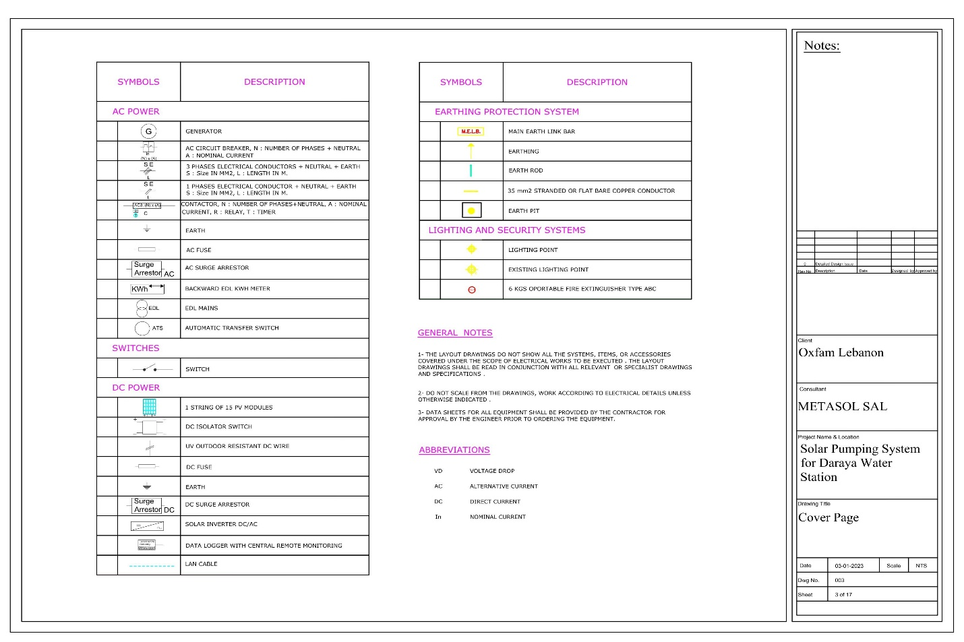
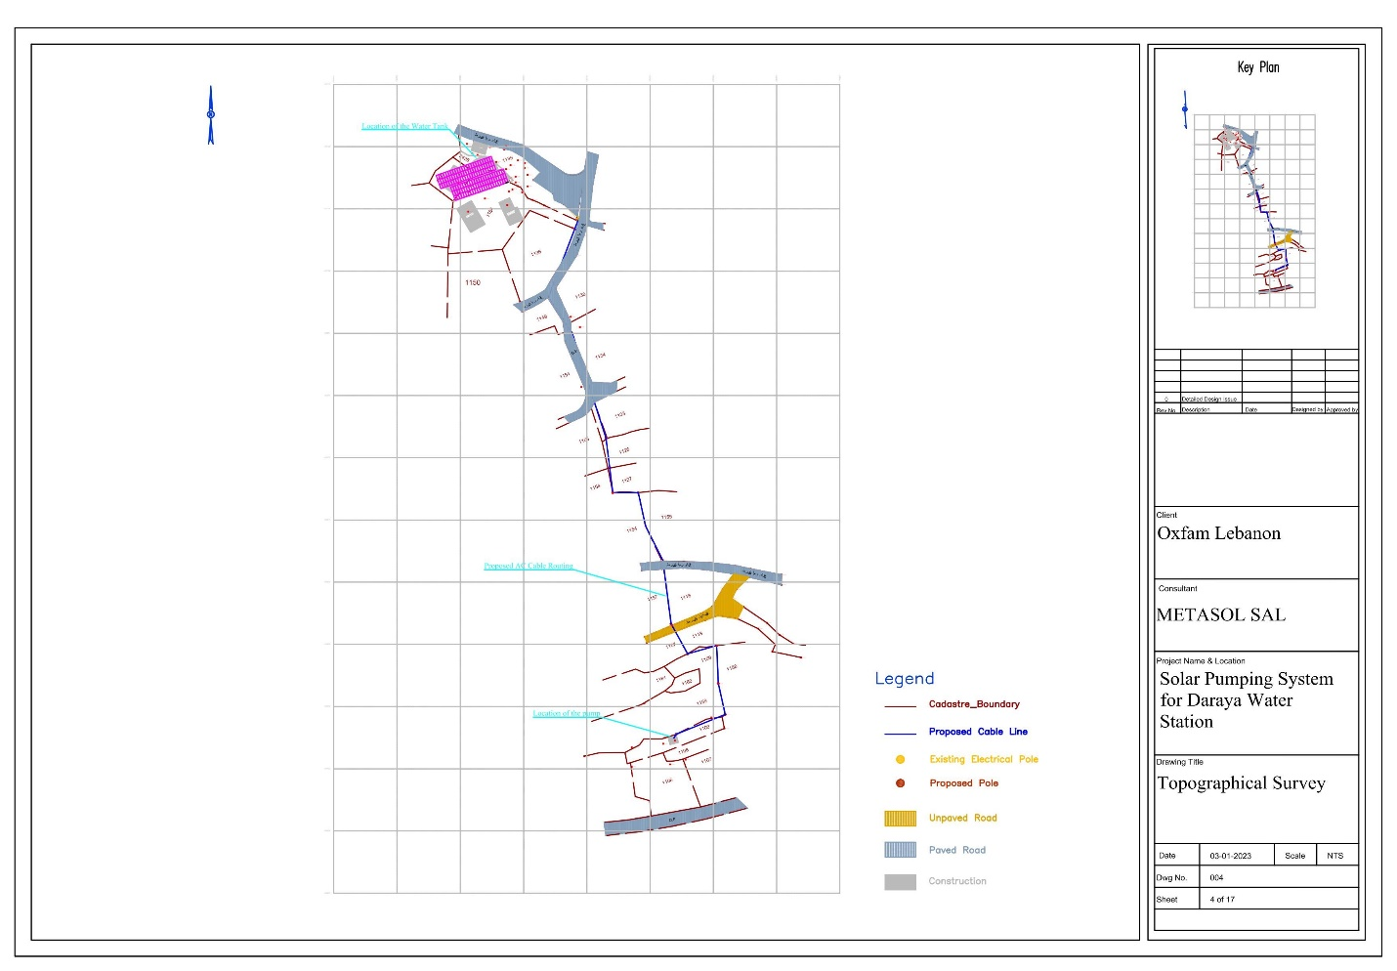
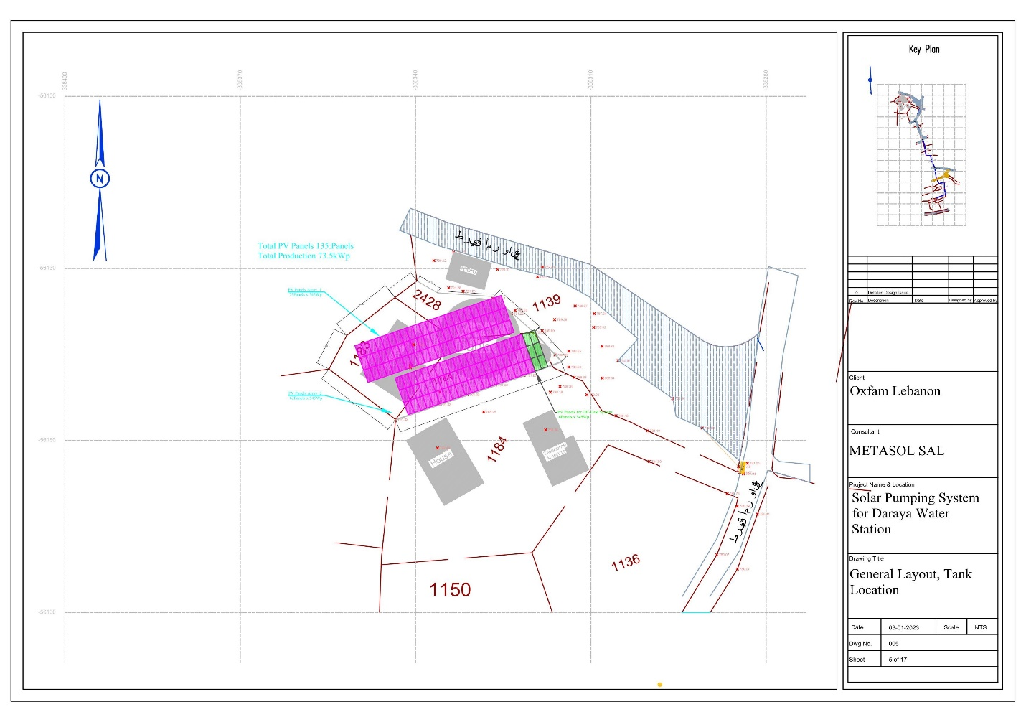
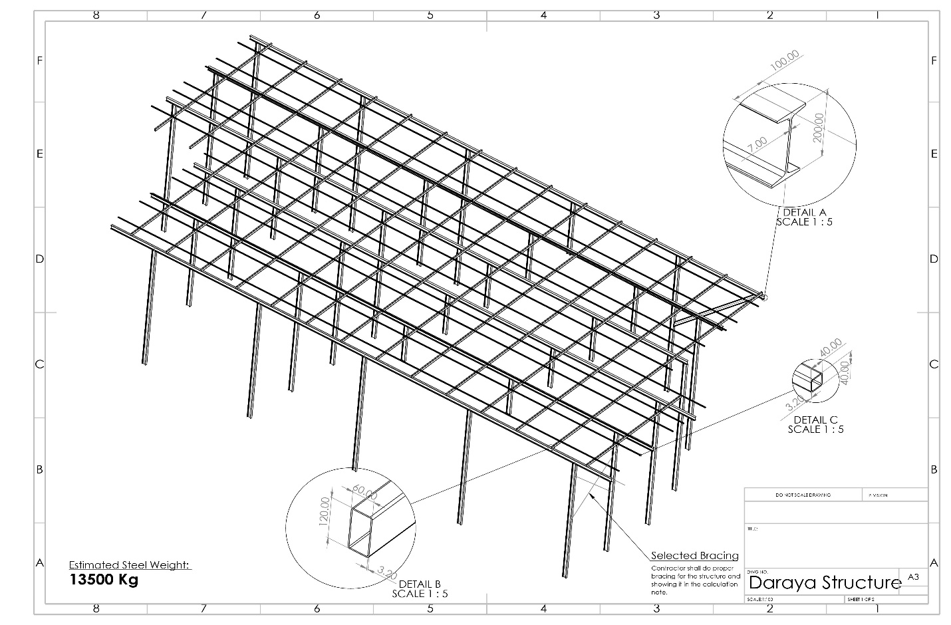
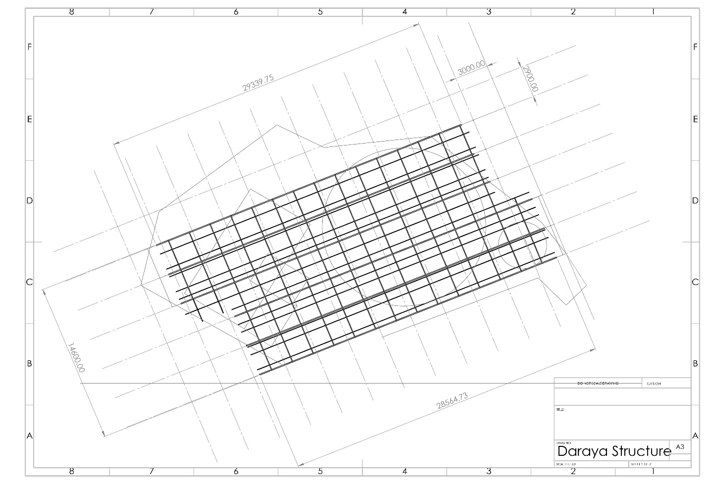
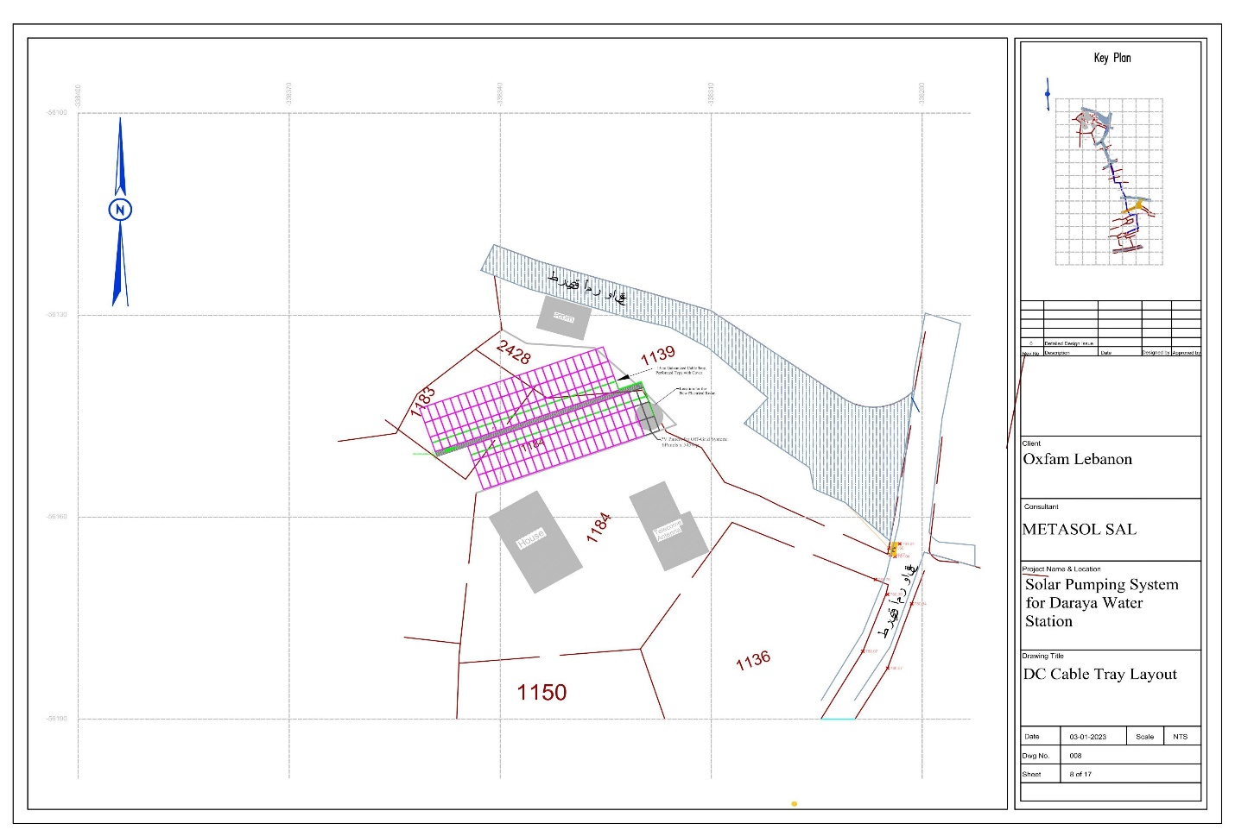
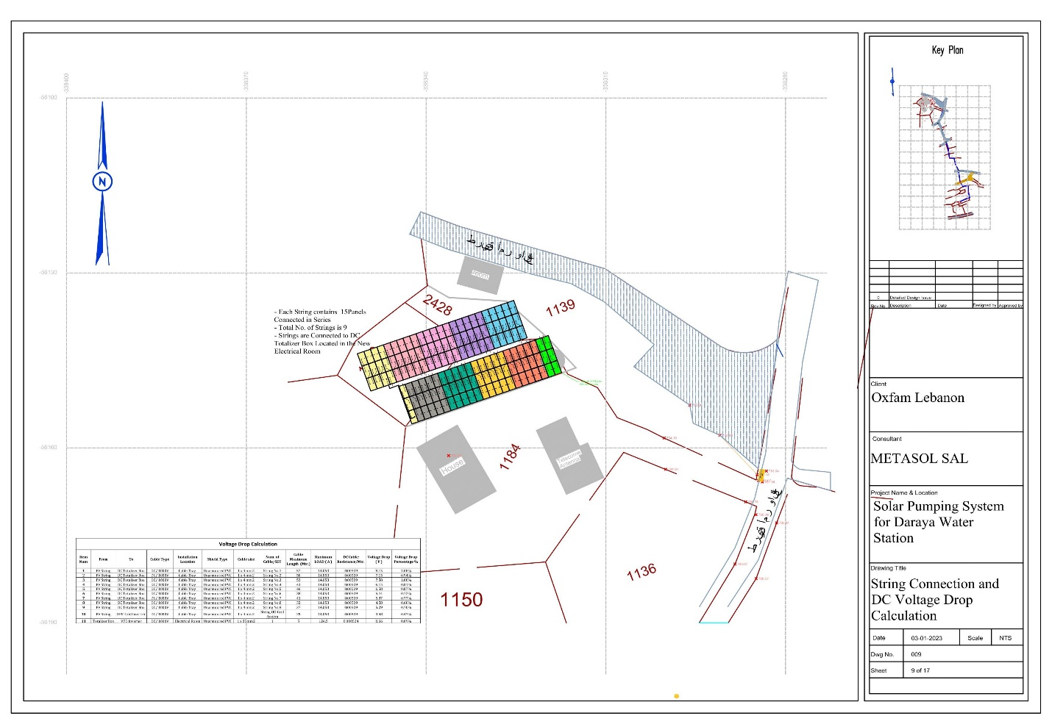
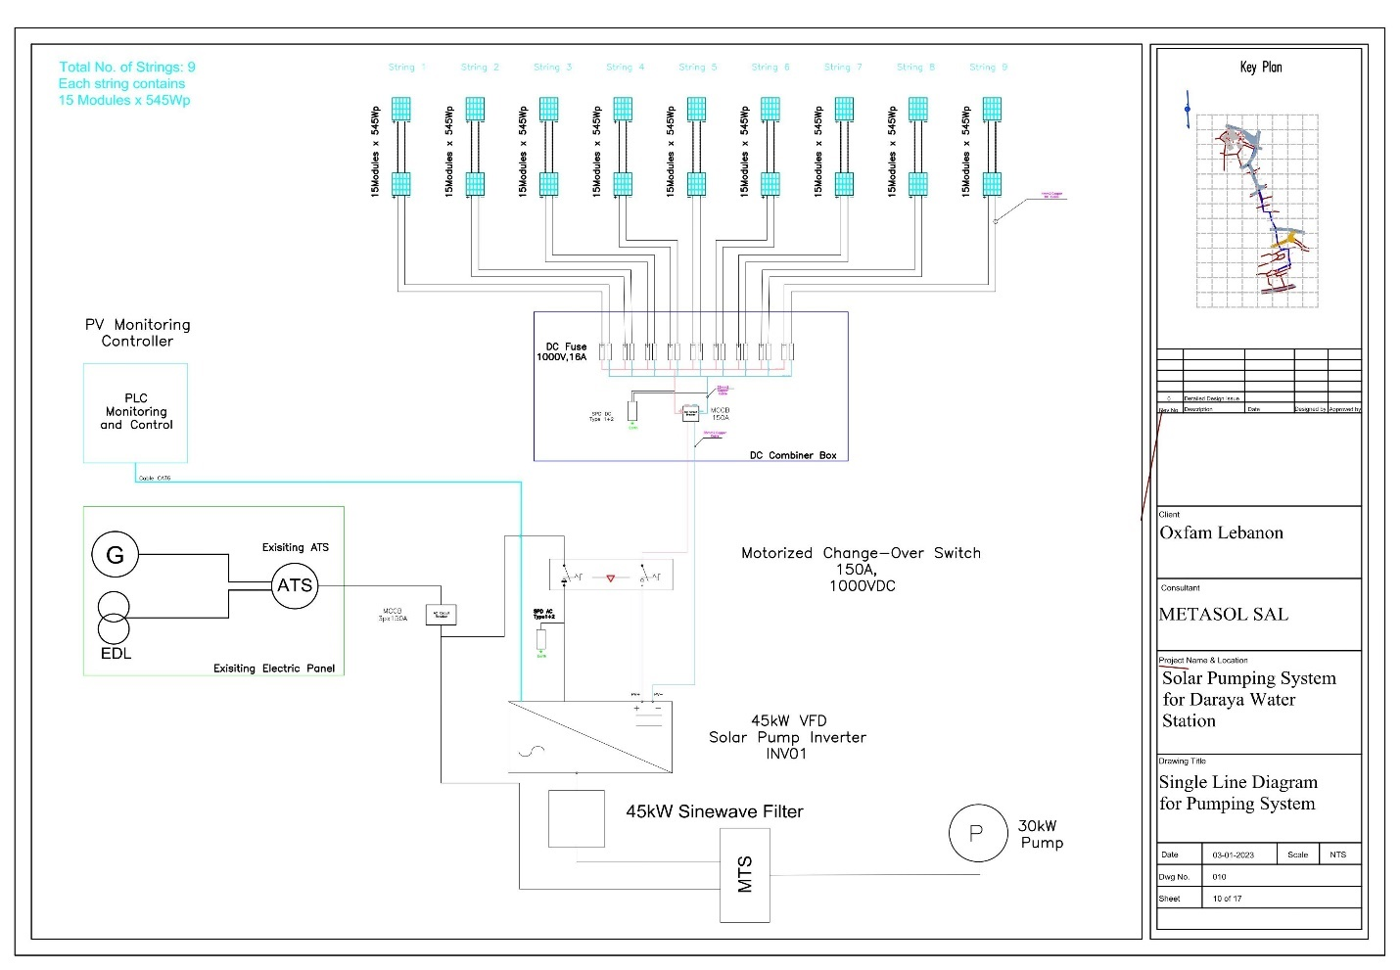
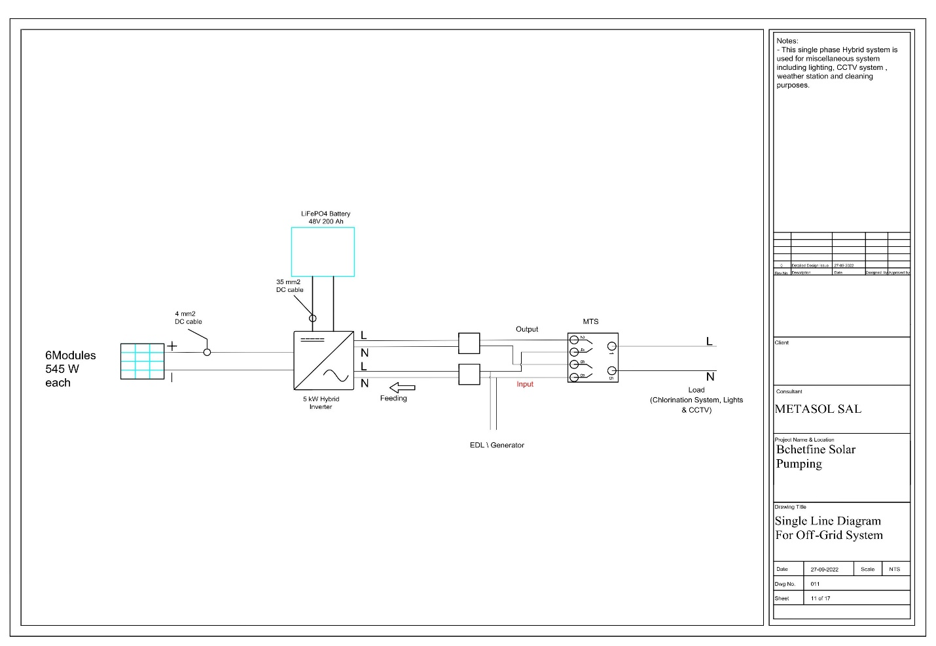
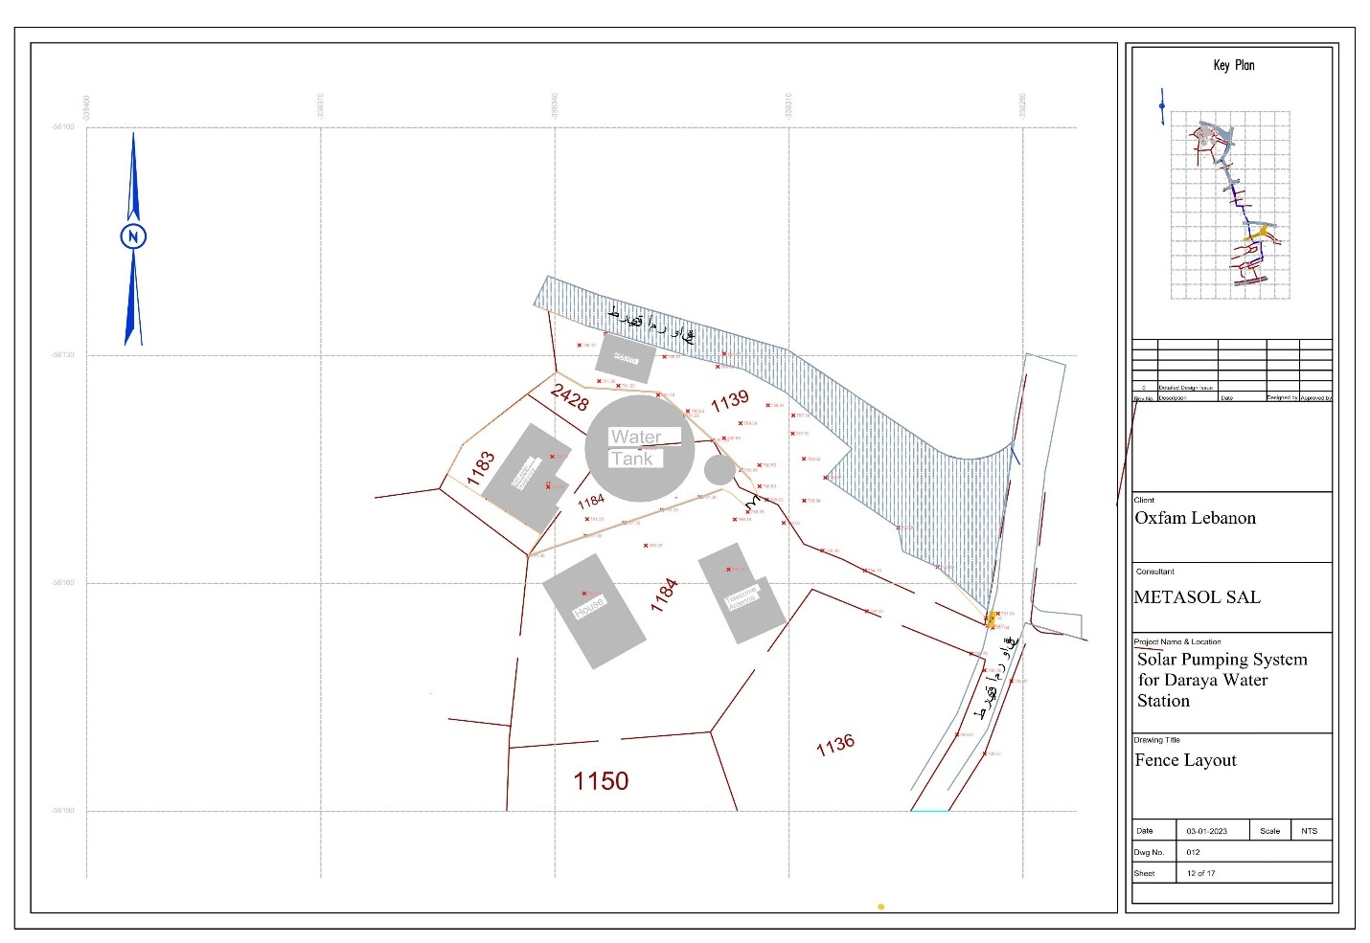

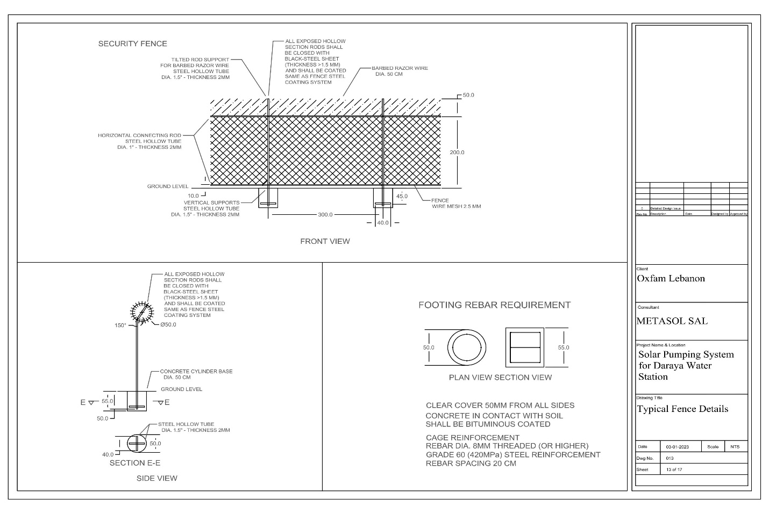
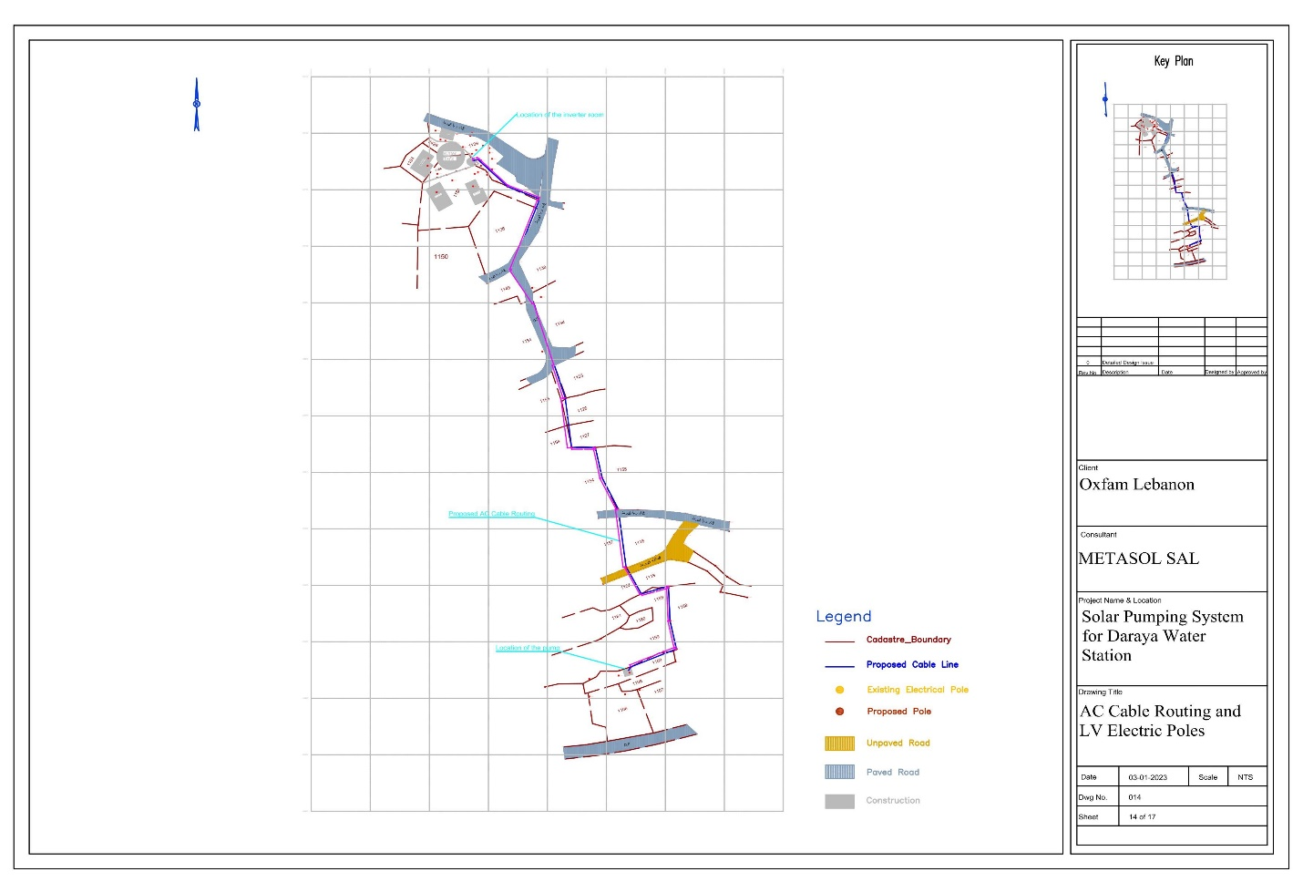
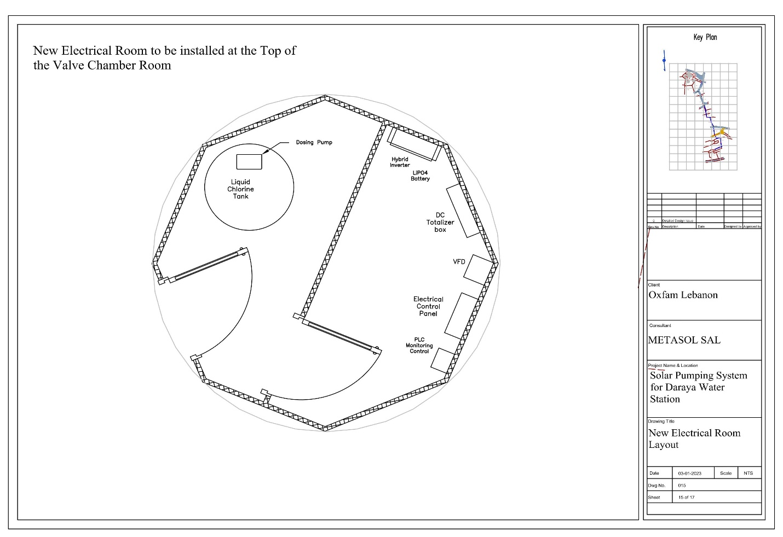
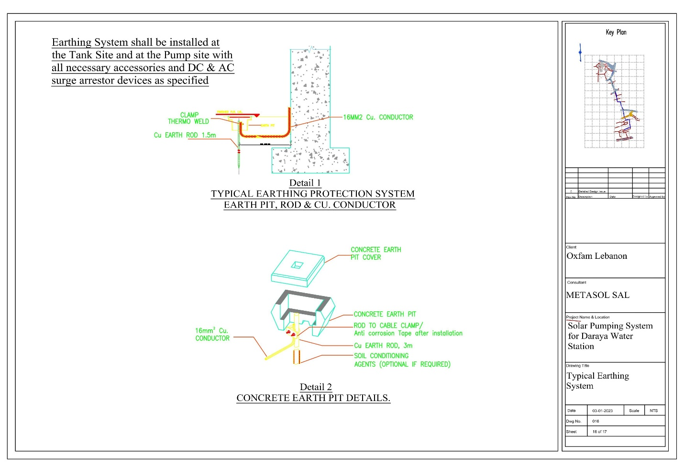

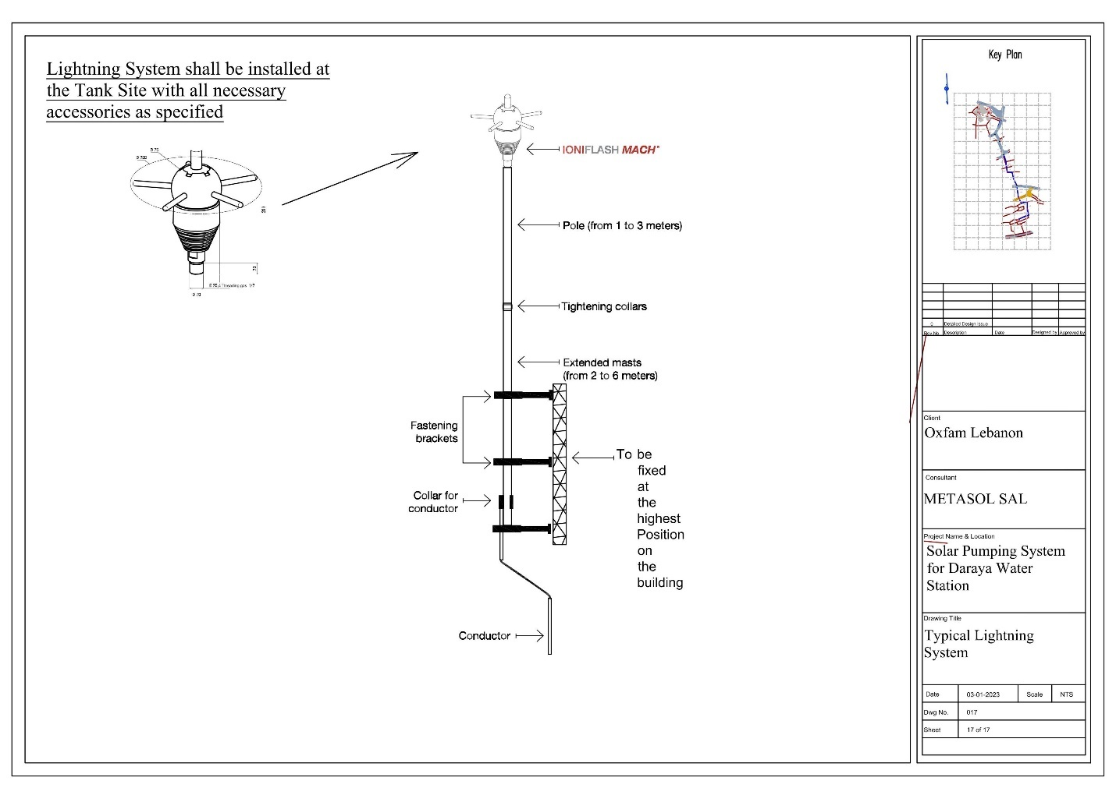

Appendix H: Stress Analysis

Appendix I: Unpriced BoQ

UNDER THE PROJECT ‘’ SUSTAINABLE SAFE ACCESS TO WATER FOR LEBANESE AND REFUGEES IN DARAYA, CHOUF’’
PROJECT FUNDED BY THE LEBANON HUMANITARIAN FUND (LHF)
Oxfam Lebanon
Item Nb. | Item Description | UOM | Qty | Unit Price | Total
 | Unit rates here below shall include all required equipment, accessories and services to comply with specifications and drawings; even if not mentioned in the here below descriptions.
 | The contract price is a lump Sum price. Quantities mentioned are indicative. Contractor shall verify exact quantities . Here below unit rates may be used for Variation Orders evaluation(if any)
1 | Solar PV module
1.1 | Supply, install and connect of Solar modules of a Crystalline technology 545Wp as per specification 7.1 | Pcs | 135
2 | VFD Inverter
2.1 | Supply, install and connect 45kW solar drive inverter for operating the pump with variable frequency drive, MPPT functionality and all features requested in specifications. | Pcs | 1
3 | Metallic Support Structure
Supply, install, test and commission of the metallic support structures , with all needed accessories for a complete installation, including site clearing, excavations, concrete slabs, metallic structure installation, complete with all accessories needed (estimated steel = 13500kg). |  | LS | 1
3.1 | Supply and install galvanized G90 steel I-Beam of dimensions 200x100x7mm as per the attached civil design drawings | LS | 1
3.2 | Supply and install G90 galvanized Rectangular Steel profile of dimensions 120x60x3.4mm as per the attached civil design drawings | LS | 1
3.3 | Supply and install G90 galvanized Steel Solar Rail C-Channel of dimensions 41x41x2mm as per the attached civil design drawings | LS | 1
3.4 | Supply and install steel plates of dimensions 400x400x16mm as per the attached civil design drawings | LS | 1
3.5 | Supply and install steel plates of dimensions 600x400x16mm as per the attached civil design drawings i | LS | 1
3.6 | Supply and install floor grating 80cm, and of thickness 3cm as per the attached civil design drawings | LS | 1
3.7 | Supply and install concrete foundation for the steel structure of dimensions 600x600x1500mm. The concrete base is underground and enforced with rebars. | LS | 1
3.8 | Supply and install bracing members to support the steel structure design | LS | 1
4 | Hybrid 1-Phase Inverter
4.1 | Supply, install and connect 5kW monophase Hybrid solar inverter for operating the chlorination system, cleaning pump, CCTV and site lights all features requested in specifications | Pcs | 1
4.2 | Supply, install and connect of Solar modules of a Crystalline technology 545Wp as per specification 7.1 | Pcs | 6
4.3 | Supply, install, test and commission Lithium Battery, 48VDC, 200Ah, 6000 cycle @ 95 DOD, to power up chlorination system, CCTV and lights during night | Pcs | 1
5 | Cable Tray for DC cables
5.1 | Supply, install, test and commission of Hot dip galvanized 10 cm wide covered cable tray for DC combiner box cables as per technical specifications and drawings | LM | 55
5.2 | Supply, install, test and commission of Hot dip galvanized 15 cm wide covered cable tray for DC combiner box cables as per technical specifications and drawings | LM | 7
5.3 | Supply, install, test and commission of Hot dip galvanized covered cable trays required for all connections inside the technical room | LS | 1
6 | DC Solar Cables
6.1 | Supply, install, test and commission of solar PV RED cable 4mm2 as per technical specifications and drawings | LM | 392
6.2 | Supply, install, test and commission of solar PV BLACK cable 4mm2 as per technical specifications and drawings | LM | 392
7 | DC Totalizer Box
Supply, install, test and commission of waterproof IP65 metallic enclosure DC Totalizer Box as per technical specifications and drawings including:
7.1 | 10X PV Fuses PV 16A, for positive and negative polarities | Pcs | 1
7.1 | 10X PV Fuses holders
7.1 | 1X DC Surge arrester Type 1+2, 1000VDC or higher, with fuse
7.1 | 1x Cable gland for the Cu 18x4mm2 DC cable entering the totalizer box
7.1 | 1x Cable gland for the Cu 2x35mm2 DC cable exiting the totalizer box
7.1 | 1x DC Disconnector 150A, 1000VDC or higher
7.1 | 1 X 2 mm Bus bar on positive and negative polarities
8 | AC Main Cable
Supply, install, test and commission of AC power cable, TUV certified, as per technical specifications and drawings, the main AC Cable is to run from the new electrical room down to pump room
8.1 | 3x95mm Aluminium Cable, Unarmoured PVC Material, as specified in Annex I- Daraya Technical Drawings | LS | 1
9 | Sinewave Filter
9.1 | 45kW Sinewave Filter | Pcs | 1
10 | Technical Room BOS
Supply, install, test and commission of all necessary components for a fully functional and safe system operation. BOS components should be installed in indoor enclosures with forced ventilation. Following is a list of main components only. The bidder has to make sure to include all necessary equipment relevant to his chosen technical room design
10.1 | Motorized change over switch, 180A, 1000VDC or higher | Pcs | 1
10.2 | AC Surge arrester Type 1+2, 400VAC, with fuse | Pcs | 1
10.2 | Manual Transfer Switch 150A, 400VAC | Pcs | 1
10.3 | MCCB 150A, Isc 50kA for solar drive | Pcs | 1
11 | Electrical Room
11.1 | Supply, install and commission a new electrical room of block work type covered by insulated sandwich panels. The room size should be 2.5 x 2.5 x 2.2 meter. | LS | 1
12 | Chlorination Room
12.1 | Supply, install and commission a new chlorination room of block work type covered by insulated sandwich panels. The room size should be 2.5 x 2.5 x 2.2 meter. | LS | 1
13 | Chlorination System
13.1 | Supply, install and commission a new chlorination dosing system consist of 2 dosing pump (duty/standby basis), FRP tank 200 Litter, mixer and all required accessories for dosing chlorine in the inlet and monitor the outlet water to be 2-3 ppm | LS | 1
14 | Control & Monitor instruments
14.1 | Supply, install and commission a multi-channel transmitter for monitoring water flowrate, pH/ORP, Cl2 and pressure | LS | 1
14.2 | Supply, install and commission a pH/ORP sensor | LS | 1
14.3 | Supply, install and commission a hydrostatic level sensor | LS | 1
14.4 | Supply, install and commission Cl2 sensor | LS | 1
14.5 | Supply, install and commission 1x digital and 1x mechanical pressure gauge | LS | 1
14.6 | Supply, install and commission flow meters at each Discharge Line | LS | 1
14.7 | Supply, install and commission a PLC for all control & instrumentation logic | LS | 1
14.8 | Supply, install, test and commission the monitoring , logging and control system including all necessary meters, sensors ,weather station, cables, internet access and accessories as per technical specifications. | LS | 1
 | CCTV system
 | Supply, install, test and commission CCTV system as per specifications and below items: | LS | 1
15.1 | DVR. 4CH, DS-7104HGHI-F1, H.264+, AHD,CVI,TVI Up to 2MP, Analog, IP Up to 5 MP, Up To 4-ch IP Cameras Connected, Full channel recording at up to 1080p lite resolution, Audio: 1 Rca, HDMI/ | Pcs | 1
15.1 | CCTV System | HD Camera | Bullet | 2MP TVI, 3.6mm, IR: 20Meter | Pcs | 4
15.1 | CCTV System | Hard Disk | 3.5" | 4 Terra | SV |Seagate Skyhawk Surveillance HDD, SATA, RPM: 7200 | Pcs | 1
15.1 | CCTV System | Cable | RG-59 | 92M | Thin | Black CCTV System | Cable | RG-59 | 92M | Thin | Black Video, Audio, Power | Pcs | 1
15.1 | CCTV System | Power Supply | 12V | 15A | Pcs | 1
15.1 | CCTV System | Connector | BNC Cable | BNC Male| DC Male BNC & DC Cable: 20cm | Pcs | 4
15.1 | CCTV System | Connector | BNC Cable | Male Shield BNC Male Open-End Wire 30cm w/ Shield | Pcs | 4
15.1 | Power Cable | German Plug - Open Cable End, 3x0.5mm Open End Electrical Cable German Plug 3x0.5mm Open End Electrical Cable German Plug | Pcs | 1
15.1 | Cable | HDMI | 1.5m HDMI Male - Male Cable 1.5m | Pcs | 1
15.1 | Power Strip | 5 Outlet UK | 2x0.75mm | 2M | Outlet, UK, 5x Socket, Choko 4.0mm, Cable 2m, 0.75mm | Pcs | 1
15.1 | Cabinet | 4U | 60x45 Wall Mount, (W:60 x D:45 x H:30) cm | Pcs | 1
16 | Water Cleaning System
16.1 | Supply, install, test and commission of water cleaning system as per specifications. System mainly to include 1-hp pump, 30-meter flex hose reel. As per specification 7.8
16.2 | Supply, install and commission of a Centrifugal water pump, monophase, 1-hp motor, complete with valves and electrical connection | LS | 1
16.3 | Supply and install a 30-meter hose with reel | Pcs | 1
16.4 | Supply and install Level switches; for pump start/stop | LS | 2
16.5 | Supply and install all necessary pipes and valves | LS | 1
16.6 | Supply and install Pressure switch, 0-60 psi | LS | 1
17 | Earthing and Lightning System at Tank Location
 | Supply, install, test and commission of an earthing system next to the PV arrays, including all elements and connections. A maximum value of 5 Ohms will be accepted. All following elements should be properly earthed: | LS | 1
 | PV panels frames
 | Mounting Structure
 | Cable trays
 | Fences
 | Supply, install, test and commission of a Lightning protection early streamer, covering the total area of the PV field | LS | 1
18 | Earthing System at Pump Location
 | Supply, install, test and commission of an earthing system next to the pump location, including all elements and connections. A maximum value of 5 Ohms will be accepted. All following elements should be properly earthed: | LS | 1
 | Miscellaneous works
 | Renovation of the existing pump room with the following services: 1-New painting (white colour) with primer coat 2-fix the pathway so that operator can reach pump room easily. | LS | 1
 | Supply and install Projector Light, 400W LED type, complete with cables and connections | Pcs | 8
 | Supply and execute a Disinfect and flushing job for the existing tank to be ready for storing new fresh water. | LS | 1
 | Project sign board as per specification 7.13 | LS | 1
 | Supply and install a new fence around the tank area | LS | 1
 | Labelling
 | Any element installed in the scope of this project should be clearly referenced and Labelled. References are to be clearly shown on As-Built drawings | LS | 1
 | Spare parts
 | Spare Solar Modules | Pcs | 6
 | Complete VFD to be connected a spare incase of original VFD malfunctioning | Pcs | 1
 | Repair Kit for the chlorine dosing pump (one complete set from manufacturer) | Pcs | 1
 | Chemical injection Valve for the same dosing pump | Pcs | 1
 | Testing & commissioning
 | Testing& commissioning to be executed as described in the specifications 7.10. | LS | 1
 | O&M manuals and training
 | Provide as built drawings as described in the specifications 7.11 and 7.12 | LS | 1
 | Provide O&M manuals as described in the specifications 7.11 and 7.12 | LS | 1
 | Provide a two days training program as described in the specifications 7.11 and 7.12 | LS | 1
TOTAL (USD) |  |  |  |  | 0.00

