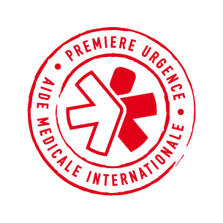
CALL FOR TENDER
ANNOUNCEMENT

Tender reference: LIB/COO/20/ITB/002

Object: Call for Framework contract for Health Insurance

THE NGO PREMIERE URGENCE – AIDE MEDICALE INTERNATIONALE launches a Call for tender for Health Insurance

The complete tender documentation can requested by email ( lib.log@pu-ami.org) or withdrawn in hard copy, during the opening hours of the office (Monday through Friday and from 8.30 am to 4.30 pm), at the following address:

PU-AMI

Premiere Urgence – Aide Medicale Internationale
Nehmeh building, El Shouhada Street,
Ain El Remmaneh, Chiyah, Beirut

For information on the tender collection process, please contact 03-411800

Provisional calendar:

Step | Date | Time
Call for applications (publication of tender announcement) | July 7th,2020 | 9:00 am
Start collecting documents of participation | July 7th, 2020 | 9:00 am
Deadline for submitting offers | July 22nd,2020 | 16:00 pm
Estimated contract award (except if unsuccessful procedure) | August 20th, 2020

