From
Contact Person:
Address 1:
Phone #:
E-mail:
 | TO: | Lebanese Red Cross
 | Contact Person: | Rayane Sabra
 | Address 1: | Spears – Kontari – Facing Barbar
 | Phone #: | 00961 1 372802
 | E-mail: | Rayan.sabra@redcross.org.lb

The Lebanese Red Cross Society (LRCS) hereby invites bids from manufacturers/reputed firms registered / suppliers for the supply of the following supplies/ services:

Request for Quotation Details
RFQ #: | MSS8/24 | Currency of Bid (3-letter code): | USD
RFQ Issuing Date: | 31/07/2024 | Bid Validity Period (days): | 160 DAYS
RFQ Closing Date: | 07/08/2024 | Required Delivery Date: | IMMEDIATE
RFQ Closing Time: | 02:00 PM | Required Delivery Destination: | SPEARS HQ
Questions to the RFQ |  | Required Delivery Terms: | DDP (INCOTERMS 2021)
Important Note:

- All bids received in pencil will be disqualified
- LRC reserve the right to correct any miscalculation on the bid form
- Bids in any currency may be disqualified
- All RFQ pages should be signed and stamped
- The Awarding will be based on the Lowest Cost Technical Compliant bid.
- Company profile is mandatory

Documents to be Submitted Via email:
- Copy of company registration – (Ministry of Justice)
- Copy of tax registration (Ministry of Finance)
- Copy of VAT registration (Ministry of Finance) if any
- Official USD Bank details Signed by the Bank

Bid Submission Details:
Please submit your offer and the related Datasheet in a sealed envelope to LRC Spears procurement unit, and include the following inscription on the envelope: RFQ#: MSS191/24. The deadline is August 07, 2024 at 2:00PM.

Annex 1 Supplier Registration Form
Please fill in this questionnaire in order to register.
- NAME OF COMPANY:
Mailing Address
 | Country:
Contact Person (s)
Telephone No | Fax:
Email
Website
Owner(s) Name(s):
Nationality:
VAT Number
Date of Registration of VAT
- ORGANISATION REGISTRATION: | Year Established: Under the laws of:
- SIZE OF BUSINESS | No. of Employees: No. of Branches:
 | No. of International Offices:
 | Location of Factories:
 | No. of Plants:
 | No. of Warehouses
- AFFILIATED/HOLDING/ SUBSIDIARY COMPANIES: | Name Address Nature of Affiliation

Financial Proposal

LRCS to Complete |  |  |  | Bidder to Complete
Item Number | Item /Milestone Required | Required Unit | Required Quantity | Unit Price in USD, Exclusive VAT rated at 11%, but inclusive Labor Fees, Execution, installation, Delivery and all other fees | Unit Price in USD, inclusive VAT, Labor Fees, Execution, installation, Delivery and all other fees | TOTAL Price in USD Inclusive VAT, Taxes, Labor Fees, Execution, installation, Delivery and all other fees | Lead Time of Delivery to ROUMIEH WH
1 | Bosu ball : Trainer Balance Dome with Pump and 2 resistance bands  Dome platform face up  Anti-slide base  High-density resistance bands with comfy grip handles  Width, Length, Height, Diameter APPRO. : 65, 68, 27, 65 cm | Piece | 6
2 | Medical stool:  - Frame chromed steel base , height adjustable  - 5 running safety wheels  - Seat padded foam, height adjustable , 360 degree rotatable, black color, round shape  - Height 23 inch, diameter seat 12 inch, diameter base 20 inch, Seating height 17-25 inch Approx  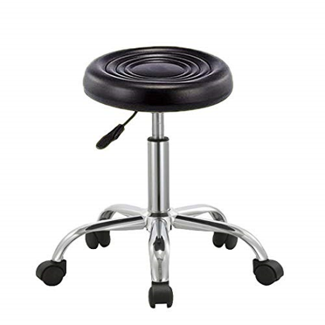 | Piece | 24
3 | Wall mounted shoulder wheel:  - Wall-mounted powder-coated steel structure with chrome-plated sliding part.  - Height 160 cm Width 110 cm Depth 30 cm Approximately  - A 360 degree scale is provided on the drum to measure the degree of revolution from either direction.  - Wheel is mounted on three laminated wall boards of which two boards are fitted with Two stainless steel channels to give wheel 50cm height  - The height and tension (resistance) of the wheel can be adjusted with the knobs.  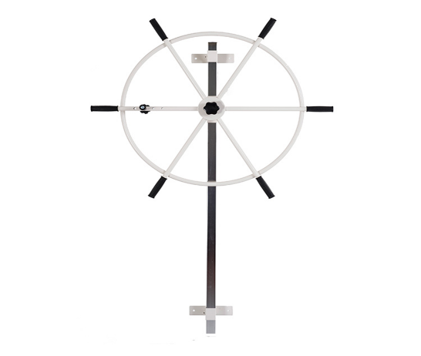 | Piece | 4
The bid should be concisely presented and structured in the following order to include, but not necessarily be limited to the following information listed below. The information should be sufficient for evaluators to draw scores according to the below evaluation criteria.

The techical, and financial Evaluation will be done on the basis of the following, of best value for Money.

Payment terms: Fresh to Fresh Transfer up to 45 days of receipt of invoice and items- VAT amount will be paid with Cheque LBP based on SAYRAFA rate of the previous day– Please submit your IBAN Official Document

OTHER PAYMENT TERMS ARE NOT ACCEPTED

The following is important information regarding this RFQ:
Delivery Lead Time (from receipt of LRC Purchase Order):

Bid Validity Period: ____________ (Calendar) days
I certify that I have read and understood the LRC General Conditions of Contract for the Procurement of Goods and the LRC Code of Ethics. I further certify that the above mentioned company has not engaged in corrupt, fraudulent, collusive, or coercive practices in competing for, or in executing, any Contracts.

Signed: __________________________ Position: ______________________

Print Name: ________________________ Date: _______________________

Please stamp this Bid Form with your Company Stamp

