From: | Wahat-Al-Farah Association for special needs | To:
Address : | Bkeftine-El-Koura-Lebanon | Address :
Contact Person: | Rim Fares/Procurement Specialist | Contact Person:
Phone: | +961 71 98 66 97 | Phone:
Email: | procurement.wahafarah@gmail.com | Email:

Wahat-Al-Farah Association for Special Needs invites Company to submit quotation(s) for the provision of the items as detailed in this Request for quotation.
Request for quotation details:
RFQ #: | C4W047/24
RFQ Issuing Date: | July 19, 2024
Quotation Submission deadline: | July 25, 2024, 2:00 p.m.
Currency of Bid (3-letter code): | USD
Bid Validity Period : | 90 days
Required Delivery Date: | Within 1 week from receiving PO
Required Delivery Destination of the Goods: | Bkeftine-El-Koura-Lebanon
Payment terms : | Bank Note

IMPORTANT NOTE
- WAF will award this contract to the lowest-cost technically compliant bid / Lot, and the bidder must bid on all items listed in the financial offer.
- All bids received in pencil will be disqualified.
- WAF reserves the right to correct any miscalculation on the bid form.
- Bids in any currency other than USD may be disqualified.
- WAF the right to cancel any item from this RFQ and adjust the quantity based on budget availability.
- Bidder must be able to deliver sample if needed
N.B: It is essential that all proposed items be of high quality, durable, and known brand.
RFQ INSTRUCTIONS
One sealed envelope should be submitted in person and not by email to our Head office in Koura with the inscription: RFQ#: C4W0047/24 provision of Kitchen Tools and Equipment No other inscription should be included on this envelope.

The following Documents are required (Mandatory):
- This RFQ completed signed and stamped.
- Data sheet for each item proposed Signed and Stamped.
- Financial offer form fully and accurately filled in, signed and stamped.
- Copy of company registration.(mandatory)
- Copy of VAT registration if any (Ministry of Finance)
- Bidder must fill all the Item /Milestone Offered Item /Milestone Offered :Model Name, Model, UOM, picture of the item and (Full Descriptions if different than what is required in the required technical description)
Financial Offer Form:
WAHAT-AL-FARAH ASSOCIATION FOR SPECIAL NEEDS TO COMPLETE |  |  |  | BIDDER TO COMPLETE
Item No. | Item Description | Estimated Quantity | UOM | Item /Milestone Offered  Model Name, Model, UOM and (Full Descriptions if different than what is required in the required technical description) |  | Unit Price (USD)  Excluding VAT | Total Price (USD)  Excluding VAT
1 | Disposable Nitrile gloves for cooking Small Powder Free non-sterile 50 Pair/ Box 10 box/Carton | 2 | Carton
2 | Disposable Nitrile gloves for cooking Medium Powder Free non-sterile 50 Pair/ Box 10 box/Carton | 2 | Carton
3 | Disposable Nitrile gloves for cooking Large Powder Free non-sterile 50 Pair/ Box 10 box/Carton | 2 | Carton
4 | Disposable Nitrile gloves for cooking XL Powder Free non-sterile  50 Pair/ Box 10 box/Carton | 2 | Carton
5 | Disposable nylon mesh hairnet for food cooking 50 pcs/bag 20 Bag/Carton | 2 | Carton
6 | Disposable Nonwoven Sleeve White 40*20 50 Pcs/bag 20 Bags/carton | 2 | Carton
7 | Disposable LDPE Apron for cooking 71*117 50 Apron/Bag – 20 Bags/carton | 2 | Carton
8 | Disposable Face mask 50 Mask/box 20 carton/ box كمامات | 2 | Carton
9 | برميل زبالة بلاستيك مع غطاء 73*58*98, 240 L Green Color | 2 | Pcs
10 | ورق ساندوش تشيكي طويل | 30 | KG
11 | ورق خشخاش | 30 | KG
 |  |  |  |  | SUBTOTAL Excluding VAT:
 |  |  |  |  | VAT 11% (If any):
 |  |  |  |  | TOTAL Including VAT:
Lot #1: Disposable items & plastic Bins
Lot #2 Kitchen Tools
WAHAT-AL-FARAH ASSOCIATION FOR SPECIAL NEEDS TO COMPLETE |  |  |  |  | BIDDER TO COMPLETE
Item No. | Item Description | Estimated Quantity | UOM |  | Item /Milestone Offered  Model Name, Model, UOM and (Full Descriptions if different than what is required in the required technical description) | Unit Price (USD)  Excluding VAT | Total Price (USD)  Excluding VAT
1 | Stainless cooking Pot 45 L | 4 | Pcs
2 | Stainless cooking Pot 55 L طنجرة للطبخ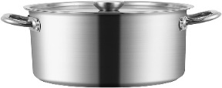 | 1 | Pcs
3 | Frying pot Stainless or Granite مقلاة بطاطا حجم كبير | 2 | Pcs
4 | Round aluminum service tray (Approx. 50cm Diamètre) صينية الومنيوم مدورة 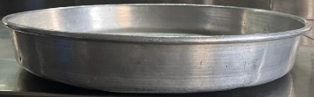 | 4 | Pcs
5 | Stainless cooking Pot 8 L(30cm Diamètre) طنجرة للطبخ | 2 | Pcs
6 | Small coffee rot 12 Oz, stainless steel طقم ركاوي قهوة حجم صغير | 2 | Pcs
7 | Large coffee rot 32 Oz, stainless steel ركاوي قهوة حجم كبير | 6 | Pcs
8 | Slighter قداحات صناعية نوعية جيدة | 10 | Pcs
9 | Spoon Set for cooking (60or 70cm) طقم ملاعق للطبخ حجم وسط من الستانلس صب | 2 | Pcs
10 | Small Forks (dessert forks) شوك صغيرة من الستانلس | 3 | Set of 12
11 | Regular Forks (for table) شوك من الستانلس | 3 | Set of 12
12 | Tea Spoon ملاعق صغيرة من الستانلس | 3 | Set of 12
13 | Table Spoon ملاعق اكل من الستانلس | 3 | Set of 12
14 | Small knife Inoxidable Stainless Steel سكين صغيرة | 3 | Set of 12
15 | Cutting Boards (60*40) ألواح للتقطيع حجم وسط (متعدد الالوان اذا توفرت) | 6 | Pcs
16 | Large bowl washing vegetable (60cm diamètre) جاط كبير | 4 | Pcs
17 | 5 Pcs Plastic Bowl Set  جاط بلاستيك متعدد الاستعمالات عدد 5  Box Size: 36.5 x 36.5 x 15.5 cm approx.. | 2 | Set
18 | Stainless Bowl with cover (35cm diamètre) جاط استانليس مغ غطاء مدور | 6 | Pcs
19 | Plastic Measuring Cups 1000 ml  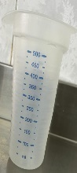 | 2 | Pcs
20 | Measuring Spoons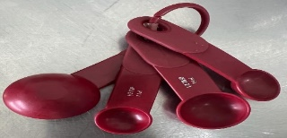 | 2 | Pcs
21 | Rectangle cake pan Granite (Granite) (20*10) قالب كيك مستطيل | 12 | Pcs
22 | Round Glass bowl transparent (30cm Diamètre) جاط من الزجاج شفاف  | 4 | Pcs
23 | Garlic Press كباسة ثوم | 2 | Pcs
24 | Stainless Steel cutter pizza knife سكينة بيتزا | 2 | Pcs
25 | Wooden Spoon 50 cm ملعقة خشبية نوعية ممتازة | 6 | Pcs
26 | Ice cream scoop different sizes set of 6 Heavy duty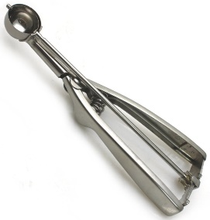 | 2 | Set
27 | Rectangle coffee service tray (50*30) صينية لضيافة القهوة | 5 | Pcs
28 | Storage boxes for sault pepper…(0.5 liter approx) علب لحفظ المواد العذائية  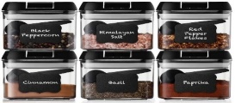 | 20 | Pcs
29 | Optimum Rectangular Roaster 40*27 approx.  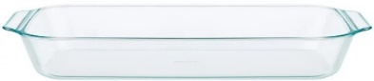 | 3 | Pcs
30 | Spatule Souple 50cm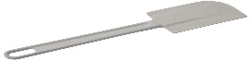 | 4 | Pcs
31 | Silicone Oil Brush 5cm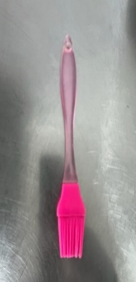 | 3 | Pcs
32 | مصفاة الشاي | 4 | Pcs
33 | مكيال معدن Grain Scoop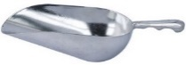 | 4 | Pcs
34 | مصبع للغاز الصناعي | 10 | Pcs
35 | سكرية (لون ابيض) | 4 | Pcs
36 | صحن للاكل فايش ميلامين (لون ابيض) | 5 | Set of 12
37 | صحن للاكل غميق ميلامين (لون ابيض) | 5 | Set of 12
38 | Glass Coffee Cups (white color) فناجين للقهوة شفة لون ابيض | 1 | Set of 12
39 | Glass Coffee Cups (white color) فناجين للقهوة مع صحن لون ابيض | 1 | Set of 12
40 | Glass Mug for tea (white color) | 36 | Pcs
 |  |  |  | SUBTOTAL Excluding VAT:
 |  |  |  | VAT 11% (If any):
 |  |  |  | TOTAL Including VAT:
Delivery Lead Time:(From receipt of Purchase Order/signing the contract) |  |  |  |  |  |  | (Calendar) days
Bid Validity Period: Bid must be valid as stated on the Request for Quotation Details. Bids not meeting the Bid Validity Period may be disqualified. |  |  |  |  |  |  | (Calendar) days
Supplier Payment Modality: Bid not meeting Wahat al farah payment terms may be disqualified
Supplier name: as per the registration paper
Submission Date:
Signature & Stamp: Company Stamp only is accepted

