Challenging Stereotypes, Providing Services, Convening, and Advocating: A multi-layer approach to promote LGBTQ rights in Lebanon
Proposal Template

- General Information

Title of the project:
Implementing Civil Society Organisation(s) (CSO):
Location(s) of the project:
Total duration of the project:
Total Cost of the Project
Objectives of the project | Overall objective:
 | Specific Objectives (S.O.) | S.O. 1.
 |  | S.O. 2.
 |  | S. O. 3.
Target group(s)
Estimated Results
Main activities | Under S.O.1:  - A.1.1  - A.1.2  - A.1.3
Under S.O.2:
- A.2.1
- A.2.2
- A.2.3
Under S.O.3:
- A.3.1
- A.3.2
- A.3.3
- Description of the Project (1 page max)
- Present background information
- Present the linkage to the “Challenging Stereotypes, Providing Services, Convening, and Advocating: A multi-layer approach to promote LGBTQ rights in Lebanon- Present the linkage to the advocacy strategy of the CSO network” project
- Present the significance of the proposed project

3. Activities: (2 pages max)
- List the main activities of the project
- For each of the activities present:
- Detail description of the activities
- Who will implement the activities
- The approach/methodology that will be used
- The beneficiary groups
- The expected outputs

4. Participating CSO(s)
- Briefly describe the expertise of the CSO(s) participating in the project and how this will contribute and add value to the project? (2 paragraphs max)
- Present a diagram or describe the relations between all those involved in the implementation of the project
Example:

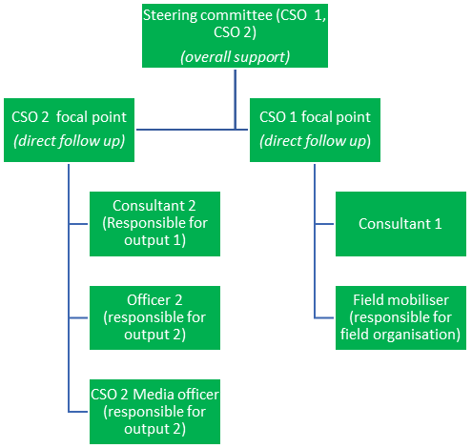

5. Risk analysis

Activity | Description of the risk | Who would be impacted | Ranking of the risk (High, medium, low) | Mitigation measure

6. Sustainability (few paragraphs)
- Present the implementing CSOs will ensure that the proposed project will be sustained or how the learning from the activities will be used for other initiatives/ongoing projects

7. Communication (1 paragraph)
- Briefly present the communication activities that will be implemented as part of the project

