**LITB-2023-9186582- LTA for Adolescent Wellbeing Kit**

**Answers to Queries**

1. Item: "Solar lamp With batteries-Hand pressing flashlight" can you please provide us with more specifications about the product and if a picture is available?

Answer: 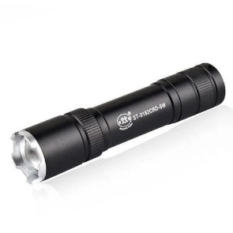 personal lamp light, (small not bigger than 10-15 cm .

1. Item: Colored Rubber Bracelet is a picture available for more clarification?

Answer: 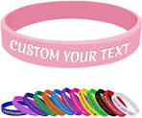

1. Item: Leaflet should the leaflet be binded? Should be printed on a standard A4 80g paper. Should the paper be glossy? 

Answer: It is A5 and could be smaller. And the paper quality should be good not necessary glossy .

1. Item: Bag for Kitting Do you have a specific size the bag should be? Can you provide us with an approximate size if not.

Answer: 40*50 cm