REQUEST FOR QUOTATION

Wahat-Al-Farah Association for special needs, kindly requests you to submit your price quotation(s) for the purchase and installation of equipment for the Interactive room as detailed below in the financial offer form of this RFQ# INT-WAFSCL001-24
Request for quotation details:
RFQ #: | INT-WAFSCL001-24
RFQ Issuing Date: | June 10, 2024
RFQ Closing Date | 18 June, 2024/3:00 p.m. Beirut Local time
Question regarding the RFQ: | All question should be submitted via email to the following email address youssef.bssawmai@gmail.com (contact person: Youssef Bssawmai)
Currency of Bid (3-letter code): | USD
Bid Validity Period (days): | 60 Day
Required Delivery Date: | Before the end of July
Required Delivery Destination: | Bkeftine-El-Koura-Lebanon
Required Delivery Terms:
Payment terms : | Bank Note upon delivery the goods

IMPORTANT NOTE
- Wahat-Al-Farah may choose to bid to one or two bidders based on the necessary.
- All Bids received in pencil will be disqualified.
- Wahat-Al-Farah reserve the right to correct any miscalculation on the bid form.
- WAF the right to cancel any item from this RFQ and adjust the quantity based on budget availability.

N.B: It is essential that all proposed items be of high quality, durable, and known brand.

RFQ INSTRUCTIONS
- Submission of Bid:

Bidders are requested to submit their offer in response to this request for quotation to the following email address Youssef.bssawmai@gmail.com by June 18, 2024, along with all of the documents listed below.

The Envelope should include the following Documents:
- This RFQ all the pages should be signed and stamped.
- Financial offer form fully and accurately filled in, signed and stamped.
- Copy of company registration. Mandatory
- Copy of tax registration (Ministry of Finance).
- Copy of VAT registration (Ministry of Finance)

 | Financial Offer form
 | Wahat-Al-Farah Association for special needs TO COMPLETE |  |  |  |  | BIDDER TO COMPLETE
Item No. |  | Item Description | UOM | QTY |  | Item /Milestone Offered Model Name, Model, UOM and (Full Descriptions if different than what is required in the required technical description) |  | Unit Price include delivery and installation fees (USD) | Total Price include delivery and installation fees (USD)
1 | 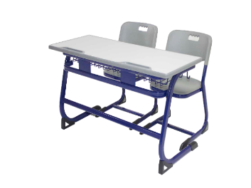 | Student Double Desk: Dim : 110*40*64 cm with penhole-fixed on metal chassis.Water resistant , Anti-Scratch, heavy duty wooden surface framed . (German Standard) Student Chair: 38*40*38 cm made of plastic and fixed on metal chassis of thickness:1.8mm-double coated with anti-rusting agent ectrostatic poweder paint (80 mic).Chairs are designed to provide comfort & durability made of high quality material.(German standard) | Pcs | 6
2 | 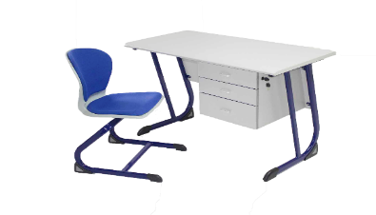 | Teacher Desk dim.: 120*60*76cm Including 3 drawers with central key lock system. Desk is fixed on metal chassis of 1.8mm thickness double coated with anti-rusting agent ectrostatic poweder paint (80 mic). (German Standard) | Pcs | 1
3 | 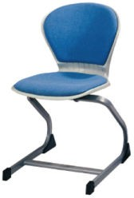 | Teacher Chair dim.: 45*45*h46 cm Made of highly durable and resistent PU plastic and fixed on metal chassis of thickness:1.8mm-double coated with anti-rusting agent ectrostatic poweder paint (80 mic). (German standard) | Pcs | 1
4 | 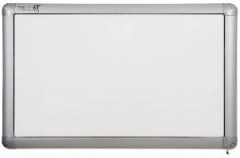 | Touchit Interactive Ceramic Whiteboard (MADE IN USA)  Technical Specification Dimension (in inch) (78") Power Supply : USB  -Operating Systems: Windows 2000/XP/Vista/7/8, MAC & Linux  -Software Wiz teach OEM (NB:AUTOMATIC UPDATE FREE OF CHARGE)  Comes with 1 Pen  *36 Languages Features:  -Enamel Steel Surface with 30 year surface warranty/ Touch  Input/No rechargeable nor battery pen required/ durable/ Multi-touch | Pcs | 1
5 | 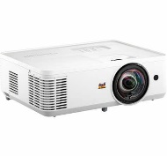 | View sonic Projector PS502W 4,000 ANSI Lumens offering clear images in any environment 0.52 Short throw ratio for minimal space consumption Up to 300" ultra large screen with lower cost-per-inch Easy and flexible connection: dual HDMI ports, USB Type- A port | Pcs | 1
6 |  | Wall Mount  -Range from 60cm to 120cm  -Solid, heavy-gauge steel construction with durable coated finish  -Support up to 60kg |  | 1
7 |  | Lenovo Laptop  Specifications: V15-82C7007VED (Iron Grey) AMD RYZEN3-3250U 4GB DDR$ Onboard  + 1 Slot 1 TB - HDD Support - NVME - Shared VGA - 15.6" HD EN/AR DOS 1YR  (Windows pre-installed) | Pcs | 1
8 |  | Computer Speakers | Pcs | 1
9 | 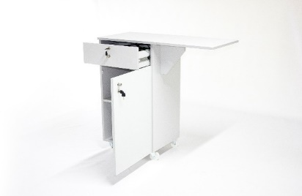 | Moveable Laptop stand with drawer and closet including keylock system and right extension dimensions : 94x42x100 cm | Pcs | 1
10 |  | Bulletin Board: framed with aluminum, Dimension: 180*120 cm | Pcs | 1
11 | 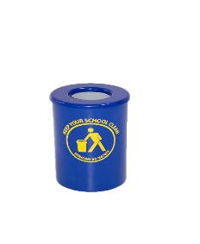 | FRP Garbage Bin (Fiber Glass) (Color of Your Choice - Capacity 30L): Known to be Anti- Scratch, Acid Resistant, and Highly Durable | Pcs | 1
 |  |  |  |  |  | SUBTOTAL:
 |  |  |  |  |  | VAT 11%:
 |  |  |  |  |  | TOTAL:
Delivery Lead Time: (From receipt of Purchase Order) |  |  |  |  |  |  | (Calendar) days
Bid Validity Period: Your Bid must be valid as stated on the Request for Quotation Details. Bids not meeting the Bid Validity Period may be disqualified. |  |  |  |  |  |  | (Calendar) days
Supplier Payment Modality: Bid not meeting Wahat al farah payment terms may be disqualified
Supplier Expected delivery date: delivery date not meeting the Required Delivery Date Mentioned in The RFQ details may be disqualified.
Supplier name: as per the registration paper
Submission Date:
Signature & Stamp: Company Stamp only

