Supplier Logo
Supplier commercial title: …………………………………………...……...
Contact person and position: ………………………….…………….…….
Detailed address (town, street, bldg.): …………….………………….
………………………………………………….…………………………………………..
Phone number: ……………………………….…………………………...………
Email address: ...…………………………………………………………………..

Technical Offer
DRR/LCD/NL/03
Supply of Firefighting Gear for LCD

Project Title: | DRR Intervention in Akkar
Request for Tender Reference: | DRR/LCD/NL/03
Tender Publication Date: | 18/07/2022
Tender Submission Deadline: | 25/07/2022
Submission Email: | abdulhamid.lakkis@north-leda.org
Quotation Validity: | 10 working days

- Suppliers who wish to bid are requested to complete the templates on the following pages as per the below:
  - Columns 1 to 6 filled by North LEDA listing the required items, minimum specifications (not to be modified by the tenderer), other explanatory remarks, minimum and maximum quantities requested, in addition to an illustrative picture.
  - Column 7 to be filled by the tenderer detailing what is offered in terms of capacities, material, etc. consolidated with pics and catalogue when possible (for example the words ‘compliant’ or ‘yes’ are not sufficient)
  - Column 8 allows the tenderer to make comments on its proposed supply and to make eventual references to the documentation
  - Column 9 is reserved for the evaluation committee.
- The requested specs being minimum the suppliers are encouraged to suggest equivalent or superior items with clear explanations.
- The eventual documentation supplied should clearly indicate (highlight, mark) the models offered and the options included, if any, so that the evaluators can see the exact configuration. Offers that do not permit to identify precisely the models and the specifications may be rejected by the evaluation committee.
- Suggested pictures may include additional items than the required descriptions, which only help visualizing the main requested items. Please consider only the main elements shown in the picture in line with the description.
- The offer must be clear enough to allow the evaluators to make an easy comparison between the requested specifications and the offered specifications.
- Suppliers may apply to 1 or more lots.

Lot 1

1. Required Item | 2. Minimum Specifications | 3. Picture | 4. North LEDA's Remarks | 5. Min Qty | 6. Max Qty | 7. Specifications Offered | 8. Supplier's Notes, Remarks, Ref. to Documentation | 9. Evaluation Committee's Notes
Walkie-Talkie | 2-way radio; 3 km range; rechargeable; battery capacity: 1200 mAh |  | Technical data sheet required | 34 | 59

Lot 2

1. Required Item | 2. Minimum Specifications | 3. Picture | 4. North LEDA's Remarks | 5. Min Qty | 6. Max Qty | 7. Specifications Offered | 8. Supplier's Notes, Remarks, Ref. to Documentation | 9. Evaluation Committee's Notes
Flood Boots | Lightweight; firefighter protection. | 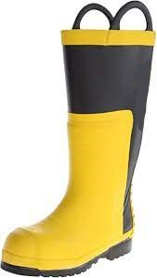 | Sample Required | 24 | 24
Gloves | 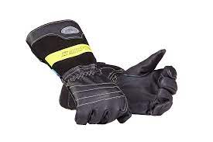  Firefighter protection; long sleeve. |  | Sample Required | 10 | 10

Lot 3

1. Required Item | 2. Minimum Specifications | 3. Picture | 4. North LEDA's Remarks | 5. Min Qty | 6. Max Qty | 7. Specifications Offered | 8. Supplier's Notes, Remarks, Ref. to Documentation | 9. Evaluation Committee's Notes
Helmet | Firefighter protection; thermoplastic or fiberglass; with face shield. | 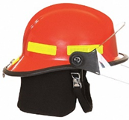 | Sample Required | 44 | 53
Uniform | Firefighter protection; Nomex fabric; with light-reflecting stripes. | 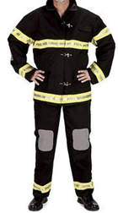 | Sample Required | 104 | 188
Ranger Boots | Lightweight; firefighter protection sole; 8" height from bottom of heel to top of boot. | 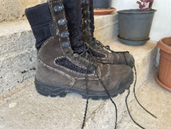 | Sample Required | 104 | 188

Lot 4

1. Required Item | 2. Minimum Specifications | 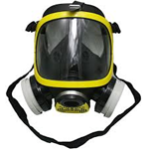3. Picture | 4. North LEDA's Remarks | 5. Min Qty | 6. Max Qty | 7. Specifications Offered | 8. Supplier's Notes, Remarks, Ref. to Documentation | 9. Evaluation Committee's Notes
Mask | Firefighter protection; with filter. | 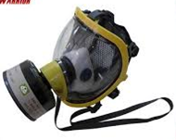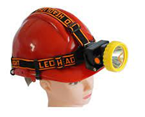 | Sample Required | 15 | 15
Torch | Strappable on helmet; rechargeable; with flashing option |  | Sample Required | 67 | 133

Date: ____________________________________________________________________________

Supplier Stamp & Signature: __________________________________________

