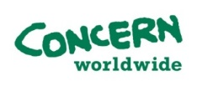

**Tender Reference: JUL-19-17**

**The Lebanon branch of Concern Worldwide invites bids from registered contractors for Desludging of Sewerage at its Informal Settlement Sites in Akkar**

. The tender dossier can be requested by email from: [lebanon.tenders@concern.net](mailto:lebanon.tenders@concern.net) with the tender number mentioned in the subject. Tender dossier can also be collected from the Procurement office of Concern Worldwide located at,

HDYS Building (Opposite Abdel Karim Rifai Petrol Station), Halba, Akkar.

The deadline for submission of tenders is **1200Hrs Lebanon Local Time (GMT +2) on July 22, 2019**

(Concern retains the right to accept or reject any offer/proposal prior to the award of contract and to annul the bidding process and reject all offers at any time without assigning any reason.)