Bhanin – Srakiss
- Install door handles on two doors to facilitate entry.
- Cover the floor and stairs with tiles.
- Lower a high board.
- Repair toilets.
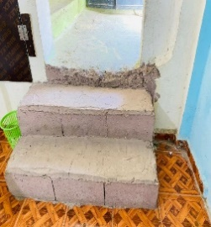 | 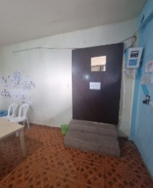 | 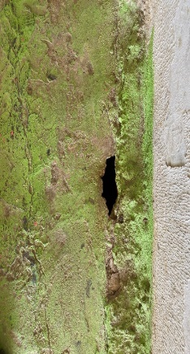
Annexe 9: Uneven staircase | Annexe 10: Doors without handles
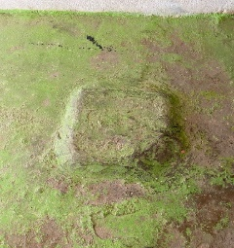 | 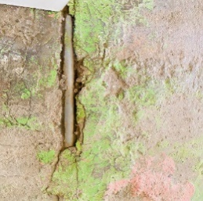 | 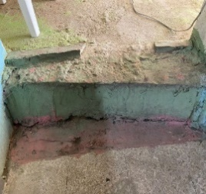
Annexe 11 : Unsafe Floor )full of obstacles(
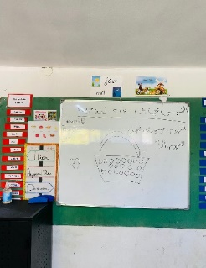 | 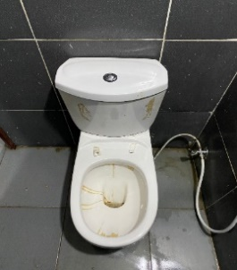
Annexe 12 : High board | Annexe 13: toilet needs to be repairs

Anwar El Mnieh :
At Al Nassij Center, it’s remarquable that this center can accommodate person with physical disabilities, so I suggest the following :
- Small Ramp at the Entrance:
  - Installing 2 small ramp at the entrance is a practical and inclusive solution. It ensures that individuals with physical impairments can easily access the facility.
- Doors without Door Handles:
  - For the 10 doors without handles, consider installing lever-style handles. These are generally easier to use for individuals with limited hand mobility.
- Colorful Scotch on Stairs:
  - Painting the stairs or using colorful tape is an excellent idea to assist individuals with visual impairments. It enhances visibility and makes it easier for them to navigate the stairs independently.
- Window Security:
  - Ensuring security for windows is important for the safety of everyone, including those with physical disabilities. Consider installing window locks or safety bars at an appropriate height to prevent accidents.
- Lowering Boards:
  - Lowering boards to a more accessible height is a thoughtful adjustment for individuals who may be in a wheelchair or have difficulty reaching higher surfaces.
- Build an Accessible Toilet:

- Establish an accessible toilet within the center.

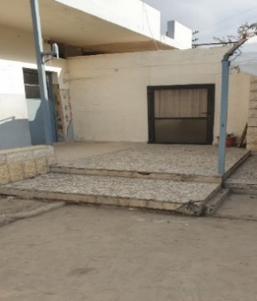 | 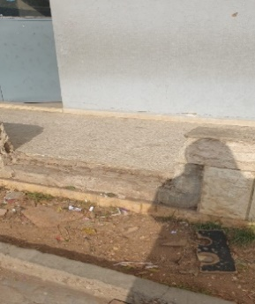 | 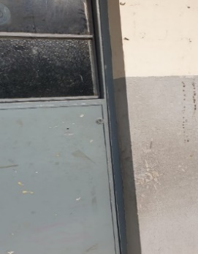
Annexe 1 : 2 stairs can be replaced with ramps |  | Annexe 2: doors don’t have handles (10)
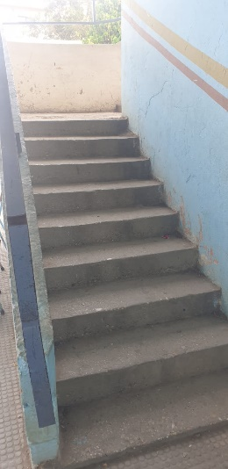 | 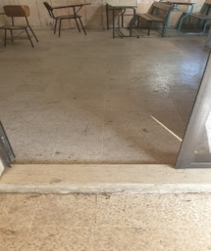
Annexe 3 : stairs need color tape | Annexe 4 : step door can be removed
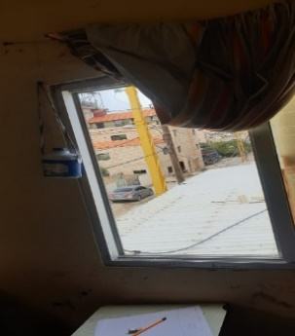 | 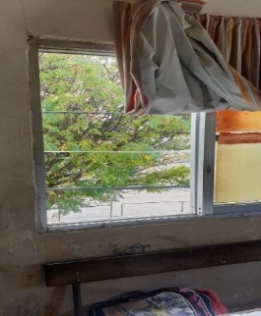
Annexe 5: Unsafe window
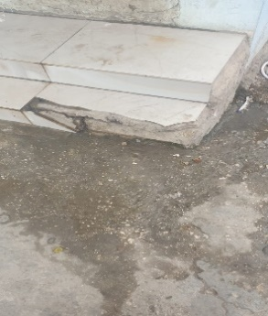 | 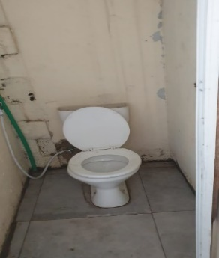
Annexe 6: stairs for toilets can have baton | Annexe 7: toilets are not accessible
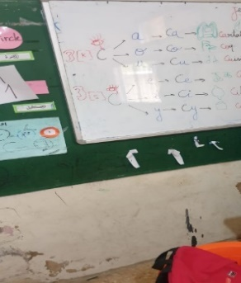 | 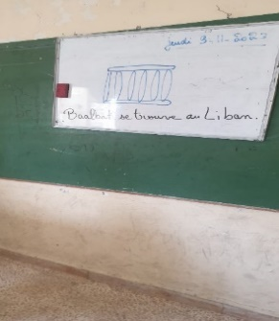
Annexe 8: The boards are so high

Al Abir:
Optimize the management of corridors to improve accessibility.
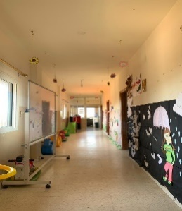
Annexe 14: Corridor of Al Abir

IS085
- Replace the old doors
- Build a toilet
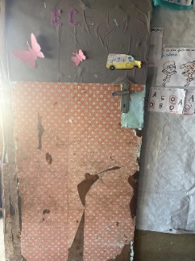 | 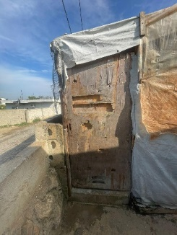
Annexe 15 :Door of the class | Annexe 16: Toilet’s door

Ajyal El Aarab
Adweh
1. Remove step doors.
2. Lower boards.
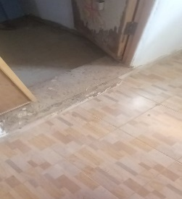
Annexe 17: Step door can be removed
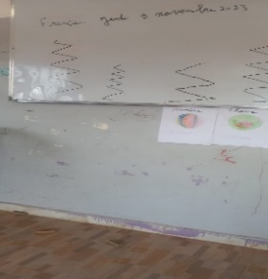 | 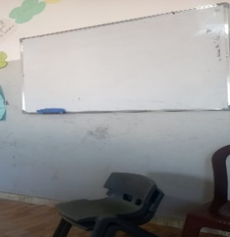
Annexe 18: Boards are so high (2)

Ajyal Al Arab
Meryata1
1. Lower boards.
2. Change door handles.
3. Replace a big stair with a ramp.
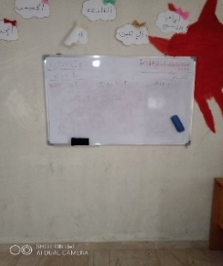 | 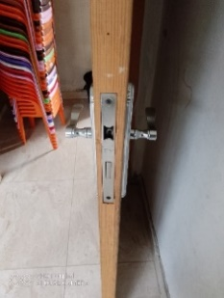
Annexe 19: Board are so high | Annexe 20 : 5 handle door need to be removed
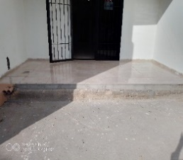
Annexe 21: a stair can be replaced by a small ramp

AICA
Nakhleh
1. Change boards.
2. Add handles to doors.
3. Add handrails to the long stairs for the safety of visually impaired individuals.
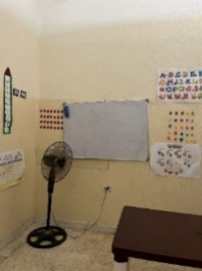 | 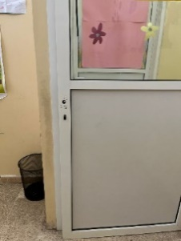
Annexe 22: Board not fix | Annexe 23: door needs Handle

AICA
Tebbeneh
Add handrails to the long stairs for the safety of visually impaired individuals.
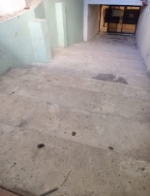
Annexe 24: the entrance of the center

Ribat
Nouri
- Add handles to doors.
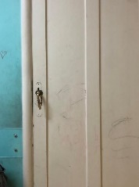
Annexe 25: Door without handle
- Install a lamp in the therapy room

Ribat
Deir Ammar
- Install Ramp in the entrance
- Remove the step edge in the entrance
- Remove the Step edge of the toilet or put an iron ramp
- Lower the board in the ece classes
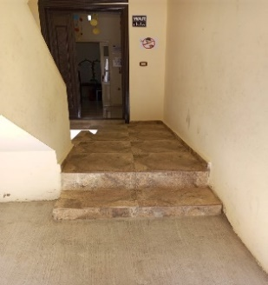 | 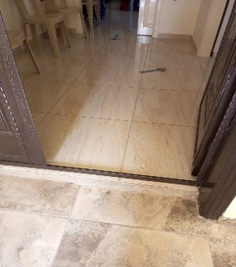
Annexe 26: the entrance of the center | Annexe 27 : a step edge in the entrance
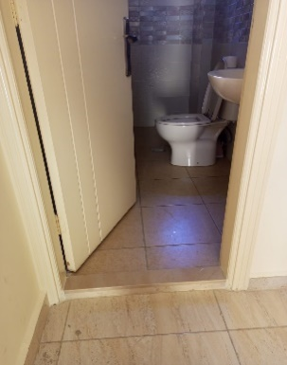 | 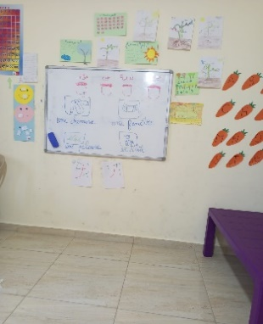
Annexe 28: the entry to the toilet | Annexe 29: the board of the class

Ribat
Mankoubin
1. Change handles.
2. Fix stairs and add a handrail.
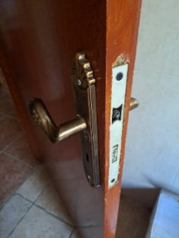 | 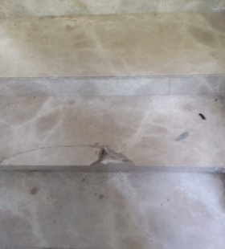 | 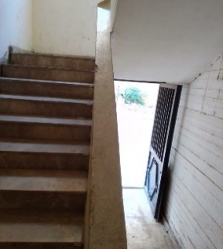
Annexe 30: handle needs to be fixed | Annexe 31 : Stairs need Concrete | Annexe 32 : stairs need handrail

Midan
Fouar
- Install three ramps for the entrance, playground, and therapy room.
- Remove two step edges.
- Lower the washbasin.
- Install an iron ramp for the toilets.
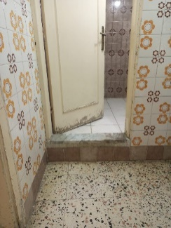 | 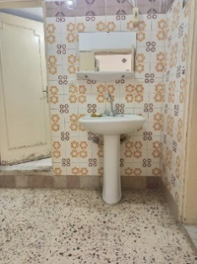
Annexe 33: entrance of the toilets | Annexe 34: washbasin is high for the ece children
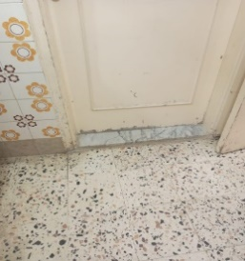 | 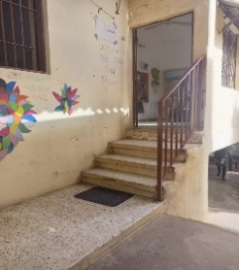
Annexe 35: step edge | Annexe 36: the entrance of the center
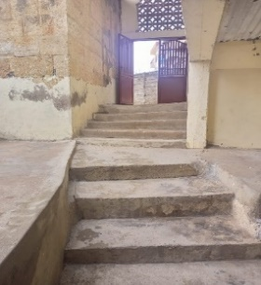 | 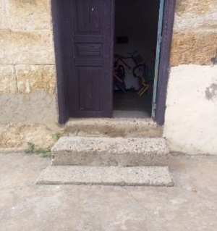
Annexe 37 : stairs to reach the playground | Annexe 38 : entrance for the therapy room

Cross Art Haddadin
- Install fixed board in classes (2).
- White Polish for all the rooms of centers (5 rooms) + entrance+next to the toilet
- Blue polish for the playground
- White polish for the wooden balcony door
- Maintenance for Kitchen sink

