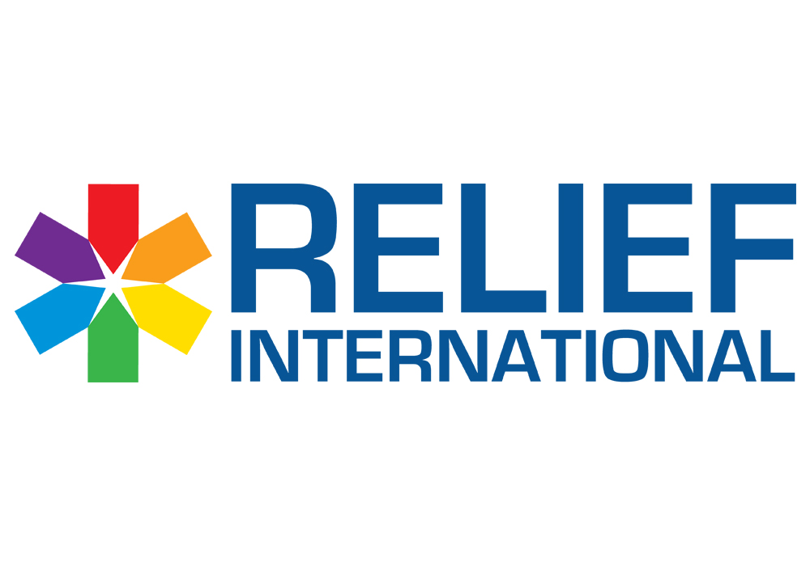

Call for Proposal – Water Gallons for RI offices and Educational Centres
RELIEF INTERNATIONAL (Non-Governmental Organization) intends to sign a Frame Work Agreement for 2 years to distribute Water Gallon for RI Offices and educational centres in Beirut, North and Bekaa.

Please note the below:
- The deadline for submission of bids is May 15, 2024, at 4:00 PM.
- You are kindly requested to submit the quotation in USD currency.
- You are requested to submit: Financial Proposal
- Proposals/Bids are to be submitted in a sealed envelope only to one of the below locations:
- Beirut office: Sin El Fil, Jisr El Bacha, St. Elie Church Street, Bacha Garden Centre, 4th floor.
- Zahle office: Zahle, main road, Al Mousawi building, 1st floor.
- North Office: Barsa El Koura, Facing Sammour for Wood, Antoun Abdo Building.

A valid bid should contain the documents below:
- Financial Proposal should include the below:
- RFQ form below should be filled signed and stamped:
- Terms and conditions should be signed and stamped:
- A copy of your legal documents (MOF registration, VAT registration, Commercial Circular…)

