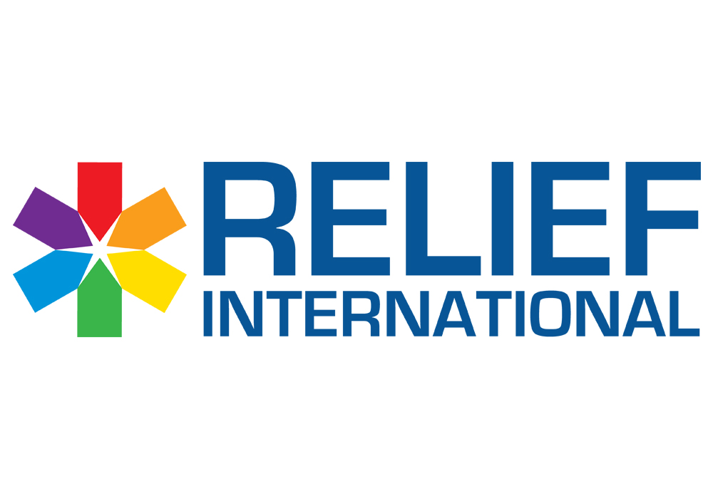

**Call for Proposal – Basic Assistant Items**

RELIEF INTERNATIONAL (Non-Governmental Organization) intends to purchase Basic Assistant items for displaced people in Aakar schools / Shelters

Please note the below:

* The deadline for submission of bids is Oct 9, 2024, at 2:00 PM.
* You are kindly requested to submit the quotation in **USD currency**.
* **Proposals/Bids are to be submitted by email to: ghassan.malkoun@ri.org (copying: joy.francis@ri.org).**

A valid bid should contain the documents below:

* RFQ form below should be filled signed and stamped:



* Terms and conditions should be signed and stamped:



* A copy of your legal documents (MOF registration, VAT registration, Commercial Circular…)

​

**\*\*\*For the supplier who will win the tender:** Please be informed that while the Purchase Order will be signed, we need to receive the items within maximum 3 Days.