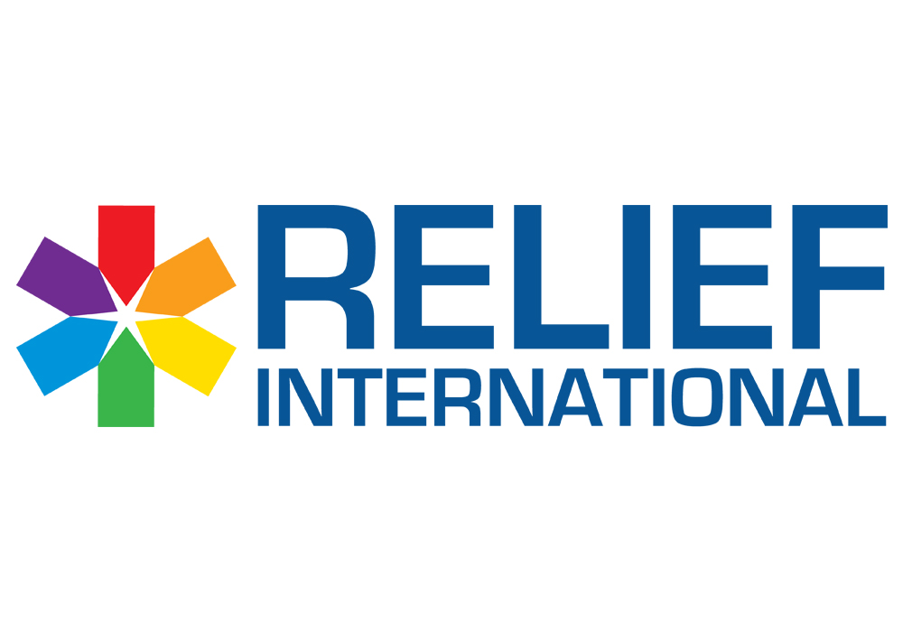

Call for Proposal – Animal Feed and Livestock farmer’s Tools
RELIEF INTERNATIONAL (Non-Governmental Organization) intends to purchase Animal Feed and Livestock Farmer’s Tools

Please note the below:
- The deadline for submission of bids is May 29, 2024, at 4:00 PM.
- You are kindly requested to submit the quotation in USD currency.
- You are requested to submit: Financial Proposal
- You are requested to submit Picture for Each farmer’s tools mentioned in the RFQ.
- You are requested to submit the mixed formula sheet for the animal feed signed and stamped.
- Proposals/Bids are to be submitted in a sealed envelope only to one of the below locations:
- Beirut office: Sin El Fil, Jisr El Bacha, St. Elie Church Street, Bacha Garden Centre, 4th floor.
- Zahle office: Zahle, main road, Al Mousawi building, 1st floor.
- North Office: Barsa El Koura, Facing Sammour for Wood, Antoun Abdo Building.

A valid bid should contain the documents below:
- Financial Proposal should include the below:
- RFQ form below should be filled signed and stamped:
- Terms and conditions should be signed and stamped:

- Mixed Formula sheet form below should be signed and stamped:

- A picture for Each farmer’s tools mentioned in the RFQ.

- A copy of your legal documents (MOF registration, VAT registration, Commercial Circular…)

​
***For the supplier who will win the tender: Please be informed that while they are filling the mixture, one of the RI staff will be monitoring and checking to ensure the supplier is putting the same amount in every ton of animal feed that will be distributed.

