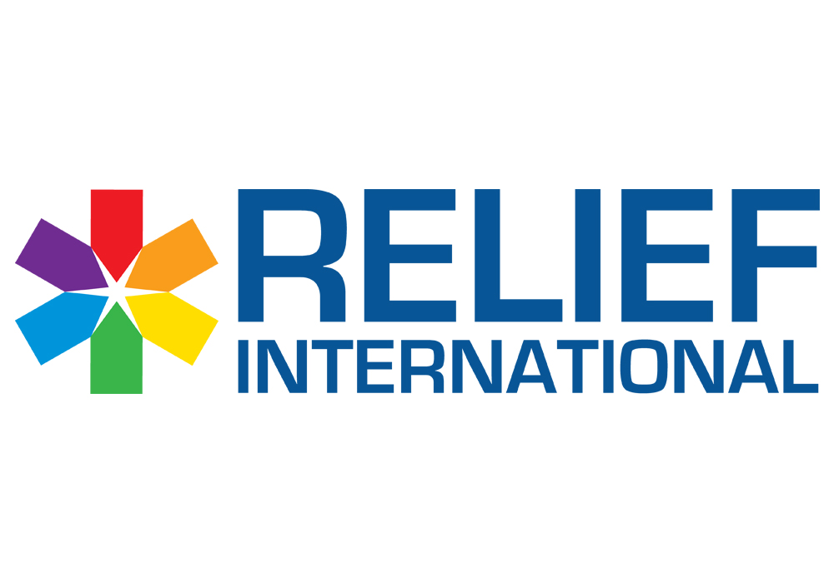

**Call for Proposal – MH technical advisor**

**LEB-BEI-OPS-PROC-2024-0056**

"RI - Lebanon office" intends to sign a framework agreement with a selected psychotherapist to provide “Mental Health Technical Advisory services”, as per the Scope of Work and Requirements.

Please note the below:

* The deadline for submission of bids is Wednesday March 13, 2024, at 4:00 PM.
* You are kindly requested to submit the quotation in **USD currency**.
* Proposals/Bids are to be submitted only **by hand** in **sealed envelopes** in one of the following addresses:

1. **Sin El Fil, Jisr El Bacha, St. Elie Church street, Bacha Garden center, 4th floor**
2. **Barsa El Koura, Antoun Aabdo Building , First floor**
3. **Zahle-Al Maalaa Highway, Al Moussawi building , Second Floor.**

* The only information on the envelope should be the following:

*Title: MH Technical Advisor*

*Relief International Lebanon Office*

*Bid Reference: LEB-BEI-OPS-PROC-2024-0056*

**A valid bid should contain the documents below (double click on each logo to open the document):**

1. RFQ form below should be filled signed and stamped:



1. Terms and conditions should be signed and stamped:



1. Signed Copy of the Below Scope of Work:



1. Technical proposal, and copy of the needed certificates as mentioned in the SOW.
2. A copy of your legal documents MOF registration, VAT registration (if applicable), Commercial Circulair, Articles of Association, etc…).

If you’re not registered in the MOF, please mention it in the RFQ form. And if selected 8.5% fees will be deducted.

**Note:**

1. Any bid missing one of the first four essential requests/documensts will not be considered valid.
2. RI Payment terms are via: Wire transfer if you have Bank of Beirut accounts or Fresh USD checks (with 7/1000 fees to be deducted by the bank)