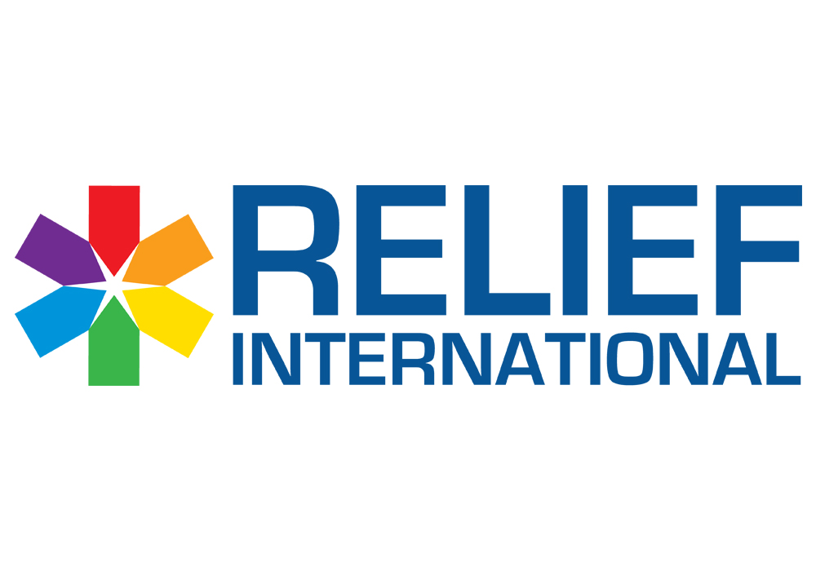

**Call for Proposal– Infection Prevention and Control (IPC)**

"RI - Lebanon office" intends to sign a contract with a selected firm/service provider to provide "Infection Prevention and Control (IPC)", as per the attached Scope of Work and Requirements.

Please note the below:

* The deadline for submission of bids is Monday, March 7, 2023, COB.
* You are kindly requested to submit the quotation in **USD currency**.
* Please note that VAT (if applicable) will be paid in USD (calculated on the official rate and then divided by the OMT sayrafa rate)
* All your questions should be sent via email to wael.chalak@ri.org and will be answered within 24 hours.
* Proposals/Bids are to be submitted by email.

**A valid bid should contain the documents below (double click on each logo to open the document):**

1. RFQ form below should be filled signed and stamped:



1. Terms and conditions should be signed and stamped:



1. Signed Copy of the Below Scope of Work:



1. A technical offer based on the requirement listed in the Scope of Work.
2. A copy of your legal documents (MOF registration, VAT registration, Commercial Circulair…)

**Note:** Any bid missing one of the five essential requests/documents will not be considered valid.