Annex F: RI BID FORM
Invitation To Bid No: LEB-BEI-OPS-PROC-2023-0105
Each page should be signed and stamped

S.No | Description of Goods / Services  (add attachment for technical specification if very detailed) | Unit / Form | Estimated Quantity required per year | Currency | Unit Price (excluding VAT) | Unit Price  (Including VAT if applicable)
1 | Newborn Kit containing each (provide samples):  • 1 pack of diapers for children between 3-6 months (pack of  32) :3-5KGS  • 1 box of sterile gauze (box of 50)  • 1 baby towel size small: 100% cotton grey or white colour  • 1 baby bath sponge soft  • 1 baby shampoo 400ml: not irritating(tear-free) and doesn’t  have parabens and phthalates/sulphates/fragrance and alcohol  free specific for children between 3-6months (recyclable bottle)  • 1 body shower gel 500 ml: for children between 3-6 months  doesn’t have parabens and phthalates/sulphates/fragrance and  alcohol free (recyclable bottle)  • 1 new born bag grey colour with embroidery/printing:  RI/USAID logo for packaging | Kit | 130 | USD | Fill Here | Fill Here
2 | PNC baby kit containing each (provide samples):  • 1 pack of diapers for children between 3-6 months (pack of 48)  from 3-5 kgs  • 1 piece of portable diaper changing pad: without pillow with  strap and water resistant (easy to clean)  • 1 piece of baby shampoo 400ml: not irritating(tear-free) and  doesn’t have parabens and phthalates/sulphates/fragrance and  alcohol free specific for children between 3-6months (recyclable bottle)  • 1 baby wipes (pack of 64 sheets): free of lotions, fragrances,  parabens, alcohol, dyes, and chlorine for children between 3-6  months  • 2 baby towel size small :100% cotton white colour  • 1baby overall: 100% cotton for children between 3-6 months  white colour  • 1 new born bag grey colour with embroidery /printing:  RI/USAID logo for packaging | Kit | 100 | USD | Fill Here | Fill Here
3 | PNC mother kit containing each (provide samples):  • 6 menstrual hygiene pads packs (each pack contains 10 pads):  pads need to be long thick with wings-anti leakage for heavy  flow and cotton  • 1 piece of shampoo 1 L for adult women: for all hair types (recyclable bottle)  • 1 medium towel for adults :100% cotton white coloured  • 2 small white towels for adults: 100% cotton white colour  • 1 fabric bag with zipper embroidery/printing: RI/USAID logo  for packaging of PNC mother kit light yellow colour | Kit | 100 | USD | Fill Here | Fill Here
4 | Female Health promotion kit containing each (provide samples):  • 6 menstrual hygiene pads packs (each pack contains 10 pads):  pads need to be long thick with wings-anti leakage for heavy  flow and cotton  • 2 small towels for women :100% cotton pink colour  • 5 soap bars for adult females  • 1 body shower gel 1Litre for adult females (recyclable bottle)  • 1 toothbrush for adult females (recyclable)  • 1 toothpaste 120ml for adults (recyclable)  • 1 shampoo 1litre for adult females for all hair types (recyclable bottle)  • 1 deodorant 200ml for adult females (Aluminium free)  • 1 fabric mask for adults  • 1 fabric bag with zipper: coloured light creamy pink  embroidery/printing: RI/USAID logo for packaging | Kit | 1,620 | USD | Fill Here | Fill Here
5 | Male Health Promotion Kit containing each (provide samples):  • 1 toothbrush for adult males (recyclable)  • 1 toothpaste 120ml for adults (recyclable)  • 1 shaving gel 100G (recyclable bottle)  • 1 shaving gel brush (recyclable)  • 5 soap bars for adult males  • 1 body shower gel 1Litre for adult males (recyclable bottle)  • 1 shampoo 1litre for adult males for all hair types (recyclable bottle)  • 1 plastic comb for adult males (recyclable)  • 1 deodorant 200ml for adult males’ aluminium free  • 1 fabric mask for adults,  • 1 fabric bag with zipper coloured blue embroidered RI/USAID  logo packaging | Kit | 300 | USD | Fill Here | Fill Here
6 | Child Health Promotion Kit containing each (provide samples):  • 1 toothbrush for children: soft (age >12 years, head 25mm)  coloured Green (recyclable)  • 1 toothpaste :(for children age >12 years-for personal  hygiene,75ML) (recyclable)  • 1 piece of body shower gel 500ml not irritating for children  age >12 years (recyclable)  • 1 shampoo 400 ml for children age >12 years not irritating for  all hair types (recyclable bottle)  • 1 exfoliating body loofah  • 1 plastic lice comb for children (recyclable)  • 2 small towel 100% cotton for children age >12 years white  colour  • 1 medium sized towel 100% cotton for children age > 12  years old white colour  • 1 fabric mask for paediatric (children age >12 years)  • 1 fabric bag with zipper l embroidery/printing: RI/USAID logo  for packaging light grey colour | Kit | 500 | USD | Fill Here | Fill Here
7 | Delivery fees to Beirut Warehouse (Including casual workers to dispatch the kits) | Trip | 15 | USD | Fill Here | Fill Here
8 | Delivery fees to North Warehouse (Including casual workers to dispatch the kits) | Trip | 5 | USD | Fill Here | Fill Here
9 | Delivery fees to Bekaa Warehouse (Including casual workers to dispatch the kits) | Trip | 5 | USD | Fill Here | Fill Here

Packaging Instruction:

- Fabric Bags Picture
(please refer to the requested colors in the annex F): 2) Newborn Bags Picture:
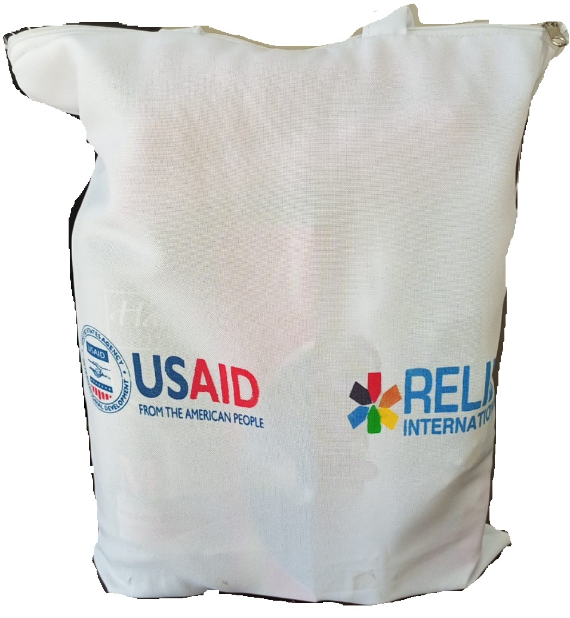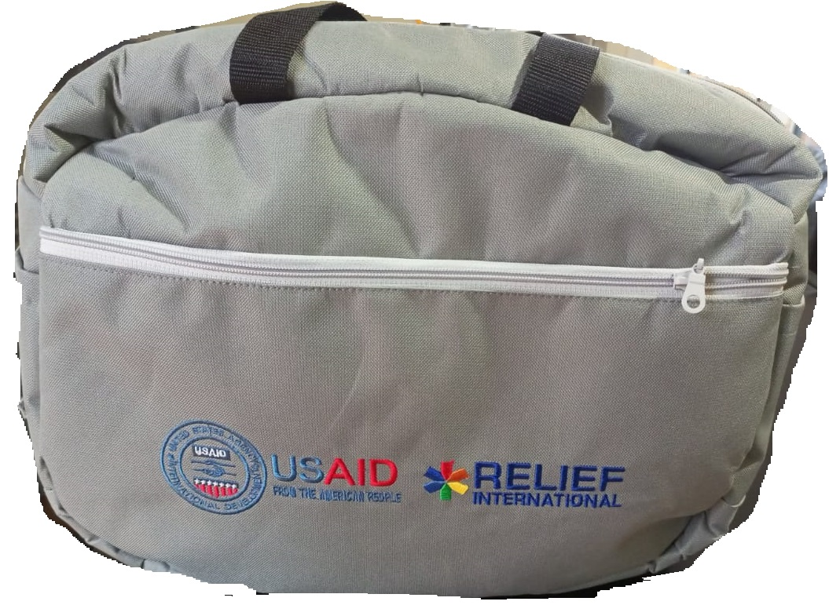

Note:
- Fabric Bags:
Proposed size: 35 cm x 45 cm, the size could be changed from your side if you consider this size is not enough or if you might think it’s too big for the items. You can change the sizes to be higher or lower based on your estimation but on your full responsibility regarding the delivery (no kits will be received without full quantity fitted properly in each bag).
Handle and fabric should be of a high quality.
- New born Bags:
Proposed size: 40 cm x 30 cm x 15 cm, the size could be changed from your side if you consider this size is not enough or if you might think it’s too big for the items. You can change the sizes to be higher or lower based on your estimation but on your full responsibility regarding the delivery (no kits will be received without full quantity fitted properly in each bag).
Handle and fabric should be of a high quality.

Samples Instructions:

- Technical Evaluation will be done based on the samples provided (Bidders do not move to the financial evaluation if their samples are not technically accepted).
- Only 1 sample is requested for each kit.
- Samples should be tagged with a sticker or paper as per the description provided from RI.
- Bags could be sent without logos (they will only be assessed based on the quality at the first stage)
- All samples will be returned back once the process will be finalized.

Required Delivery Date: starting May 1, 2023. Offered Delivery Date: ________________

Required Delivery Destination: Beirut Warehouse mainly
(North and Bekaa warehouse upon need) Offered Delivery Destination: ________________

This Bid is valid for: ___90___ days

Currency of Bid: USD.
Payment terms: USD invoice and wire transfer (national and/or international)

Question | Answers | Comment
Prices can be fixed for a period of 24 months? | Yes/No
What is your estimated delivery time after Purchase Order issuance? (How many working days until you complete the order)

List all professional licenses and certificates your company holds (if applicable):
Please attach copies of these with your submission.
___________________________________________
___________________________________________
___________________________________________
___________________________________________

