# Annex 1: Technical Specification/Technical Offer form

**Child MUAC Tape**

# General Description:

Children's Mid Upper Arm Circumference (MUAC) measuring tape with cut-off point at 11.5 cm, pack of 50 tapes with text and pictorial instructions for use.

# Technical Specifications:

MUAC measuring tape is suitable for measuring child's Middle Upper Arm Circumference (MUAC)with range up to 26.5 cm.

Graduated with 1 mm precision with thicker line at 21.0 cm. Accuracy: ± 1 mm of the maximum measurement (26.5 cm)

# Front side:

Color-coded as follows:

Red (Pantone code 1795 C): from 0 to 11.5 cm, Yellow (Pantone code 107 C) from 11.5 to 12.5 cm, Green (Pantone code 369 C) from 12.5 to 26.5 cm.

# Reverse side:

Includes instructions and diagrammatic drawings. The written instructions may be requested to be in Arabic, Spanish, French or English. The drawings represent 5 steps in taking the MUAC measurement either the ‘string’ method of measuring the mid-point, or the ‘tape’ method.

# String method for finding the mid-point of the arm:

*Drawing 3: Bend the arm so it is at a right angle, and place the string on the tip of the shoulder, to the elbow.*

*Drawing 4: Fold the string over in half to find the middle of the arm Drawing 5: Mark the middle of the arm with a pen*

*Drawing 6: Straighten the arm, insert the tape at the mid-point and measure the MUAC Drawing 7: Make sure the tape is not too tight*

*Drawing 8: Make sure the tape is not too loose*

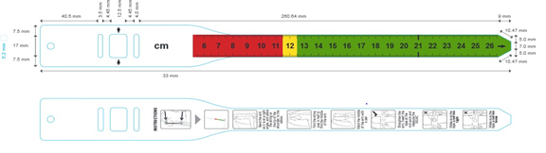

# Tape Method of finding Mid-point of the arm:

*Drawing 2: Bend the left arm to a right angle, put wide end of the tape to shoulder, measure the length to the elbow*

*Drawing 3: Calculate the midpoint of the child’s left upper arm, mark with a pen*

*Drawing 4: Straighten the child’s arm, insert the tape at the mid-point and measure the MUAC (include a cross mark* ✘)

*Drawing 5: Make sure the tape is not too tight (include a tick mark* ✔)

*Drawing 6: Make sure the tape is not too loose (include a cross mark* ✘)

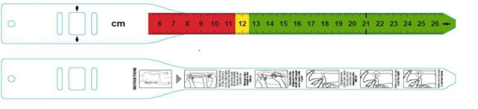

# Material:

Non-tear stretch-resistant material e.g., plasticized / synthetic paper using polypropylene, or polyethylene. (Supplier must specify which of these materials is offered).

Minimum thickness 0.3mm.

**Working temperature** range 0 - 50 °C.

# Storage conditions:

Minimum acceptable range 0 – 50 °C

**Checking the MUAC sample:**

* The MUAC tape should be made from synthetic paper/ paper coated in plastic that is resistant to tearing, stretching and cleaning with alcohol-based hand sanitizer.
* Check measurements with a calibrated ruler, starting at the arrows and continuing to the end of the tape. All the mm and cm markings must be precise, accurate and clearly legible.
* The tape must not be able to be stretched, this is tested by pulling the tape firmly and seeing if the tape matches the ruler used to check the mm and cm after you have attempted to stretch it.
* The tape must not tear or rip. This is tested by attempting to tear the tape with your hands.

To test that the ink does not rub off with cleaning, use hand sanitizer on the tape to check if there are any changes to the print

**Adult MUAC Tape**

# General Description:

Adults' Mid Upper Arm Circumference (MUAC) measuring tape with a range of up to 56cm. Pack of 50 tapes with pictorial and text instructions for use printed on underside.

# Technical Specifications:

MUAC measuring tape

Suitable for measuring adult's Middle Upper Arm Circumference (MUAC, range to 56 cm). Graduated with 1 mm precision

Accuracy: ± 1 mm of the maximum measurement (50 cm)

# Material:

Non-tear stretch-resistant material e.g., plasticized / synthetic paper using polypropylene, or polyethylene. (Supplier must specify which of these materials is offered). Minimum thickness 0.3mm.

# Front side:

Black print on white tape.

# Reverse side:

Includes instructions and diagrammatic drawings. The written instructions may be requested to be in Arabic, Spanish, French or English. The drawings represent 5 steps in taking the MUAC measurement, using the ‘string method’ or the ‘tape method’ for finding the midpoint:

# String method for finding the midpoint:

Drawing 3: *Bend the arm so it is at a right angle and place the string on the tip of the shoulder, to the elbow.*

Drawing 4: *Fold the string over in half to find the middle of the arm*

Drawing 5: *Mark the middle of the arm with a pen*

Drawing 6: *Straighten the arm, insert the tape at the mid-point and measure the MUAC*

Drawing 7: *Make sure the tape is not too tight*

Drawing 8: *Make sure the tape is not too loose*

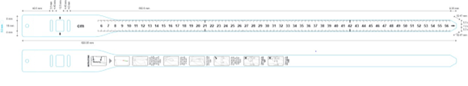

*Drawing 2: Bend the left arm to a right angle, put wide end of the tape to shoulder, measure the length to the elbow*

*Drawing 3: Calculate the midpoint of the left upper arm, mark with a pen*

*Drawing 4: Straighten the arm, insert the tape at the mid-point and measure the MUAC Drawing 5: Make sure the tape is not too tight*

*Drawing 6: Make sure the tape is not too loose*

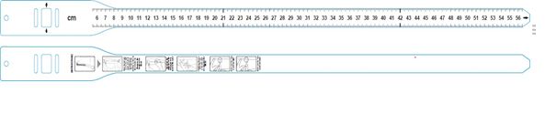

# Storage conditions:

Minimum acceptable range 0 – 50 °C

# Context in which item is mainly used:

Recommended for rapid screening of pregnant/lactating women.

Good for nutrition emergencies when illiterate field workers are used for screening.

# Target:

Pregnant/lactating women.

## Checking the MUAC sample:

* The MUAC tape should be made from synthetic paper/ paper coated in plastic that is resistant to tearing, stretching and cleaning with alcohol-based hand sanitizer.
* Check measurements with a calibrated ruler, starting at the arrows and continuing to the end of the tape. All the mm and cm markings must be precise, accurate and clearly legible.
* The tape must not be able to be stretched, this is tested by pulling the tape firmly and seeing if the tape matches the ruler used to check the mm and cm after you have attempted to stretch it.
* The tape must not tear or rip. This is tested by attempting to tear the tape with your hands.
* To test that the ink does not rub off with cleaning, use hand sanitizer on the tape to check if there are any changes to the print.

**Delivery place…………………………………………………………………….**

**Delivery Date……………………………………………………………………..**

**Payment…………………………………………………………………………….**

**Offer validity…………………………………………………………….**

**Warranty……………………………………………………………………………..**

**Name of Person Signing: ……………………………………………………………**

**Position in the Company: ………………………………………………………………**

**Company name: ………………………………………………………………………………………**

**Signed………………………………. Date…………………………...Stamp ……………………………**