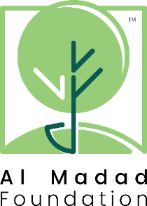

Art Grant (2019)
Reporting Requirements

Introduction
Reporting and analysis is an important part of any project. Effective practices allow organisations to improve the work that they do and help us, as the grant-giver, to discern whether or not our expectations have been met.

Al Madad Foundation aim to demonstrate how the projects we fund fit within the jigsaw of need in a particular geographic area or educational theme.

We will favour organisations that can commit to providing regularly scheduled updates which will be agreed upon during the application process and will subsequently become a requirement of the grant. If it is determined that this requirement is not being met and/or there is evidence that the grant is not being used for the purposes for which it was originally given or is not being used effectively, AMF reserve the right to discontinue funding.

Reporting Framework
This will be tailored to each project but might typically include information such as:
- Number of recipients/service users
- Number of hours of art or art education conducted
- Details of recipients’/service users’ academic progress
- Number of recipients/service users who have achieved the aim of the project (e.g. entry or re-entry into formal school)
- A longer-term measure of recipients’/service users’ achievements following the end of their time in the project

Please be aware that AMF use information gained through the projects we support for analytic and research purposes. Any public communication by AMF or the grantee relating to the project (e.g. results, analysis or comment) must be agreed by all parties before release.

Acknowledgement Requirements
Grant recipients will be asked to acknowledge AMF support for the project on any related print and promotional materials.

