**Tender FEB-18-003**

**Instruction to tender and BOQ**

**1 year service contract with Media Agency or Registered Individual Designers/videographers**

**Nature of Assignment:** Visibility and Communications – Lebanon Branch of Concern Worldwide

**Services Requested:**

* Production of longitudinal video covering various project activities funded by different donors respecting donor guidelines.
* Designing and Printing services; pamphlets, manuals, roll-ups, t-shirts, coffee mugs, caps, jackets
* Advertisement, press release and blog writing in both English and Arabic - in regional and national newspaper (print media and online) as per request.

**Duration of Contract: 1 year - tentatively starting from Feb 25, 2018 – Feb 24, 2019**

**1.** **Background**

Concern Worldwide is an Ireland based international humanitarian organisation dedicated to tackling poverty and suffering in the world’s poorest countries and countries with refugee crisis. In collaboration with our generous donors like WHH/BMZ, The Big Heart Foundation (TBHF), Addressing Root Cause (ARC) Fund, Echo and IMPACT, Concern Worldwide has been implementing various activities to improve livelihoods of host and refugee communities in Lebanon. Based out of Halba, Concern Worldwide’s office operates to strengthen construction, agriculture and green job sectors to create inclusive and decent income opportunities.

This request for quotation is to invite registered media houses, printing presses and/or individuals designers, videographers and writers to produce videos, promotional videos, printed materials and distribute communication material to local media on Concern Worldwide Lebanon’s livelihoods programmes and other programs in order to demonstrate how donors’ funds have been spent and to raise awareness of Concern’s livelihoods programmes and other programs in Akkar and Tripoli/T-5.

# **2.** **Requirements**

Concern is looking for a registered media agency or printing house preferably based out of Tripoli or individual expert(s) to provide various services and supplies aimed at visibility of Concern activities in line with donor communication guidelines.

* Media/Printing company or an individual consultant(s) must be registered or tax paying with excellent aesthetic sense and editing skills.
* Must have access to all designing and printing related software and resources.
* Excellent capacity to read, translate and write in three languages; English, Arabic and French.
* Capacity for background voice recordings, voice overs and inserting captions in videos and clips.
* Ability and willingness to visit various Concern Livelihoods program project sites.
* Capacity to understand Concern communication and visibility guidelines along with any donor specific policy that may be communicated from time to time.
* Ability to maintain record, data and correct logos on file for linear project management.
* Must provide the prices of all kinds of printings (CMYK, RGB, B&W)
* Describing all the products and materials to achieve a better quality
* Review job orders to determine quantities to be printed, paper specifications, colours, and special printing instructions

**3. Work Scope:**

Services and supplies that could be requested over the year are listed below.

1. **Digital Printing and Design Services:**

In Concern’s livelihoods projects, Concern and different donors are visible in the field by printed material carrying the respective organisational logos and project titles. High quality material such as signs, posters, staff t-shirts and gilets clearly communicates Concern and donors’ presence during the projects and identifies them to project participants and communities.

**Service provider(s) must have following capacities;**

* Designing and printing knowledge dissemination material i.e. pamphlets of various sizes from minimum of 3 folds to maximum 10 pages booklet, manuals of standard size minimum 30 pages to maximum of 400 pages.
* Designing and printing of visibility materials and certificates i.e
* **Roll-ups**
* **Background banners**
* **Advertisement design and printing for various advocacy campaigns on bill boards**
* **Shoulder canvas bags**
* **Calendars**
* **Graduation and Training participation certificates**
* **Invitation cards**
* **T-shirts**
* **Polo necks**
* **Winter Jackets**
* **Caps**
* **Sleeveless vests**
* **Cups**
* **Shields**
* **USBs**
* **Note pads and diaries**
* **Business visiting cards**

1. **Advertisement; Social Media circulation, e-advertising and Search Engine Optimization:**

Concern is seeking to reach the largest audience possible with its communications products on livelihoods projects and other projects. This allows Concern to demonstrate its projects and activities and to recognize the donors who support the projects. Media distribution will contribute to wide-reaching communication by ensuring key communication products are disseminated in local (Akkar/T5) and national media. This approach coincides with Concern’s accountability commitments, ensuring the communities we work in are informed of our work.

- **Service provider(s) must have capacity to arrange for;**

* Bill board advertisement in Halba and Tripoli for the specific advocacy campaigns on international days.
* Posting and sharing the projects on social media (Fb, Instagram) with basic SEO.
* Publication of press releases and advertisements in national and regional newspapers print media and online upon request.

**3. Videography and Photography service for Concern projects:**

Case studies and images bring our work to life for our donors. As such, we need testimonies, anecdotes and facts about the situation – things that can help to link donors directly to our beneficiaries. To see and hear someone telling their story themselves connects our donors to the people that they are supporting. By sharing a case study of a person, family or child, our supporters have a unique insight into our beneficiaries’ lives.

Images are a powerful medium to really bring to life the elements of the programme and to show supporters in more detail what life is like for the programme participants.

- Service provider(s) must have experience in filming with DSLR or small size HD film camera with;

* Strong aesthetic sense, experience in planning the video to optimize visibility and create a storyline with Strong photojournalistic images that help tell the story and provide context.
* Ability to film in challenging and culturally sensitive settings in terms of gender, nationality, ethnicity and religion.
* Capacity to design interviews and obtain beneficiary testimonials to bring out positive impact of the project on beneficiaries in dignified way.
* Capacity for voice over in the videos, background voice and background basic sound effects.
* Ability to insert captions in English, Arabic and/or French.

**4.** **Timeframe**

Contract will be awarded for a period of one year. Key Deliverable will be

|  |  |  |  |  |
| --- | --- | --- | --- | --- |
| **Start** | **End** | **Activity** | **Final Product** | **Expected Delivery of final product** |
| February | February | * Briefing on Livelihoods Project and exposure visit of the project sites to plan videos and appropriate visibility. * Submission of Work plan * Finalizing story line and requirements for the videos * Reviewing Concern produced existing videos to understand style, colour schemes, captioning etc. | Work plans for;   * Filming of video * Suggestion for visibility in videos * Interview guides * Storyline * Props, if any | February, 2018 |
| March | August 2018  Oct, 2018 | * Filming of videos throughout the project. * Minimum 2 monthly visits for recording and photography * Testimonial of Concern Staff | * 3 videos * Longer version; 7-10 minutes long * Shorter versions 2-3 minutes long | 2 videos - Sept, 2018  1 video – Nov, 2018 |
| March 2018 | Feb 2019 | * Case studies * Testimonials * Press release and E-publishing | * 4 case studies * 20 testimonials * 2 press releases * 2 blogs | TBD |
| March | March | * Printing of T-shirts * Printing of Jackets * Printing of Vests | * T-shirts: 30 different sizes and designs * Jackets: 30 * Vests: 30 * Caps: 30 * Shoulder bags 10 * USB 4 GB: 10 * Certificates: 300 | March 2018 |
| April 2017 | August 2017 | * Printing of manuals, notebooks and pamphlets | To be decided | To be decided |

**5. General** **Notes:**

**Interviews**

Syrians have experienced an extremely violent civil war. Many have witnessed unbelievable atrocities and lost friends and family members. As such, it is critical that we at Concern do not put anyone unknowingly at risk. An increased focus should be put on positive stories, highlighting not only how Concern has helped, but also the resilience of local communities. At the same time, honesty is needed in showing remaining challenges which impede reaching results despite efforts and availability of funding. Interview questions must ensure that the dignity of interviewees is guaranteed and that the sensitivity of the context is considered to prevent inflicting harm on people interviewed and videoed.

**Images**

**In all cases** visual content must comply with Concern’s communication guidelines and have the **subject’s informed permission**. Care should be taken to ensure that images do not enable the identification of exact locations (i.e. don’t include signs or landmarks). Likewise, images should not include any political markings or organisational logos in the background.

**5. How to apply:**

**Please submit following for the administrative screening;**

* **For media and printing company/publishing houses:**
* **Company profile with Registration Certificate, bank details (**if not registered 7% VAT will be deducted from the payment)
* **last 3 year experience and**
* **List of physical assets or machines.**
* **CV of minimum 2 technical staff; one for designer and one for translator**
* **Number of technical permanent staff for designing, printing and delivery**.
* **For individual designers/experts applying for the RFQ:**
* Portfolio with bank details (if not registered 7% VAT will be deducted from the payment).
* Last 3 years’ experience,
* 2 client references
* sample of previous work along
* **List of software used/any published work:** any example of online work will be appreciated.
* **List of affiliated media networks and news agencies if applying in Lot 3:** Offeror willing to circulate press releases, knowledge material must also list affiliated media networks and news agencies.
* **Financial offer:** Financial offer must be submitted on prescribed templates. Request for quotation has been divided in different lots. Offeror can choose to apply in one or multiple lots.
* **Submission of samples;** Any 5 samples of printed cards, pamphlets, reports, certificates for quality evaluation.

**5. Evaluation Criteria:**

* **Concern is looking for a provider which can provide maximum services divided in three lots for a reasonable price and high quality. Hence company offering maximum number of service may be selected. Concern can request a visit to facility or meeting with technical staff.**

**Technical Evaluation based on portfolio, samples, resources, staff and assets –** 45 marks

**Geographical location –** 5 marks

**Offeror has applied in 2 lots -** 10 marks

**Financial Evaluation –** 40 marks

**6. How to submit Quotation:**

**Sealed Quotes must reach; Concern Worldwide, HDYS Building (Opposite Abdel Karim Rifai Petrol Station), Halba, Akkar on or before 1200 Hrs, Feb 22, 2018**

**Quotes can be submitted by hand or by registered mail.**

For Clarifications and to request complete documents please contact email address: [lebanon.tenders@concern.net](mailto:lebanon.tenders@concern.net)

Email Title: **tender visibility and communication**

**Financial Proposal**

**LOT 1: Digital Printing and Design Services**

* **Quantities: Tentative and will be requested over the period of one year – actual quantities ordered may be above or below amounts than stated below.**
* **Bidder can add more items or services in this list with explanation in comment section.**

**Rates should be given in total for item, printing and designing.**

|  |  |  |  |  |  |
| --- | --- | --- | --- | --- | --- |
| **No.** | **Item / Services** | **Specification** | **Unit** | **Cost per unit** | **Comments** |
| 1. | Design | Designing of booklet/pamphlet etc. | 8 hours |  |  |
| 2. | Design | Designing of booklet / pamphlet etc. | 4 hours |  |  |
| 3. | Colour Printing | Pamphlet - A4 / semi matt / 2-3 folds / double sided | 100pcs |  | See Annex 1 – Item 1 for example  Weight: 110g |
| 4. | Colour Printing | Booklet – A5 /semi matt /10 pages total | 100pcs |  | See Annex 1 - Item 2 for example  Weight: 110g |
| 5. | Colour Printing | Booklet – A5 / semi matt – up to 100pages | 100pcs |  | See Annex 1 – Item2 for example Weight: 110g |
| 6. | Colour Printing | A4 / Semi matt / single pages | 100pcs |  | See Annex 1 – Item 3 for example Weight : 80g |
| 7. | Colour Printing | A4 /Semi matt / single pages | 100pcs |  | See Annex 1 – Item 3 for example  Weight : 110g |
| 8. | Colour Printing | A4 / Semi matt / single pages | 100pcs |  | See Annex 1 – Item 3 for example Weight : 150g |
| 9. | Colour Printing | A3 / Semi matt | 100pcs |  | See Annex 1 – Item 3 for example Weight: 110g |
| 10. | Colour Printing | A3 / Matt | 100pcs |  | See Annex 1 – Item 3 for example Weight: 110g |
| 11. | Colour Printing | A1 / Semi matt | 100pcs |  | See Annex 1 – Item 3 for example Weight: 110g |
| 12. | Colour Printing | A1 & A2 / RGB & CMYK Map prints | 50pcs |  | High quality detailed map printing with heavy detail PDF files |
| 13. | Binding | A4 – Ring binding | 1 pc |  | See Annex 1- Item 4 for example |
| 14. | Binding | A4 – Glue binding | 1 pc |  | See Annex 1 – Item 5 for example |
| 15. | Black and white Printing | A4 / Single pages / semi matt | 100pcs |  | Weight: 110g |
| 16. | Colour Printing | Roll up banner printing / RGB | Per sq meter |  | See Annex 1 – Item 6 for example  With stand |
| 17. | Colour printing | Roll-up banner printing | Per sq meter |  | See Annex 1 – Item 6 for example  Without stand |
| 18. | Colour Printing | Standard Banner | Per sq meter |  |  |
| 19. | Colour Printing – Business cards | Colour | 100pcs |  |  |
| 20. | Colour Printing | Colour / Panaflex | Per sq meter |  | For Billboards |
| 21. | Printing – Calendars | Table Calendar / Colour | 100pcs |  | See Annex 1 – item 7 for example  For office tables with photos from Concern project sites |
| 22. | T-shirts / Polo t-shirts | Green / Breathable / with embroidered Concern logo | 50pcs |  | Final design & logos will be provided  **Sample required** |
| 23. | Coffee Mugs | Ceramic / One picture & one Concern logo | 50pcs |  | Each mug must come in gift wrapping |
| 24. | USBs | 4GB | 50pcs |  | White colour casing & green Concern logo printed |
| 25. | Winter Jackets | Colour Black / Brown /water and wind resistant / warm with embroidered logo | 50 pcs |  | S / M / L sizes  With embroidered Concern logo  **Sample required** |
| 26. | Jumpers | Green / White | 100pcs |  | S / M / L sizes  With Concern logo  **Sample required** |
| 27. | Sleeveless Vest / Gillet |  | 100pcs |  | See Annex 1 – item 8 for example  S / M / L sizes  With Concern Logo  **Sample required** |
| 28. | Hat (winter / Wool) |  | 50pcs |  | With Concern logo  **Sample required** |
| 29. | Baseball caps |  | 50pcs |  | With Concern logo  **Sample required** |
| 30. | Pens |  | 100pcs |  | With Concern / Donor logo |
| 31. | A4 / C3 Pads |  | 100pcs |  | With Concern / Donor logo |
| 32. | Plaques |  | 100pcs |  | See Annex 1 – item 9 for example  Small/ wooden, glass or metal stands/ silver or transparent with 3 logos and project title |
| 33. | Adhesive Stickers | Transparent | 100pcs |  | Max Size: A4  Minimum size: Post it  With Concern / Donor logos |
| 34. | Visibility Board | White board with logos | 200PCS |  | Plexiglas 29.7 x 21cm  Logos provided by Concern |
| 35. | Lanyards / ID holders | Green with white Concern logo | 50pcs |  | See Annex 1 – item 10 for example  With necklace |
| 36. | A5 lined notebook | Green / White | 50pcs |  | With Concern/donor logo |
| 32. | Solid plastic water bottles | White / Green | 50pcs |  | See Annex 1 – item 11 for example  Personal reusable personal water bottles with Concern/donor Logo |
| 33. | Stencil | With Concern & Donor logo | 4 |  | 50 x 30cm  35 x 20 cm |
|  |  |  |  |  |  |
|  |  |  |  |  |  |

**Name of Bidder: __________________________________________________**

**Sign and Stamp of Bidder: __________________________________________**

**Date: ___________________________________________________________**

**Note: First three months will be probation period. In case of dissatisfaction, contract may be revoked**

**Financial Proposal**

**LOT 2: Advertisement; Social Media circulation, e-advertising and Search Engine Optimization:**

* **Quantities: Tentative and will be requested over the period of one year – actual quantities ordered may be above or below amounts than stated below.**
* **Offeror can add more items or services in this list with explanation in comment section.**
* **For detail on preferred newspaper please see next page**

|  |  |  |  |  |
| --- | --- | --- | --- | --- |
|  | **Services** | **Unit** | **Unit Cost** | **Comments by offeror/special offers/discount** |
| 1 | Advertisement; 4-5 lines, national newspaper (in print and online, if any) | Per advertisement |  | Please see list of newspapers below |
| 2 | Press Release: 200 words, with logos in Arabic national magazine / newspaper (in print and online, if any) | Per press release |  | Please see list of newspapers below |
| 3 | Press Release: 200 words, with logos in English national magazine / newspaper with logos | Per press release |  | Please see list of newspapers below |
| 4 | Online press release; minimum 10 different social media outlets with pictures, video or testimonials | Per press release |  | Please see list of newspapers below |
| 5 | Search Engine Optimization; for 2 weeks of specific online release of video | Per SEO |  |  |
| 6 | Publication on the online portals (any two of the listed portals) | Per publication |  | Please see list of online portals below |

List of preferred newspapers

|  |  |  |
| --- | --- | --- |
| Category | Name of news paper |  |
| In – English News agencies | * Al Akhbar * Lebanon Daily Star | Minimum 1 |
| Daily Newspapers | * Ad-Diyar * Al Akhbar * Al Amal * Al Anwar * Al-Balad * Al Binaa * Al Ittihad * Al Joumhouria * Al Liwaa * Al-Mustaqbal * An-Nahar * Al-Sahawat Times * El Shark | Separate cost for minimum 3 news papers. |
| Monthly Magazine (for blogs) | Lisan al Hal  Al-Intiqad (Beirut)  At-Tadamon (Tripoli)  Hamzat Wassel (Beirut, Tripoli) | Quotation for minimum one |
| Online news portals | * Alankabout * Iloubnan.info * Lebanese Examiner * Lebanon * Tayyar.org * Lebanon Debate * Lebanon Files * LibanVision * Lebanonwire * Naharnet * NOW Lebanon * Ya Libnan | Quotation for minimum 3 |

**Name of bidder: __________________________________________________**

**Sign and Stamp of bidder: __________________________________________**

**Date: ___________________________________________________________**

**Note: First three months will be probation period. In case of dissatisfaction, contract may be revoked.**

**Financial Proposal**

**LOT 3: Videography and Photography service for Concern projects**

|  |  |  |  |  |
| --- | --- | --- | --- | --- |
|  | **Activity** | **Specification (please also refer to work scope)** | **Unit** | **Total Cost** |
| **1** | Production of 3 videos as per specification in work scope. | * 4 field visits for each video * 6 testimonials for preparation of each video * Captions in English , Arabic and French * Story line for each video * One planning meeting for each video * Background voice over in Arabic and English. | Per video  7-10 minutes long  4-5 minutes long |  |
| **2** | Designing of cover page for manuals and aesthetic editing of manuals |  | Per manual |  |
| **3** | Photography of project activities | * 1 visit per month (upon request * Editing and delivery of 40 selected pictures per month within 1 weeks * 1 poster based on project picture. | Per month |  |

**Name of bidder: __________________________________________________**

**Sign and Stamp of bidder: __________________________________________**

**Date: ___________________________________________________________**

**Note: First three months will be probation period. In case of dissatisfaction, contract may be revoked.**

**ANNEX ONE**

**Item 1**

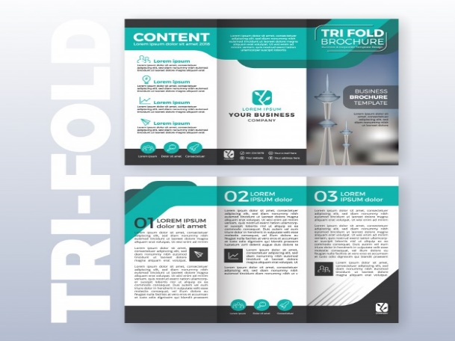

**ITEM 2**

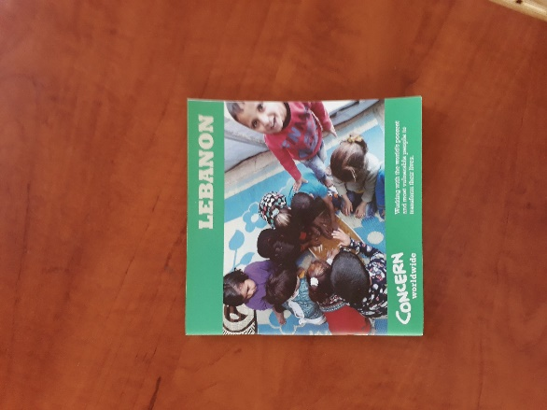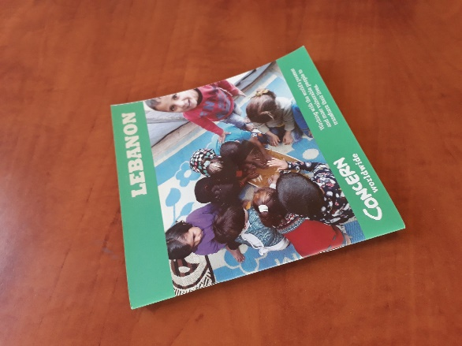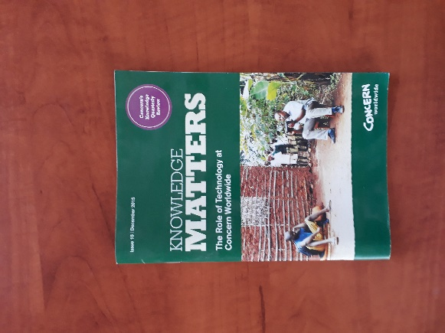

**ITEM 3**



**ITEM 4**



**ITEM 5**



**ITEM 6**

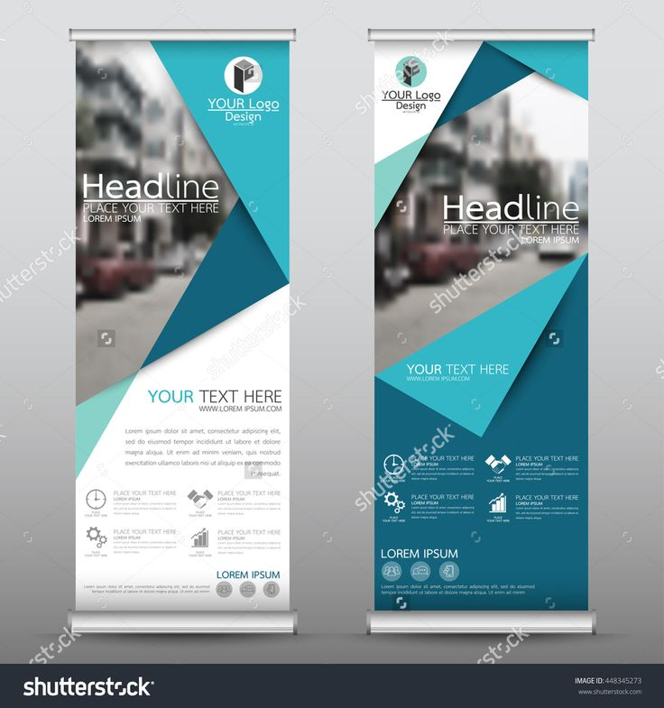

**ITEM 7**

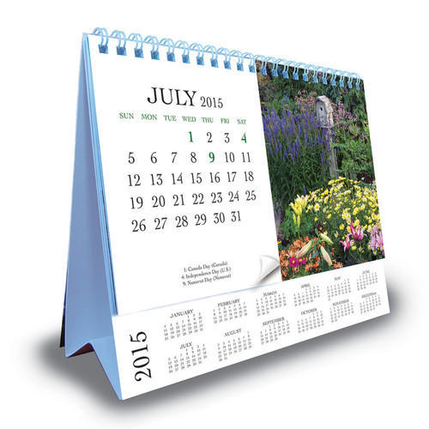

**ITEM 8**

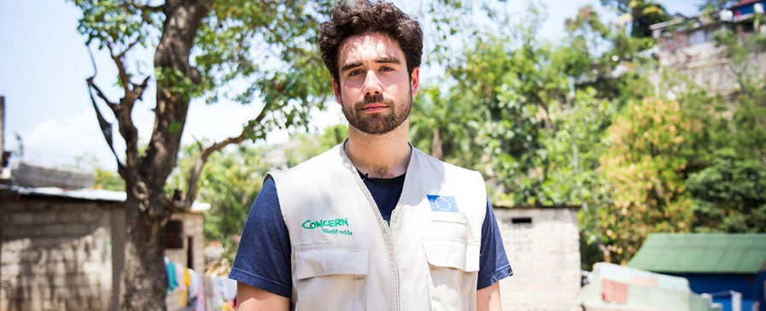

**ITEM 9**

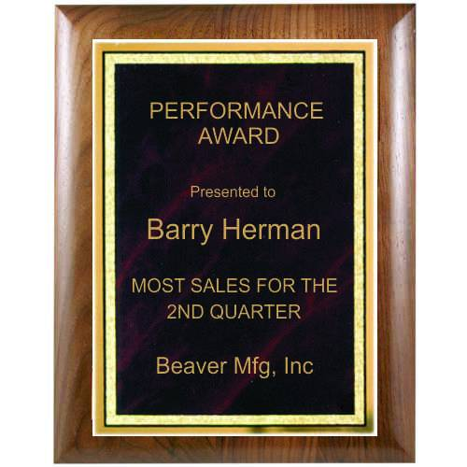

**ITEM 10**

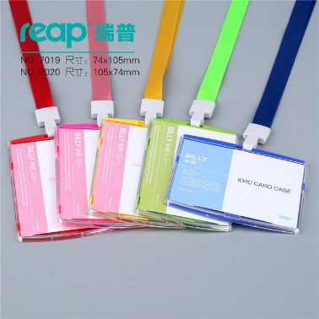

**ITEM 11**

