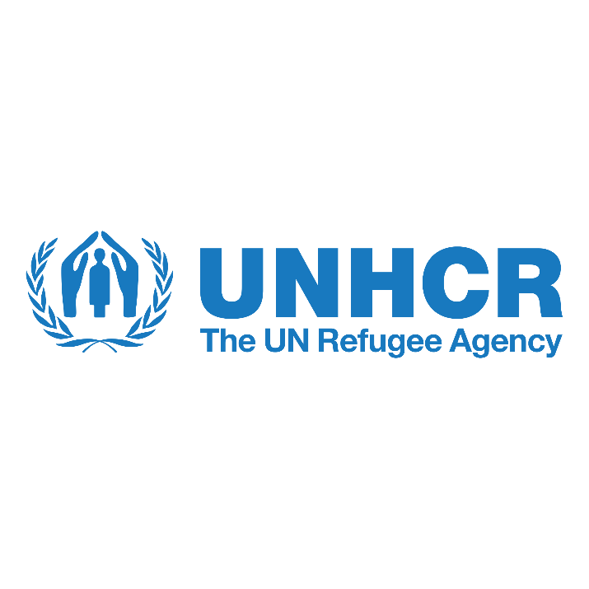
Beirut office

2023-2025 Call for Expression of Interest
EOI Reference #: EOI.2023.1.32101

Contents
Basic Data 1
IMPACT 1 – PROTECT 2
Capacity Development of Law Enforcement Agencies and support to the rights and needs of GBV survivors, particularly victims/ individuals at risk of trafficking for sexual exploitation 3
Strengthening the Capacity of the Government of Lebanon staff and local actors to respond to incidents of violence against children and gender-based violence. 5
Provision of legal aid in Beirut 9
Detention monitoring and provision of legal aid and other services in detention 11
Inter-Agency Mapping Project 13
IMPACT 2 – RESPOND 15
Youth Education Programme 16

Basic Data
Project Location:
Beirut: Centralized Projects Covering all of Lebanon | 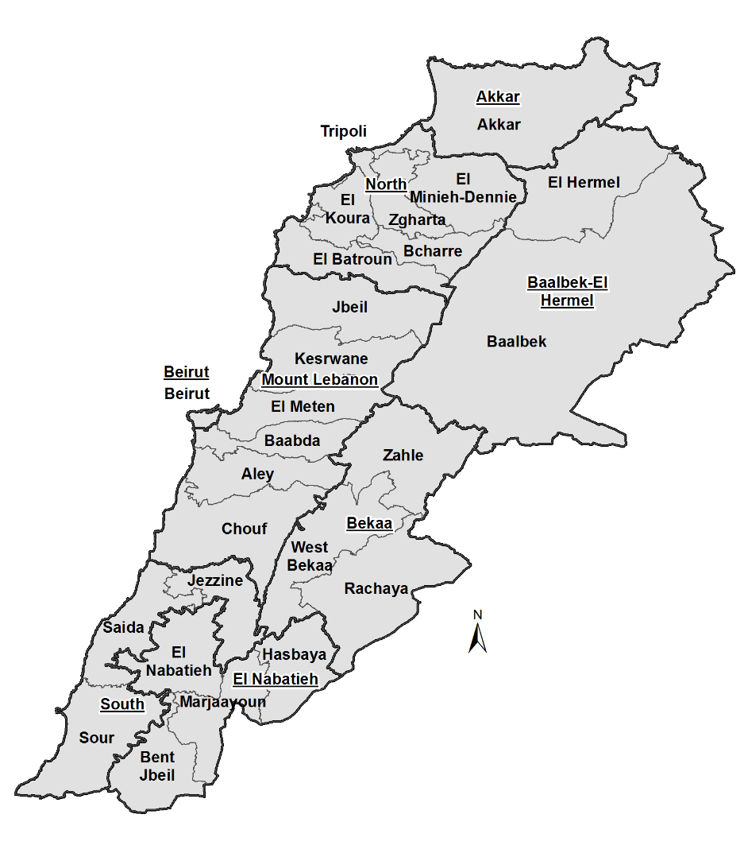

IMPACT 1 – PROTECT
Impact Statement: Persons of concern enjoy a safe protection environment, with access to fundamental rights, fair procedures and specialized support services

PILLAR 1 - PRESERVING PROTECTION SPACE

Support a safe protection environment and ensure access to protection, temporary legal residency, and birth and civil status documentation for refugees, reduce risks associated with detention and ensure protection from refoulement.

Projects included under this Impact Area
Prioritized Outcome Areas (OA): | Project Reference No. | Project Title
OA 4: Gender-Based Violence | EOI.2023.1.32101.1 | Capacity Development of Law Enforcement Agencies and support to the rights and needs of GBV survivors, particularly victims/ individuals at risk of trafficking for sexual exploitation
OA 5: Child Protection &  OA 4: Gender-Based Violence | EOI.2023.1.32101.2 | Strengthening the Capacity of the Government of Lebanon staff and local actors to respond to incidents of violence against children and gender-based violence
OA 6: Safety and Access to Justice & | EOI.2023.1.32101.3 | Provision of legal aid in Beirut.
OA 6: Safety and Access to Justice | EOI.2023.1.32101.4 | Persons at risk in detention have their basic and legal needs addressed.
EA 20: External Engagement and resource mobilization | EOI.2023.1.32101.5 | Inter-Agency Mapping Project

Project title

Capacity Development of Law Enforcement Agencies and support to the rights and needs of GBV survivors, particularly victims/ individuals at risk of trafficking for sexual exploitation
Sector | Project Reference No
Gender-Based Violence (GBV) | EOI.2023.1.32101.1
Outcome Statement
Gender-Based Violence: The risks of GBV are reduced, all GBV survivors have access to timely, safe and quality services and continuous prevention and risk mitigation interventions.
UNHCR Sector Guidance
UNHCR GBV interventions across all five regions of Lebanon will be based on three pillars: prevention, risk mitigation and response. Capacity-development will also be mainstreamed across. Under prevention, UNHCR will continue to promote community mobilization for GBV prevention activities with women, girls, men and boys (engaging OVs, community, WLOs, LGBTIQ+ groups, etc). In synergy, UNHCR jointly with the Inter-Agency SGBV Taskforce will focus on developing and implementing M&E mechanisms to measure the impact, identify gaps and adapt while also contributing to core GBV advocacy priorities. Under the risk mitigation pillar, UNHCR will engage with other technical Units, UN Agencies and LCRP Sectors to embed GBV mainstreaming into work plans and strategies while establishing ways to monitor implementation. Under the response pillar, through a survivor-centred approach, UNHCR will ensure that all GBV survivors who are persons of concern have access to timely, safe and quality services that meet their needs. This will be achieved in three ways: first, based on the geographical coverage of GBV case management across regional districts in Lebanon (GBV geo-split), UNHCR will be providing services (case management, PSS and emergency safe shelter) to high-risk and medium-risk GBV cases. Secondly, for those geographic areas not covered by UNHCR’s own GBV programme, the IA LCRP network of GBV partners will be involved to provide services (CM, PSS, safe shelter) to high-risk and medium-risk GBV cases. Thirdly, in line with the GBV referral pathways, low-risk cases survivors of GBV will be safely referred to IA LCRP partners and other partners.

Output Statement
Relevant partners, sectors and Government counterparts have increased knowledge on GBV prevention and risk mitigation, and response mechanisms are available for all GBV survivors.
Brief Description of the Project
The project seeks to enhance the capacity development of Law Enforcement Agencies, including police, ISF and GSO offices working on responding to the needs of refugee women and girls, victims/survivors of GBV and/or at risk GBV, particularly detained persons of concern engaging in selling and exchanging sex or who are victims of trafficking for sexual exploitation. The capacity-building may be extended also to other GBV actors working on addressing the needs of victims of trafficking in Lebanon.
Main Activities:
Activity 1: Through a proven solid experience in the coordination with national authorities of the Government of Lebanon (police, ISF, GSO, etc.), agree on the launch of the capacity-building initiative and targeted audiences within the GoL.
Activity 2: Conduct an assessment of identified training needs of GoL staff and other actors on protection, safe identification and referrals related to counter-trafficking.
Activity 3: Implement in-person or remote training workshops targeting ISF and GS officers as well as other relevant actors.
Activity 4: Conduct a comprehensive evaluation of the capacity-building activities implemented in order to measure effectiveness and knowledge retention level of participants.
Activity 5: Develop a brief summary report with the data and findings of the evaluation conducted with the participants of the capacity-building activities.
Intended Population Coverage per year:
Government staff, implementing partners of UNHCR as well as other GBV actors.

Output Statement
All GBV survivors and persons at risk of GBV known to UNHCR are adequately assessed in safe spaces and receive quality GBV case management and other services, including safe shelters
Brief Description of the Project
The project seeks to improve the prevention and protection responses towards refugee women and girls, victims/survivors of GBV and/or at risk GBV, including those selling and exchanging sex and victims of trafficking for sexual exploitation. The main focus of the project is on Syrian refugee women and girls, refugees and asylum seekers from other nationalities who are disproportionately affected by GBV/Trafficking issues due to the lack of national protective mechanisms and whose vulnerabilities are exacerbated by the current socio-economic crisis in Lebanon. Also, refugees and asylum seekers in Lebanon from minority groups (LGBTIQ+) and other nationalities (non-Syrians) and stateless individuals who fall under the mandate of UNHCR will be targeted by the project activities.
Main Activities:
Activity 1: Provide psychosocial-legal counselling to women in detention at the Anti-trafficking bureau at Hbeish Police Station.

Activity 2: Provide a safe space for persons of concern selling and exchanging sex and trafficked victims for sexual exploitation.

Activity 3 Conduct awareness raising sessions on risk of trafficking for sexual exploitation and prostitution with Syrian refugee women and adolescent girls.
Intended Population Coverage per year:
- Refugees and Asylum Seekers, Host community, Stateless

Project title

Strengthening the Capacity of the Government of Lebanon staff and local actors to respond to incidents of violence against children and gender-based violence.
Sector | Project Reference No
Child Protection & Gender-based Violence | EOI.2023.1.32101.2
Outcome Statement
Child Protection: Children are protected from abuse, neglect, violence, and exploitation.
Gender-Based Violence: The risks of GBV are reduced, all GBV survivors have access to timely, safe and quality services and continuous prevention and risk mitigation interventions.
UNHCR Sector Guidance
In its child protection response, UNHCR seeks to ensure that children are protected from abuse, neglect, violence, and exploitation, with access to solutions. UNHCR will continue to operationalize the Best Interests Procedure for children at high-risk in line with the National Child Protection Case Management SOPs. Children at low and medium risk will be assessed, referred to services and provided with a complementary community-based response. The Specialized Child Protection Outreach Volunteer Program will be strengthened. UNHCR will strengthen alternative care mechanisms in coordination with UNICEF and the Sector.
To build on the capacities within the refugee community, UNHCR will continue to support community-based identification and referral mechanisms; to raise community awareness on children’s rights and prevention and response to child protection issues (and exploring linkages to QUDWA); to capacitate its community structures to provide non-specialized psychosocial support to children and families; and will strengthen child-friendly complaint and feedback mechanisms. UNHCR will continue providing case management, psycho-social support, other specialized services and facilitating access to services for youth and children at risk. Emphasis will be put on youth mobilization and inclusion in learning programs to promote self-development while building on existing potentials. Child labour, street-connection and child marriage are identified as particular areas of concern. UNHCR will strengthen its work with the Sector and with UNICEF on the 2021-2022 Sector Child Labour Roadmap. UNHCR will ensure that child protection programming is implemented by a qualified, diverse, and trained workforce.
UNHCR’s GBV interventions across all five regions of Lebanon will be based on three pillars: prevention, risk mitigation and response. Capacity-development will also be mainstreamed across. Under prevention, UNHCR will continue to promote community mobilization for GBV prevention activities with women, girls, men and boys (engaging OVs, community, WLOs, LGBTIQ+ groups, etc). In synergy, UNHCR jointly with the Inter-Agency SGBV Taskforce will focus on developing and implementing M&E mechanisms to measure the impact, identify gaps and adapt while also contributing to core GBV advocacy priorities. Under the risk mitigation pillar, UNHCR will engage with other technical Units, UN Agencies and LCRP Sectors to embed GBV mainstreaming into work plans and strategies while establishing ways to monitor implementation. Under the response pillar, through a survivor-centred approach, UNHCR will ensure that all GBV survivors who are persons of concern have access to timely, safe and quality services that meet their needs. This will be achieved in three ways: first, based on the geographical coverage of GBV case management across regional districts in Lebanon (GBV geo-split), UNHCR will be providing services (case management, PSS and emergency safe shelter) to high-risk and medium-risk GBV cases. Secondly, for those geographic areas not covered by UNHCR’s own GBV programme, the IA LCRP network of GBV partners will be involved to provide services (CM, PSS, safe shelter) to high-risk and medium-risk GBV cases. Thirdly, in line with the GBV referral pathways, low-risk cases survivors of GBV will be safely referred to IA LCRP partners and other partners.
In order to ensure that its partners, government counterparts and other CP and GBV actors have strong capacities to work in child protection and the prevention and response to GBV, UNHCR seeks to implement a Coaching Program on CP and GBV. Through this program, UNHCR and the selected partner aims to support and strengthen the capacities of child protection and GBV case managers and case workers in case management, standardize the case management approach, promote best practices and enhance coordination and strengthen networking among CP & GBV actors including government and local institutions such as MosA, Ministry of Justice and the MOJ-mandated NGOs. The program will be implemented across the country and train UNHCR’s partner staff and specialized outreach volunteers, government counterparts, and other CP and GBV actors.

Output Statement
Relevant partners and Government counterparts have increased knowledge of prevention and response services for children and adolescents.
Brief Description of the Project
Under this project, the selected partner will strengthen the capacity of staff of UNHCR child protection partners, staff from other child protection agencies, and government staff through the provision of capacity building initiatives on CP-related issues. It is also intended to support CP Actors to supervise and address complex child protection cases, understand, and implement the National SOPs, and provide mentorship for them to support different categories of children at risk to prevent further harm that may require case management services. It also intends to build the capacity of Outreach Volunteers in order to provide community-based protection and mentorship to low-risk child protection cases, including Unaccompanied and Street Children (UASC), children with disabilities as well as Street Connected children.
Topics of the trainings include but are not limited to safe disclosure and referral of CP cases to case management, CP prevention, awareness on CP and child rights issues, etc. Remote or in-person trainings will target especially case workers, focusing on case management-related issues and how to work with vulnerable groups such as children with disabilities, or other groups to ensure equitable services.
Main Activities:
Train participants (Government staff, implementing partners of UNHCR and child protection actors) on child protection and Children’s Rights.
Detailed list of main activities:
- Activity 1: Conduct a follow-up survey among CP actors that have taken part in the 2022 programme to measure the retention of knowledge.
- Activity 2: In coordination with the interagency CP working groups, launch of the 2023 CP Coaching programme.
- Activity 3: Assessment Workshops to identify the needs of targeted caseworkers and supervisors of front-liners.
- Activity 4: Conduct workshops with CP case workers and supervisors to identify their technical and interpersonal skills learning needs.
- Activity 5: Develop tools, materials and guidance, in English and Arabic, for topics related to Child Protection based on the need and changes in the protection environment with the aim of institutionalizing these materials.
- Activity 6: Organize tailored capacity building to key actors in the national Child Protection system including trainings on core case management topics such Best Interests Procedures (including Best Interest Determination) for UNHCR partners and other local and international organizations.
- Activity 7: Organizing peer-to-peer sessions for Child Protection caseworkers and peer-to-peer sessions for Child Protection managers & supervisors.
- Activity 8: Provide training, coordination and ongoing technical support for Child Protection service providers that are overseeing Outreach Volunteer programs.
- Activity 9: Provide training and coaching to Child Protection Outreach Volunteers.
- Activity 10: Mid-year and final assessments to be conducted to measure the retention of knowledge.
- Activity 11: Work with UNHCR to strengthen and improve Child Protection referral systems and procedures.
Intended Population Coverage per year:
Government staff, implementing partners of UNHCR as well as Child Protection actors

Output Statement
Relevant partners, sectors and Government counterparts have increased knowledge on GBV prevention and risk mitigation, and response mechanisms are available for all GBV survivors.
Brief Description of the Project
The project aims to enhance the quality of case management for gender-based violence (GBV) survivors in all Lebanon governorates, with a focus on underserved areas, through strengthening the technical capacity of GBV service providers and GBV frontline case workers/managers. The coaching programme will ensure that relevant partners, sectors and government counterparts have increased knowledge on GBV prevention and risk mitigation, and that response mechanisms are available for all GBV survivors. Topics will be based on the needs expressed by case management supervisors within the scope of GBV case management provision, as well as the needs for supervision and support expressed by the case workers.
Main Activities
Train participants (Government staff, implementing partners of UNHCR and GBV actors) on GBV prevention and risk mitigation, and response
Detailed list of main activities:
- Activity 1: Conduct a follow-up survey among GBV actors that have taken part in the 2022 programme to measure the retention of knowledge.
- Activity 2: In coordination with the interagency GBV taskforce Launch of the 2023 GBV Coaching programme.
- Activity 3: Assessment Workshops to identify the needs of targeted caseworkers and supervisors of front-liners.
- Activity 4: Conduct workshops with GBV case workers and supervisors to identify their technical and interpersonal skills learning needs including on service provision to vulnerable groups (Women at risk and LGBTQI+).
- Activity 5: Develop tools, materials and guidance, in English and Arabic, for topics related to GBV based on the need and changes in the protection environment with the aim of institutionalizing these materials.
- Activity 6: Organizing peer-to-peer sessions for GBV caseworkers and peer-to-peer sessions for GBV case managers & supervisors.
- Activity 7: Contribute to the specialized OV coaching program to train them on safe identification and referral including mitigating risks of GBV.
- Activity 8: Work with UNHCR to strengthen and improve GBV referral systems and procedures.
- Activity 9: Mid-year and final assessments to be conducted to measure the retention of knowledge.
Intended Population Coverage
Government staff, implementing partners of UNHCR as well as GBV actors.

Project title

Provision of legal aid in Beirut
Sector(s) | Project Reference No
Documentation and Legal Aid, | EOI.2023.1.32101.3
Outcome Statement
Safety and Access to Justice - Barrier to accessing legal remedies and documentation are reduced.
UNHCR Sector Guidance
Overarchingly, UNHCR will promote a rights-based approach by supporting persons of concern in obtaining information about their rights and accessing them through legal awareness sessions, individual counselling, assistance and where required – representation, on variety of protection issues, including legal residency, civil documentation, security of tenure, labour rights and procedures, access to penal justice, in child protection, GBV and domestic violence cases, etc. UNHCR will also provide legal aid to help stateless non-refugee persons remedy their status.
UNHCR will continue its advocacy with the GOL to ensure a more protective legal framework including a facilitated access to legal residency and civil documentation. UNHCR will continue to advocate for the establishment of an affordable, sustainable, and credible national state-funded legal aid system. Moreover, UNHCR will continue advocating for legal reform to address and prevent statelessness specifically in relation to the nationality and civil documentation (birth registration) law.
UNHCR will also continue to support key institutions through training, staffing, technical and material support, aiming at enhancing their capacity, facilitating refugees’ access to different services, as well as having positive impact on the protection environment.

Output Statement
Persons of concern have access to information on their rights and domestic legal procedures and receive support in accessing them (Stateless).
Brief Description of the Project
UNHCR, through local partners, will provide specialized legal counselling to stateless persons on legal remedies available to them to claim their right to Lebanese nationality. Individuals who can do so through judicial cases of late birth registration, which do not require legal representation, will be supported through counselling and legal assistance, while cases relating to the implementation of the nationality law will be provided legal assistance and representation in front of the court and administrative authorities
UNHCR, through local partners, will also provide legal aid to stateless persons through counselling and assistance on different topics such as family law, housing, land and property, labour law, GBV and child abuse cases.
Main Activities
- Provide legal counselling, assistance, and legal representation for stateless persons to identify solutions through judicial procedures in the form of late birth registrations and confirmation of nationality.
- Provide legal aid including counselling, assistance and awareness raising for stateless persons covering different topics such as family law, housing, land and property, labour law, GBV and child abuse cases.
- Increase availability of legal aid services to stateless persons through capacity building of members of the legal profession, including creation of a specialised training curriculum and manual on legal solutions to statelessness in Lebanon for lawyers and paralegals.
- Promote the creation of a network of NGOs that are providing legal aid to stateless persons to promote exchange of best practices on judicial cases and strengthen existing advocacy efforts.
- Link up, collaborate and coordinate with existing local, regional networks.
- Promote a review of existing cases on nationality and birth registration to identify measures that could make such cases more accessible to stateless persons.
- Develop and disseminate awareness raising tools clarifying access to basic rights by stateless persons.
Intended Population Coverage
Stateless persons in need of legal aid all over Lebanon.

Output Statement
Authorities are provided with information and technical knowledge to enhance the protection of the rights of stateless persons (Stateless).
Brief Description of the Project
The project will focus on advocating for legal reform to address and prevent statelessness, raising awareness on statelessness among the public opinion and public institutions. Activities include sensitization and capacity building targeting both public institutions and civil society to promote legal reform and prepare the ground for when the situation will be conducive for changes in legislation.
Main Activities
- Advocacy and awareness-raising among key stakeholders and decision-makers of law and procedural reforms to improve situation of marginalized target beneficiaries.
- Implement activities to sensitize audiences to the subject of statelessness, with a primary focus on the government, judiciary, academia, parliamentarians, the press and other actors who may have a role in developing solutions, in addition to the public and civil society at large.
- Monitor legislative and administrative developments on nationality and civil registration and maintain a regular dialogue with the government with a view to increase its role in designing pragmatic solutions to statelessness and the status of stateless persons.
- Engage the government, particularly the Ministry of Justice, to support a review of ongoing cases of nationality and late birth registration to identify how court procedures could be made more accessible to stateless persons within the existing legal framework.
- Engage the public opinion, through promotion of regular media reports, development of media tools, use of social media and launch of UNHCR IBelong campaign with universities in 2018.
- Support cases of strategic litigation to encourage new judicial trends in interpreting and applying the provisions under the Lebanese Nationality Law and related standards, and in enforcing existing legal safeguards against statelessness at birth.
- Conduct capacity building initiatives for lawyers, civil society, and public entities.
- Develop research studies on the situation of stateless persons in Lebanon and legal analysis on laws, decisions and jurisprudence related to statelessness in Lebanon.
Intended Population Coverage

Project title:

Detention monitoring and provision of legal aid and other services in detention
Sector: | Project Reference No:
Protection (detention) | EOI.2023.1.32101.4
Outcome Statement
Safety and Access to Justice - Risks associated with detention are reduced through improved detention conditions and enhanced access to legal aid.
UNHCR Sector Guidance
Under the auspices of the Protection sector, UNHCR continues working with key actors to ensure respect for the rule of law, non-discriminatory application of laws, regulations and instructions, and respect for due process in their implementation. Through partner organizations UNHCR maintains regular presence in places of detention to identify protection issues and respond to the needs of vulnerable detainees among persons of concern and host community by providing legal aid, and material, hygiene, medical, mental health and food assistance. Procedural advice and legal counsel provided through partners operating in places of detention facilitates just and equitable access to legal remedies and help mitigate protection risks for those in detention. Such interventions are needs-based and complementary to services provided by national authorities and other institutional actors operating in detention facilities. UNHCR continues engaging closely with partners to ensure operational coordination and advocacy for ameliorated conditions in detention, inclusion of persons of concern in partners’ support and rehabilitation programmes, and broader justice sector reform.

Output Statement
Persons at risk in detention have their basic and legal needs addressed.
Brief Description of the Project
UNHCR through its project partners will provide legal aid to refugees and stateless persons to inform, encourage and support them to access their rights. Assistance will be provided to persons of concern to UNHCR and vulnerable host community members in detention. Advocacy and legal interventions will aim to limit instances of their immigration detention, and to reduce prolonged detention, including at pre-trial stage. Legal aid will be systematically provided to children and adults based on identified needs and vulnerabilities, to ensure greater respect for the rights of detainees and access to due process. Food, material, medical and mental health support will be provided to the most vulnerable detainees in complementarity to services provided by national authorities.

Protection and assistance services provided under the project will be provided in a conflict-sensitive manner and based on individual needs assessments. Regular monitoring visits to detention facilities, including prisons, justice palaces and police stations, will allow to identify protection gaps, and cases at high risk for the purpose of service provision, and to maintain dialogue and coordination with law enforcement and judiciary counterparts around improvement of conditions of detention and procedural aspects, and facilitating access to protection and assistance for vulnerable detainees.
Main Activities
- Maintaining a regular presence in detention facilities to conduct detention monitoring with a view to assess the needs of detainees and identify overarching issues that require UNHCR’s attention.
- Provision of legal aid (legal counselling, assistance, representation and payment of bails and fines fees) in line with established prioritization criteria.
- Medical and mental health support provided through qualified nurses, psychologists, psychiatrists and medical doctors.
- Provision of relief assistance (food and NFIs) to the most vulnerable detainees based on identified needs and set eligibility criteria.
- Support to law enforcement authorities and judiciary through addressing critical material needs in their facilities with a view to facilitate judicial process and improve detention conditions.
The project partner will maintain case management system for cases of detained individuals provided with services under the project. The project will involve systematic reporting on situation in detention facilities as well as maintaining structured records of project beneficiaries, in line with UNHCR’s data protection policy and applicable standards.
Intended Population Coverage
Th project will include direct assistance to at least 2,500 detainees among persons of concern to UNHCR (refugees, asylum-seekers and stateless persons) and other vulnerable members of host community in prisons, police stations and justice palaces in Beirut, Mount Lebanon, Bekaa and South. By extension, its assistance and support services contributing to the general amelioration of detention conditions will indirectly benefit a broader number of vulnerable individuals in detention in the listed regions.
The project will also include support to law enforcement authorities and judiciary across 200 detention facilities, where monitoring activities take place, through addressing identified needs based on criticality. The support will be provided complementarily to services provided by other actors and public sector resources.

Project title:

Inter-Agency Mapping Project
Inter-Agency Mapping Project | Project Reference No:
Inter-Agency & Coordination | EOI.2023.1.32101.5
Outcome Statement
All actors responding to the impact of the Syria Crisis implement coherent and complementary programmes, with coordinated fundraising, and harmonized advocacy.
UNHCR Sector Guidance
UNHCR’s Inter-Agency (IA) Unit will seek to ensure effective coordination of the response to the Syria crisis in Lebanon through the Lebanon Crisis Response Plan (LCRP), an in integrated humanitarian and stabilization plan providing assistance and protection including through national service provision. This entails informing and coordinating the work of a broad spectrum of stakeholders including GoL line ministries, UN agencies, NGOs, academics, donors and other actors. UNHCR will lead the Protection, Shelter, Health, Basic Assistance sectors, and co-lead Social Stability sectors to ensure coherent coordination and strong technical approaches at the sub-national and national levels, in order to meet the needs of refugees and the host community.

Output Statement
Response planning leads to the development of appropriate and inclusive sector and inter-sector strategies, including effective communication on response priorities and coordination of emergency preparedness and response across national and field level actors.
Brief Description of the Project
In Lebanon, most of the Syrian refugee population live in cities and villages in the context of the governmental policy prohibiting the establishment of formal refugee camps. The remaining fraction live in spontaneously set-up tented (informal) settlements throughout the country. Refugees face harsh winters with sub-zero temperatures and flooding that affect mainly those living in informal settlements.
In 2021, the vulnerability assessment of Syrian Refugees in Lebanon estimated that 22% of the Syrian refugee population live in informal settlements. That percentage has been increasing steadily over the years.
This project seeks to continue the Inter-Agency Mapping Project (IAMP) which identifies and monitors the locations and population of Informal Settlements (IS) throughout Lebanon. This is achieved through regular sweeps and monthly dissemination of data sheets, including among other things: updated locations, number of tents, number of individuals, and selected additional data fields based on sector recommendations and needs.
The data set provided through the IAMP serves as the common baseline for humanitarian coordination, activity planning and reporting, gap identification, assessments, and monitoring as well as to respond to emergencies.
Main Activities
- Identify, map and issue unique place codes (pcodes) for new informal settlements in Lebanon according to the IAMP standards.
- Monitor changes in existing informal settlements and report back to the IA team changes in the population, structures and surface utilized by the settlements.
- Collect additional information needed by sectors about the informal settlements, the structures within, the population living in them or information about the surrounding area.
- Clean, verify and manage the data being collected on a periodic and daily basis, and communicate issues with the data to mapping partners and other relevant parties.
- Facilitate access to the collected data through an online system.
- Collate data and issue reports to UNHCR on a monthly basis (IAMP).
- Ensure that data for each informal settlement is updated at least twice each year.
- Lead (along with UNHCR) the documentation of best practices and improvement of methodology, including the development and revision of the IAMP documentation.
- Advocate for funding of the IAMP project.
- Develop visual, GIS and analytical products to highlight trends, population movements, changes in the profile of informal settlements at the end of every sweep.
- Active participation in the Information Management Working Group (IMWG) and organise any other meeting related to further development of the project.
Produce ad-hoc maps needed by sectors related to informal settlements from collected or relevant dataset.
Intended Population Coverage
All refugee population living in informal settlements in all governorates in Lebanon except for informal settlements that existed prior to the start of the Syrian refugee crisis.

IMPACT 2 – RESPOND
Impact Statement: In the context of a deteriorating socio-economic situation, further deterioration of affected populations’ well-being is mitigated through equitable access to quality basic services.

PILLAR 2 - DIGNIFIED STAY
Ensure access to quality basic services and inclusive access to social protection and a safety net to preserve the dignity and well-being of refugees in Lebanon, while supporting refugees’ ability to develop their human capital.

Projects included under this Impact Area
Prioritized Outcome Areas (OA): | Project Reference No. | Project Title
OA 11: Education | EOI.2023.1.32101.6 | Youth Education Programme

Project title

Youth Education Programme
Sector | Project Reference No
Education | EOI.2023.1.32101.6
Outcome Statement
Education - Gaps in education are bridged, resulting in improved human capital and transferable skills.
UNHCR Sector Guidance
UNHCR will continue to promote equitable and sustainable inclusion of children and youth in quality national education systems, through evidence-based advocacy and support for the operationalization of MEHE’s Five-Year Plan on General Education, the National Strategic Framework for Technical and Vocational Education and Training (TVET) and the Lebanon Five-Year Higher Education plan in areas of strategic interest to UNHCR, such as outreaching to out-of-learning youth for enrolment and provision of Vocational Training to out-of-learning youth, as well as the provision of higher education scholarships.
In order to do so, UNHCR will upscale its higher and technical education programming with a view to increasing self-reliance and implementing UNHCR’s global 15by30 goal and roadmap, by strengthening the Youth Education Program through its Vocational Training and DAFI scholarship components

Output Statement
Children are profiled for strengthened advocacy, have access to improved learning environments and receive community-based educational support that contributes to their retention in formal and non-formal education programm
Brief Description of the Project
UNHCR through its education partner will implement the Albert Einstein German Academic Refugee Initiative (DAFI) scholarship program which aims to support qualified, academically strong young refugees who meet the requirements to access higher education in their first country of asylum. The scholarship aims as well to empower young women and men equally to contribute knowledge, skills, and leadership to the refugee community. Sponsored students are expected to contribute to their community and society not only through their academic and professional careers but also through their personal engagement, supporting and inspiring other community members.
In Lebanon, the DAFI Program has been running since 2014, offering 750 qualified refugee students, until today, the possibility to earn an undergraduate degree in their country of asylum. The program covers a range of costs including tuition fees, cash support for study materials, and academic guidance.
Main Activities:
- Ensure good collaboration with the universities in which DAFI students are enrolled in Lebanon and keep close contact with the university deans to follow up on students’ progress.
- Develop and run the selection process according to the DAFI Policy and Guidelines and facilitate the enrolment of DAFI scholarship holders in universities.
- Ensure that an annual student monitoring plan is in place against which student academic progress and well-being are monitored throughout the year.
- Facilitate DAFI students to engage in community activities that serve refugee and host communities and help students develop community leadership skills.
- Organize training opportunities for DAFI students on ICT literacy, job search skills, employability skills, and entrepreneurship, through training and mentorship activities.
- Foster an active alumni network and remain in contact with the DAFI alumni group of students. Monitor the impact of the DAFI program, and link students to available opportunities that serve of interest to their educational or professional growth.
- Coordinate with other stakeholders to maximize the outreach and provide a comprehensive database on opportunities and gaps for advocacy and policy advancements to increase higher education opportunities for refugee youths living in Lebanon and advance the culture and recognition of blended and online learning.
Intended Population Coverage
Population type: Female and male refugees qualified for Higher Education
Age: 17 to 28 years old
Major sites: all over Lebanon

Output Statement
Out of School Children (OoSC) and Youth are identified and referred to quality formal or non-formal education programs and other vocational programmes available to youth, including those implemented by UNHCR partners
Brief Description of the Project
UNHCR through its education partner will provide certified short vocational training sessions (VT) to out-of-learning youth (Refugees and Lebanese) seeking training sessions in areas that offer opportunities in the local job market including skilled trades, healthcare, and services (hospitality, utilities, etc). The training sessions focus on the practical application of knowledge and competency-based skills linking the demands of the market to the training provided.
Main Activities:
- Assess the job market needs, plan the trainings, and design the curriculum accordingly.
- Outreach to potential candidates depending on the requirements of each training session and ensure that the selection process is planned and implemented according to the agreed guidelines.
- Implement the sessions, and ensure a rigorous follow-up on the trainees, learning experience, attendance, engagement, and interaction, making sure they are provided with hands-on knowledge of skills and acquired expertise in their career.
- Empower the trainees with complementary hard and soft skills, as well as life skills and employment readiness.
- Facilitate trainees to engage in community activities that serve refugee and host communities and help learners develop community leadership skills.
- Foster an active graduate network. Follow up on the trainees after graduating, and monitor the impact of the program, including evidence of internship or employment.
- Ensure good collaboration with the Ministry of Education and Higher Education vocational education directorate (MEHE/DG TVET), the Ministry of Labour, the Ministry of Social Affairs, and the Chamber of Commerce. Create and or strengthen existing partnerships with the National Center for Vocational Training, community centers, and NGOs.
Intended Population Coverage:
Population type: Female and male out-of-school youth refugees and asylum seekers as well as vulnerable Lebanese
Age: 14 to 25 years old
Major sites: all over Lebanon

