  - PART C – SUBMISSION PART COMMERCIAL DOCUMENT

Appendix G – Commercial Document (Financial Offer)

PART C – APPENDIX H
COMMERCIAL DOCUMENT
(FINANICAL OFFER)

CONTRACT TO SUPPLY AND DELIVER Toolkit and Irrigation System
No. | Description |  | Unit | Quaintly | Unit Price  (USD) | Total Price  (USD)
1. | Small Shovel  - compact and lightweight  - durable materials such as stainless steel or carbon steel  - Ergonomic design  - not too flat | 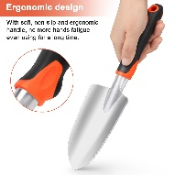 | piece | 72
2. | Small Rake  - compact and lightweight  - durable materials such as stianls steel or carbon steel  - Ergonomic design  - The rake's tines should be sturdy and spaced  - 5 teeth | 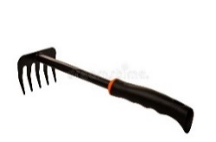 | piece | 72
3. | Water Sprayer  - 2 Litres  - durable materials high-quality plastic  - adjustable nozzle  - comfortable grip handle  - easy-to-operate trigger mechanism  - Pressure releases valve  - semi- transparent reservoir  - trigger  - clear scale | 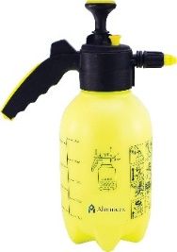 | piece | 140
4. | Prunning Scissors  - compact and lightweight  - durable material such as stainless steel  - comptable crip (egronomic handle design)  - Spring mechanism  - safety lock  - Versatility | 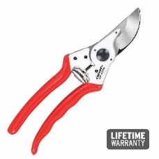 | piece | 72
5. | Gloves  - durable materials such as synthetic leather, nitrile, or reinforced canvas  - breathable materials or ventilated designs  - comfortable fit  - gloves with reinforced palm and fingertips  - waterproof  - with an extended cuff or gauntlet-style design  - machine washable | 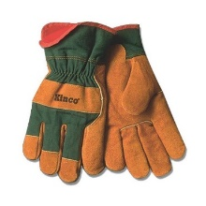 | pair | 72
6. | Big Shovel  -durable material  - complete shove with the handle attached | 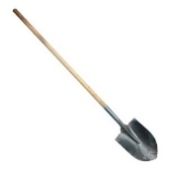 | piece | 70
7. | Agricultural Bucket  - durable materials such as heavy-duty plastic, galvanized steel, or reinforced rubber. | 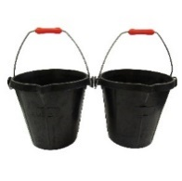 | piece | 70
8. | Hosepipe  Length 50m durable materials such as reinforced rubber or vinyl,  UV-resistance material, Diameter 1/2 inch or 5/8 inch, thickness 13-16 mm | 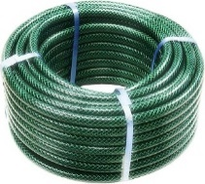 | meter | 3500
9. | Hosepipe Sprayer  Made from durable materials like heavy-duty plastics, stainless steel, or brass.  offer a variety of spray patterns such as mist, shower, stream, cone, and flat.  easy to attach to a standard garden hose and operate without  requiring excessive strength or dexterity.  have lockable trigger. | 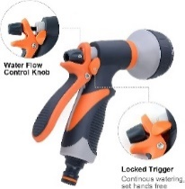 | piece | 70
10. | Drip Irrigation Water Bottle Cap  Suitable for one Liter bottle size  durable materials such as polyethylene or polypropylene  have a Watertight Seal  have capability to adjust the water flow  have a base helping for fixing the bottle in the soil | 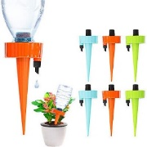 | piece | 700
11. | Poly tank connector | 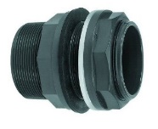 | piece | 140
12. | Tee (agricultural)  plastic, 3/4 inch | 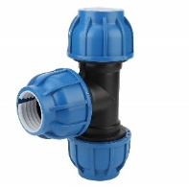 | piece | 70
13. | Water hose  3/4 inch, black, agricultural | 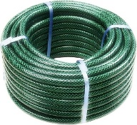 | meter | 700
14. | Water float Vulve  3/4-inch, brass, plastic ball | 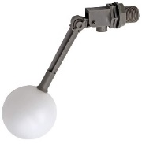 | piece | 70
15. | Thread seal tape  20 m | 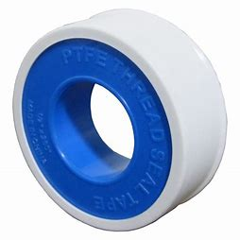 | piece | 70
16. | Hose connector  3/4 inch | 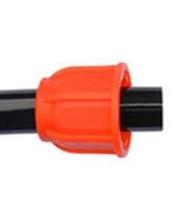 | piece | 140
17. | Hose clamp  3/3 inch | 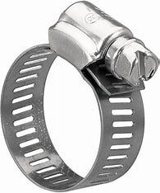 | piece | 140
18. | Tap  1/2-inch, brass | 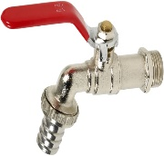 | piece | 70
19. | Ball vulve  3/4-inch, plastic | 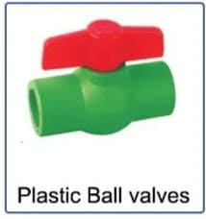 | piece | 70
20. | Electrical balance  - Scale from 0.5g until 500g  - Rechargeable battery |  | piece | 72
21. | - Zipper  - 4*6 cm |  | pack (100 piece) | 57
22. | - Zipper  - 18* 25 cm |  | pack (25 piece) | 23
Net Total
Offered Discount
Net Total after Discount
11% VAT (if applicable)
Grand Total including 11% VAT (if applicable)

Name and first name: […………………………………………]
Duly authorized to sign this tender on behalf of: […………………………………………]
Place and date: […………………………………………]

Stamp of the firm/company:

