PART B – ANNEXES

ANNEX 1 – CONTRACT TEMPLATE

ANNEX 2 – TERMS OF REFERENCE

ANNEX 3 – PO TEMPLATE

ANNEX 4 – SRN TEMPLATE

ANNEX 1 – CONTRACT TEMPLATE

Consultant Contract
- Contract for work and services No. –
[contract reference]

BETWEEN

JAFRA Foundation, represented by [add representative name]
[address]
[Telephone – extension]
[email]
MOF no: [add MOF No.]

- hereafter „JAFRA “ -

AND
[contractor name] represented by [add contractor’s representative name]
Address: [add contractor address]
Tel: [add telephone number]
Email: [add email]
MOF no: [add MOF No.]
- hereafter „Contractor “ -

WHEREAS:
- JAFRA, in the project signed with Deutsche Welthungerhilfe e.V, project number: “LBN 1010” project name:” Empowering women and strengthening the resilience of vulnerable rural and urban communities in South Lebanon and Beirut funded by WHH”

- The Service Contract will be established between JAFRA and [contractor name], to [MSMEs Business Consultant]

- By request for [MSMEs Business Consultant]; the Service Contract holder responded to request for proposal for services, representing that it is qualified, capable, and willing to provide the required services.

- The both parties agree on trustful collaboration and mutual information-sharing in the event of operational difficulties or foreseeable time delays in the contract execution.

Now, therefore, based on mutual trust, JAFRA and Contractor have entered into the present Agreement.

- Contract Period
The contract is expected to take [agreement period] and will commence on [start date] and end on [end date].

- Subject of the Contract
The Objective of the consultation is: Jafra in partnership with Deutsche Welthungerhilfe e. V. (WHH), conducting a project supported by BMZ for “Strengthening women's livelihoods and increasing the resilience of vulnerable communities engaged in smallholder and subsistence farming” with a specific focus on the Palestinian camps in Beirut and in the South. For which the MSMEs’ Business Trainer will be appointed for.

- Services Required

  - The Contractor shall fulfil and insure achieving the deliverables on the Terms of Reference attached this Contract (Annexes – Annex I: Terms of Reference) on its responsibility. If applicable for proper contract execution, technical guidelines shall be observed.

  - JAFRA shall provide the Contractor with all information and documents necessary for the performance of his assignments.

  - The Contractor shall organize its working hours at its own dutiful discretion and is not bound by any guidelines as to the location of employment. Project-related appointments, respectively deadlines that refer to the respective assignments must be observed.

  - The Contractor is also free to work for other customers and to accept assignments outside of this agreement.

  - The contractor does not have any authority to issue instructions to JAFRA employees.

- Remuneration and Payment

  - The Contractor receives a payment of (total contract value) [add payment in words – payment in numbers – currency including or excluding 11% VAT]

  - Payments can only be done after the acceptance of the services following the [add JAFRA project focal point] experts to make sure that service is delivered properly.

  - The Contractor is responsible for paying the stamp tax arising from this Contract.

  - Payment will be made monthly according to the agreed and conducted tasks.

  - JAFRA shall generally make payment through [bank transfer/cash letter] to Contractor within 7 working days, upon: receipt of the following documents and any other documents/reports that may be specified in the Contract, to be sent directly to JAFRA [Add Jafra office address, street, building, floor], procurement unit:
    - commercial invoice with valid banking instructions.
    - Signed SRN by Contractor (Service Received Note template will be shared by JAFRA-Procurement Unit).

  - JAFRA will make payment to the bank account indicated by Contractor in its invoice, providing that the bank account is in the name of Contractor and located in its country of residence. Any request for payment to a bank account other than that of Contractor or to a bank other than one located in Contractor's country of residence must be specified and justified by Contractor at the time of making its offer. [ revise this article while confirming payment method]

  - JAFRA may withhold payment, in whole or in part, without liability and without prejudice to any other of its rights or remedies under the Contract, should Contractor fail to provide the documents required by the JAFRA until the required documents are provided.

- Taxes and Social Insurance Fees
The Contractor is responsible of the fulfillment of all fiscal and social insurance law obligations arising from this contract and must perform all necessary actions himself.
- Confidentiality and Issue of Documents

  - The Contractor is responsible for the fulfillment of all fiscal and social insurance law obligations arising from this contract and must perform all necessary actions itself. The Contractor shall register its employees in the Social Security System and pay the necessary social security payments in accordance with relevant Law. The Implementer shall not engage in the employment of children. The breach of these obligations shall be considered as a substantial breach of this contract.

  - During the term hereof and for three years thereafter, the contractor and his current and future employees agree not to disclose any matters of a confidential nature to which it may be or become privy because of the contract.

  - Confidential information shall mean any information (written, oral or observed) relating to:
(a) donors or potential donors. (b) participants. (c) employees. (d) business or strategic plans (e) finances (f) procurement (g) passwords. (h) a relationship with any governmental entity.

  - The contractor shall also include information specifically designated confidential by the owner or that the disclosing party knows or reasonably should know is not public. Confidential information does not include any information generally known to the public or readily obtainable from public sources. Further, confidential information may be disclosed to government authorities if the disclosure is required by law and the disclosing party has provided the owner notice and, if practicable, a reasonable opportunity to defend against such disclosure. Upon the expiration or termination of this contract, the contractor shall surrender to JAFRA all confidential material relating to JAFRA in his or her possession, of whatever origin.

- Prevent Cooperation and Funding Armed Group
The contractor ensures not to deal with, support or service materials to armed groups or to promote violence.
- Commencement of the Contract and Termination of Contract

  - The contractual relationship begins on and ends –without need of termination- upon completion of the service the contract will only be in effect once the Contractor has signed this contract.

  - JAFRA has the right to terminate this contract at any time by giving the Contractor a written notice with 1 month notice period [adapt this part according to JAFRA terms and condition]. After the delivery of the termination notice, the counsellor is obliged to perform all things that must be performed immediately to prevent client to incur into potentially harmful or damaging situations. In case of early termination, the JAFRA shall only make payment for the services performed sufficiently by the Contractor. The Contractor shall not be reimbursed for any anticipatory profits that have not been earned up to the date of termination.

  - Each contractual party is authorized to terminate immediately (withdraw from) this contract if the other party substantially breaches this contract

  - The situations that has been set forth below are bilateral termination reasons.:
    - if the Contractor breaches any obligation under this contract and does not remedy such breach in reasonable time,
    - if it is obvious that the agreed activities will not be completed in time or carried out properly and the Contractor does not remedy the situation in reasonable time
    - in case of force majeure (such as civil disorder, military action or any similar cause beyond the control of any contractual party) which makes impossible the performance of this contract or would cause delay in performance of this contract,
    - if this contract is based on material misrepresentation or omission of fact by the Contractor,
    - if the Contractor no longer satisfies the criteria based on which the contract has been awarded to it in case there was a tender for awarding the contract.

  - The termination shall be effective upon delivery of the termination notice from the other party.

  - Notice of cancellation shall be in writing to be valid.

- Delivery conditions and Schedule

  - The Contractor must be able to provide services, within the timeframe agreed on the implementation plan. Flexibility during weekends and holidays will be favourably viewed.

  - The Contractor shall confirm the service days or cancellations/delays within a minimum of 2 working days before the agreed date of starting the service.

  - The Contractor shall notify JAFRA immediately in case of force majeure or any changes.

  - The Contractor shall provide all the necessary materials, tools and equipment, labor, supervision, and other services, for the timely completion of the work.

  - All required government permits, licenses to complete the work shall be obtained prior to the commencement of the works and paid by the contractor.

  - The Contractor shall comply with local and national building regulations imposed by appropriate government agencies, and shall keep JAFRA indemnified against all fines, penalties, and losses incurred by reason of any breach of this clause.

  - The Contractor shall assume full responsibility for the work under this agreement until the end of the contract period.

- Inspection, acceptance, and rejection

  - The Contractor shall provide and maintain inspection, quality, and process control system acceptable to JAFRA covering the services under the Contract. Records of all inspection work by the Contractor shall be kept complete and available to JAFRA during the performance of the Contract and for twenty-four (24) months after completion, if not otherwise specified in the Contract.

  - JAFRA reserves the right to inspect and test through its representatives all services ordered under the Contract at any time and place. The Contractor, without additional charge, shall provide all facilities for inspection and all necessary support to ensure that inspections can be performed in such a manner as not to unduly delay delivery of the Services.

  - Neither any inspection carried out by representatives of JAFRA, nor any acceptance of the Services or part thereof by JAFRA, nor any omission by JAFRA to inspect, accept and/or reject the services thereof, shall release the Contractor from its responsibility for such services that are not in accordance with the requirements of the Contract.

- Penalties, non-conforming goods or services, shortfalls

  - The Contractor shall be liable according to statutory legal provisions, especially for its own negligent breach of duty and negligent breach of duty by its legal representatives or vicarious agents.

  - Contractor recognizes that the Contract concerns the delivery of provision of Services where "time is of the essence" and that failure to provide the Services by the scheduled date(s) or in accordance with the quantities and/or quality specified in the Contract may cause irreparable harm to JAFRA.

  - Therefore, if the Contractor culpably defaults in remedying a defect or making a delivery – fully and timely -, JAFRA shall have the right to request lump-sum damages due to default for the defective resp. Late delivery without further proof of damage, of 0.2 % of the net remuneration agreed for the defective resp. Late delivery and/or service for each period of default of 1 working day (Monday to Saturday) but at most 5 % of the agreed net remuneration for the defective resp. Late delivery and/or service. The Contractor shall, however, have the opportunity to prove to JAFRA that JAFRA has incurred no damage or materially lesser damage.

- CONFLICT OF INTERESTS
The Contractor shall take all necessary precautions to avoid conflicts of interests and shall inform Client without delay of any situation constituting or likely to lead to any such conflict.
The Contractor shall provide the impartial and objective exercise of everyone under this contract. The Contractor. shall prevent the existence of any conflict of interests for anyone arising out of family, emotional life, political or national affinity, economic interest or any other shared interest with another person.
Ethics clauses and code of conduct
a) Absence of conflict of interest
The contractor must not be affected by any conflict of interest and must have no equivalent relation in that respect with JAFRA employees or parties involved in the project. Any attempt by the contractor or any potential conflict of interest will result in terminating this contract.
b) Respect for human rights as well as environmental legislation and core labour standards
The contractor and its staff must comply with human rights and applicable data protection rules. In particular and in accordance with the applicable basic act, contractor and its employees who have been awarded the contract must comply with the environmental legislation including multilateral environmental service contracts, and with the core labour standards as applicable and as defined in the relevant International Labour Organisation conventions (such as the conventions on freedom of association and collective bargaining; elimination of forced and compulsory labour; abolition of child labour).
Zero tolerance for sexual exploitation, abuse and harassment:
The European Commission applies a policy of 'zero tolerance' in relation to all wrongful conduct which has an impact on the professional credibility of the tenderer. Physical abuse or punishment, or threats of physical abuse, sexual abuse or exploitation, harassment and verbal abuse, as well as other forms of intimidation shall be prohibited.
c) Anti-corruption and anti-bribery
The contractor shall comply with all applicable laws and regulations and codes relating to anti-bribery and anti-corruption. The European Commission reserves the right to suspend or cancel project financing if corrupt practices of any kind are discovered at any stage of the award process or during the execution of a contract and if JAFRA fails to take all appropriate measures to remedy the situation. For the purposes of this provision, ‘corrupt practices’ are the offer of a bribe, gift, gratuity or commission to any person as an inducement or reward for performing or refraining from any act relating to the award of a contract or execution of a contract already concluded with the contracting authority.
d) Unusual commercial expenses
The contract will be terminated if it emerges that the award or execution of a contract has given rise to unusual commercial expenses. Such unusual commercial expenses are commissions not mentioned in the main contract or not stemming from a properly concluded contract referring to the main contract, commissions not paid in return for any actual and legitimate service, commissions remitted to a tax haven, commissions paid to a payee who is not clearly identified, or commissions paid to a company which has every appearance of being a front company.
Contractors found to have paid unusual commercial expenses on projects funded by the European Union, or any other donors are liable, depending on the seriousness of the facts observed, to have their contracts terminated or to be permanently excluded from receiving funds.

- WARRANTY

  - The Contractor hereby, declares and warrants that the Contractor rejects corrupt, fraudulent, collusive and/or coercive practices and that neither the Contractor nor its management have engaged in corrupt, fraudulent collusive and/or coercive practices or have been convicted of an offence or a crime concerning their professional conduct by a judgment which has the force of res judicata. The misrepresentation of the Contractor in regard of any of these warranties or the involvement of the Contractor in any of these situations described shall constitute the right of JAFRA to terminate this contract as in case of a substantial breach of this contract. In case of such termination JAFRA shall have the right for reimbursement of its damages.

  - The Contractor warrants that it shall protect the personal data it collects from JAFRA and make no other use of the selected personal data under this agreement without JAFRA’s prior written consent. The Contractor is responsible for the protection and confidentiality of the personal data. It shall take all reasonable steps to ensure that its employees, agents, and subcontractors abide by the confidentiality obligations under this agreement and it shall not further process, disclose, publish, or transmit the personal data to any third parties.

- FINAL PROVISIONS

- Should individually provisions of this contract prove to be invalid or ineffective, the remaining provisions of this contract are not affected as a result. The invalid or ineffective provision must be replaced by another valid provision that comes as close as possible to the will of the parties.

- Any modifications and supplements to this agreement shall be effective only when reduced into writing and signed by the parties hereto.

- This Contract shall be governed by Lebanese Law

- Any dispute arising out of this contract shall be initially settled through negotiations between parties. Should such negotiations fail, and no amicable settlement exists, the disputes shall be settled by the Beirut Courts and Execution Offices. Unless provided otherwise Beirut Courts and Execution Offices are duly authorized to settle any dispute arising out of this contract between parties.

- This contract shall be produced in two counterparts and each party shall receive one copy.

- This contract shall be effective on the day of its signature by both contractual parties.
- Both parties declare that this contract is an expression of their free and true will and that they have read the contract in full. In witness thereof, they attach their signatures.

JAFRA Representative Authorized Signatory  Name in Full___________________  Signature_____________________  Date _____________________ | I accept the terms and conditions of this contract by my signature hereto; I bind myself to abide by these Terms and Conditions.  Service Provider Authorized Signatory  Name in Full ____________________  Signature _____________________  Date _____________________

ANNEX 2 – TERM OF REFERENCE

Terms of Reference (ToR) – Business Trainer

1. Background:
Jafra for Relief and Youth Development (Jafra) and Deutsche Welthungerhilfe e. V. (WHH), conducting a project supported by BMZ for “Strengthening women's livelihoods and increasing the resilience of vulnerable communities engaged in smallholder and subsistence farming” with a specific focus on the Palestinian camps in Beirut and in the South.
For which Jafra is seeking a consultant to provide his/her expertise and guidance to support in establishing food distribution business for its food products produced under the activities of the project.
Jafra is looking to assign a business trainer to provide selected participants with business development and entrepreneurship skills.
2. Qualifications:
- More than 2 years of experience in the delivering business development trainings
- Master’s degree in the business sector
- Fluency in presenting Arabic and English materials
- Training of Trainers (TOT) certificate
3. Objectives:
The main objectives of this business trainer assignment are as follows:
- Provide participants with basic skills and knowledge required to establish and maintain a successful business by providing a complete and comprehensive training cycle that fulfills the following topics:
  - Marketing and branding
  - Financial management
  - Accounting
  - Strategic management
  - Research and development
  - People management
  - Legal consideration
  - Supply chain management
  - Negotiating
  - Networking

4. Scope of Work:
The consultant is expected to undertake the following tasks:

- Develop a curriculum and handouts for the training materials
- Deliver 5 training cycles, 3 days period each; for agriculture roof owners (20 participant)
- Deliver 17 training cycles, 4 days period each; for food processing participants (11 to 12 participants each cycle) over a 3-year period.
- Provide a narrative report for each training cycle conducted.
- Validate action plans and PowerPoint Presentations submitted by the food processing participants.
- Provide an evaluation for the training participants

ANNEX 3 – PO TEMPLATE
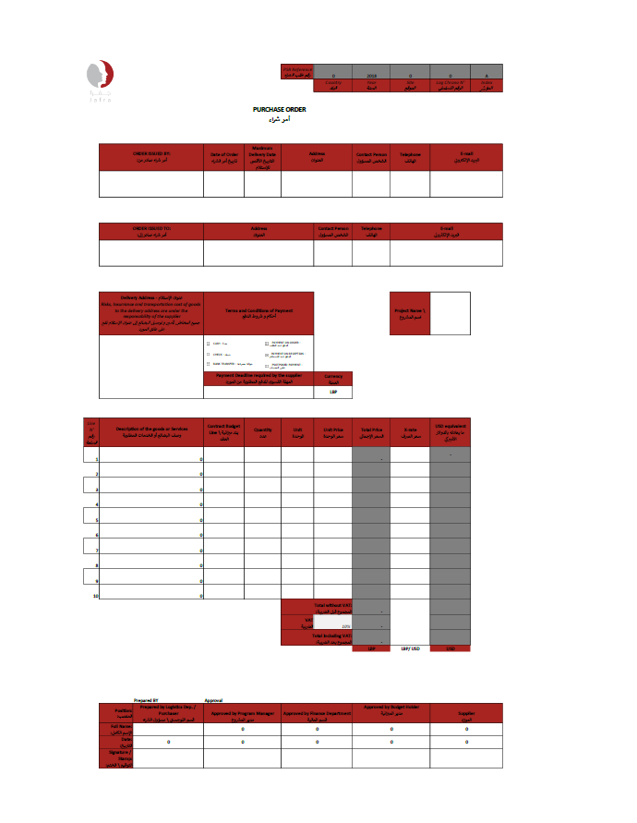
ANNEX 3 – SRN TEMPLATE

