PART B – ANNEXES

ANNEX 1 – FRAMEWORK AGREEMENT TEMPLATE

ANNEX 2 – RFQ TEMPLATE

ANNEX 3 – PO TEMPLATE

ANNEX 4 – GRN TEMPLATE

ANNEX 1 – FRAMEWORK AGREEMENT TEMPLATE

FRAMEWORK AGREEMENT

FRAMEWORK Agreement for: xxxxxxxxxx
Framework Reference: xxxxxxxxxx

This Framework Agreement is between

JAFRA Foundation, represented by [add representative name]
[address]
[Telephone – extension]
[email]
MOF no: [add MOF No.]
(Hereinafter referred to as JAFRA or First Party);
AND

[supplier name] represented by [add supplier’s representative name]
Address: [add supplier address]
Tel: [add telephone number]
Email: [add email]
MOF no: [add MOF No.]
(Hereinafter referred to as Supplier or Second Party);

WHEREAS:

- JAFRA in the project signed with Deutsche Welthungerhilfe e.V, and currently implementing a project funded by [xxxxxxxxxx] in order to supply [xxxxxxxxxx] for [xxxxxxxxxx] (the “Project”). This Agreement follows the invitation to a tender reference [xxxxxxxxxx] concerning the Project.

- Supplier was awarded the execution of the Project and hereby undertakes to supply the materials contained in the Annex No.1 according to the submitted offer and negotiations that lead to the final prices contained in the Annex itself and according to the specifications enclosed therein and in accordance with JAFRA’s business principles, ethics, and procedures, bearing in mind that the Supplier has understood all the details of supplying and identified prices on this basis.

Now, therefore, based on mutual trust, JAFRA and Supplier have entered into the present Agreement.

Preamble

The above Preamble and the Annexes constitute an integral part of this Agreement.

Duration of Framework Agreement

This agreement shall be made for a definite period from xx/xx/xxxx and expires on xx/xx/xxxx. If it is needed the agreement can be extended.

JAFRA PURCHASE ORDER

  - The official commitment from JAFRA for the supply of the goods or supplies will be through and governed by the terms of the JAFRA Purchase Order (PO), which may be revised from time to time. The current version of the PO has been provided to the Supplier, and updates will be provided in connection with orders under this Agreement. Each PO must be signed by an authorized JAFRA signatory per the specimen signature list attached. Upon receipt of an approved original PO the Supplier will deliver the items or supplies within 2 working days or as stated on the PO.

PRICES

  - The Supplier is required to provide items or supplies as per the list provided on the original bid documentation submitted on [xxxxxxxxxx] through the communicated Request for Quotation (RFQ) by JAFRA, as applicable and in compliance with the PO. JAFRA will provide the Supplier with a Request for Quotation (RFQ) which lists the items to be purchased. Upon receipt of the RFQ, the Supplier will provide a quotation within one day – 3 days. JAFRA will use the prices on the quote so as to include the prices on the PO.

  - If items are not available at the time that the quotation is prepared, JAFRA must be notified so that the items are not included in the PO.

  - As Supplier prices are regularly audited, if it is discovered that the performance does not comply with PO terms, including for example that prices are not competitive with prevailing market rates or not most-favored customer rates, this Agreement may be cancelled.

DELIVERIES

  - At the time of delivery, the Supplier is required to comply with the PO and the following:

- Deliveries should occur prior to 4 p.m. on business days
- In addition to the documentation in the PO, provide a Delivery Note, if available, that has an itemized list of the goods or supplies delivered.
- Invoice is provided to JAFRA Reception and includes an itemized list of the goods or supplies delivered and the unit and total price.
- No payments will be made without the above documents completed, signed and delivered. If goods or supplies cannot be supplied per the timeline, price and other key terms requested, this is to be communicated to JAFRA procurement prior to the issuance of a PO. After the PO is issued, Supplier is expected to comply with the terms of the PO.

SUPPLIER PAYMENTS

  - Although Suppliers are required to provide an invoice with each delivery throughout the month, payment for all invoices during the month will be made via a single cheque or fund transfer within 30 calendar days from the date of receiving the invoice / at the end of a calendar month. If there is a dispute on any invoice, those invoices will not be included for payment until all issues have been resolved satisfactorily.

CUSTOM EXPORT/IMPORT DOCUMENTS

  - If goods are for export, all Proforma Invoices, quotes and POs and invoices are to exclude VAT. The Supplier will prepare the required export papers and provide to JAFRA at the time of delivery.

PROFESSIONAL CONDUCT

  - As a JAFRA Supplier you are expected to ensure that the following does not occur:

  - Unethical conduct or unprofessional behavior by the Supplier or Supplier’s agents. This would include, but not be limited to, trying to obtain privileged JAFRA information about competitor’s prices, quotes, etc.
  - The offering of kickbacks, bribes, inducements or payments to JAFRA staff or representatives.
  - Providing poor supply, low quality products or non-adherence to the Agreement.
  - Delay in providing the goods and supplies.

The contract is made up of the following documents, in order of precedence:
- The present contract
- The appendixes to the present contract

This Agreement constitutes the entire agreement between the Supplier and JAFRA and supersedes all prior agreements or arrangements regarding the subject matter hereof. This Agreement shall not be modified or amended without specific written agreement to that effect, signed by both parties. No oral statement of any person whomsoever shall, in any manner or degree, modify or otherwise affect the terms and provisions of this Agreement.

Done in English, in Beirut in two originals, one original being for JAFRA and one original being for the Supplier.

JAFRA Representative: | The Supplier:
Name:  Date:  Signature:  Stamp: | Name:  Date:  Signature:  Stamp:

Note: The representatives must endorse all the pages of the contract. Initials of the representatives are sufficient.

ANNEXES

Annex 1: Detailed Pricing Matrix – not included in this draft

ANNEX 2 – PO TEMPLATE

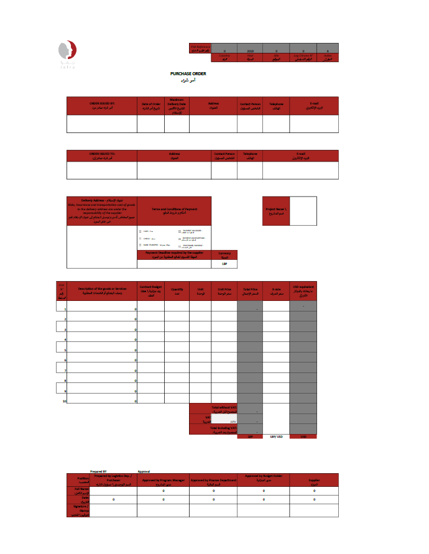
ANNEX 3 – GRN TEMPLATE

