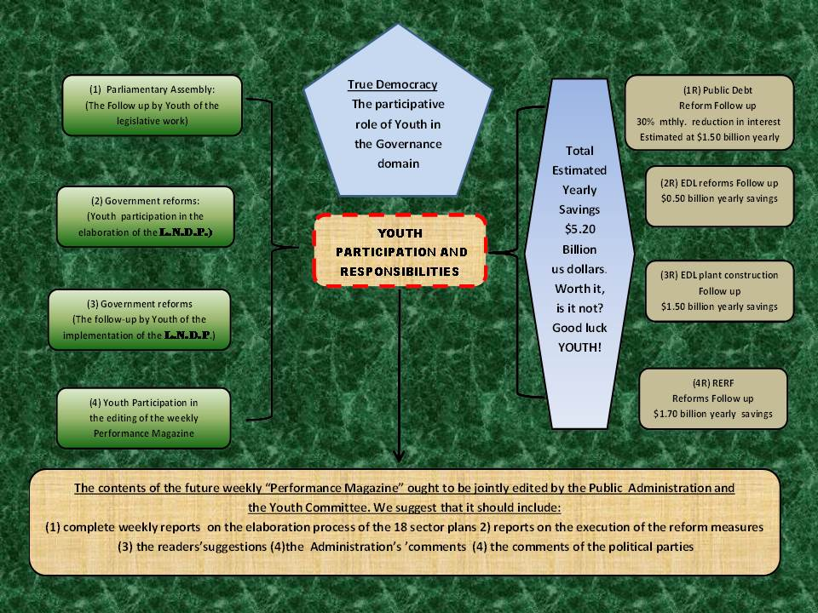
LET’S GET THE KIDS IN
A lot has been said and printed about the role that is expected to be performed by YOUTH in the governance process, but I do not recall reading any serious proposals on the subject. It is as though, some of our esteemed dinosaur leaders consider the idea so “farfetched “that, for them, it is not really worth considering. They ask: “Do you seriously think that “kids” can tell us what to do or not do?
The answers would be: First, these “kids”, as you call them, can come up with some fresh ideas that the adults may not have thought of. Second, they are legitimate Lebanese citizens and are fully entitled to their opinion. Third, in other parts of the world their opinion is seriously taken into consideration. So why should we not try this approach ourselves, especially that adults, be them politicians or citizens, have not really performed well during the past seventy years, have they?
So, here is a schematic proposal of how we could integrate YOUTH in the governance process. I suggest that you read it carefully, and if there are some things that you do not fully understand, please do not hesitate to ask.
Once more, I would like to tell the disbelievers: “Why not try it? What have we got to lose that we have not lost already?
Here are some additional explanations regarding the above presentation:

A. - ON THE LEFT SIDE OF THE PRESENTATION
The four green shapes on the left represent the initiatives that Youth would be expected to take after having undergone some solid training on the subject and some initial
“familiarisation” on the ground. These initiatives include:

- Attending some parliamentary committee meetings and following up on the results
- Working with mentors and experts to draw up the remaining nine sector plans that have been ignored so far and that ought to be completed within the next six months if enough diligence is brought to the job.
- Follow up on the implementation of the above Plans, once it starts, and reporting on the results of their investigations.
- Participate in editing a WEEKLY INFORMATION MAGAZINE where the results of their work and the work of the public administration will be records for all the citizens to read, understand, and be aware of.
B. ON THE RIGHT SIDE OF THE PRESENTATION
Here the “kids”, as one would be tempted to call them, would seek to find out, from the public records, the “practical results” of the work that was described above. This is expected to save the National Treasury some $8.7 billion dollars a year. Of course, they could not do this checking operation on a weekly basis, but their role will be to make sure, with the public administration, that the monthly financial records are clearly published on the Ministry of Finance’s web site to which they ought to have free access. This will force the Administration to write up their records in simple and easily understandable Arabic and English, and not the “technical hardly understandable jargon that is currently used.
Ultimately, we hope, these “kids “will learn that the result of their efforts, the efforts of the entire public Administration, the political parties, and the five million citizens of Lebanon, will save the National Treasury, some $8.7 billion dollars a year. Don’t you think that realizing that will make the “kids” grow up fast and become real sophisticated citizens?
C. FINAL REMARK:
Of course, this project is not expected to start tomorrow morning. It will need weeks and months to be organized and assimilated. The “kids” will have to be trained and mentored adequately. But (what the hell?) We have wasted seventy years (except the six years of Fouad Chehab’s mandate) on practically “bugger all”. We can wait six more months to try and become a NATION.
NB: I am waiting for your comments, folks.
George Sabat(ACMA)

